D7.4 Customer recruitment and contractual procedures for the demonstrations
Version 1.0
28-06-2018

Deliverable D7.4

ID & Title : | D7.4 Customer recruitment and contractual procedures for the demonstrations
Version : | V0.7 |  |  |  | Number of pages : |  |  | 32
Short Description
Deliverable 7.4 deals with the way the customers are going to be involved in the Interflex demo in the Netherlands. The second part describes the services, financial operating models and contractual agreements between the different market players.
Revision history
Version | Date | Modifications’ nature |  |  | Author
V0.1
V0.2 | 14-03-2018 | Review comment
V0.3 | 19-03-2018 | Review comment |  |  | D. Geelen
V0.4 | 22-03-2018 | Review comment |  |  | D. Geelen
V0.5 | 31-05-2018 | Chapter 3 added |  |  | K. van Doren, R. Roodenburg and M. Willems
V0.6 | 08-06-2018 | Review version E.ON
V0.7 | 25-6-2018 | Editing review E.ON |  |  | D. Geelen and M. Willems
V1.0 | 28-6-2018 | Final version |  |  | M. Willems
Accessibility
☐Public | ☒ Consortium + EC |  | ☐ Restricted to a specific group + EC |  | ☒ Confidential + EC
Owner/Main responsible
Name(s) | Function |  |  | Company | Visa
Author(s)/contributor(s): company name(s)
I. Stegmann: Jedlix
C. van den Sandt: Jedlix
R. Roodenburg: CW&D
P. Radenmakers: Elaad
K. van Doren: Enexis Netbeheer
D. Geelen: Enexis Netbeheer
T. van Cuijk: Enexis Netbeheer
O. Westerlaken: Enexis Netbeheer
D. Talsma: Enexis Netbeheer
M. Willems: Enexis Netbeheer
Reviewer(s): company name(s)
Company |  |  |  |  |  | Name(s)
E.ON. |  |  |  |  |  | Pauline Ahlgren  Peder Kjellen
Approver(s): company name(s)
Company |  |  |  |  |  |  | Name(s)
Enedis.
Work Package ID | WP 07 | Task ID |  |  | T4

Executive summary

This report describes the different roles and contractual procedures that are defined for the parties involved in the Interflex project in Eindhoven, Strijp-S.
The goal for this project is to define a marketplace for flexibility. To achieve this different parties act in a market chain with each their own distinctive roll and responsibilities.

The parties involved in the flexmarket are:
- Distribution System Operator (DSO) responsible for the planning, operation and maintenance of the distribution networks.
- The commercial aggregator (CA) responsible for the demand service provider that combines multiple short-duration flexibility sources for sale or auction in organized energy markets. This can be for example flexibility for DSO, TSO, BRP, or energy trade on day-ahead or intraday market). The flexibility is obtained through contracts with local aggregators (LA).
- The local aggregator (LA) responsible for collecting and bundling (geographically) local flexibility into a bigger aggregated flexibility offering, and to provide this to a commercial aggregator (which in turn exploits the value of the flexibility offers on energy- and flexibility markets).
- The Distributed Energy Resource owner is the owner of the DER or flexibility source (for example, but not limited to, smart storage unit, solar PV, charge points).

For testing the systems and the flexibility market mechanism, EV customers are to be recruited in the Eindhoven area. For this a customer recruitment strategy is defined. In this report the proposal to the EV driver is defined and also the EV recruitment process.

For the contractual procedures the roles of the different players are described in relation to the flexibility market (see also fig. 1). A financial operating model that describes financial aspects between the different parties and the outline of the contracts that can be made are mentioned in this report.

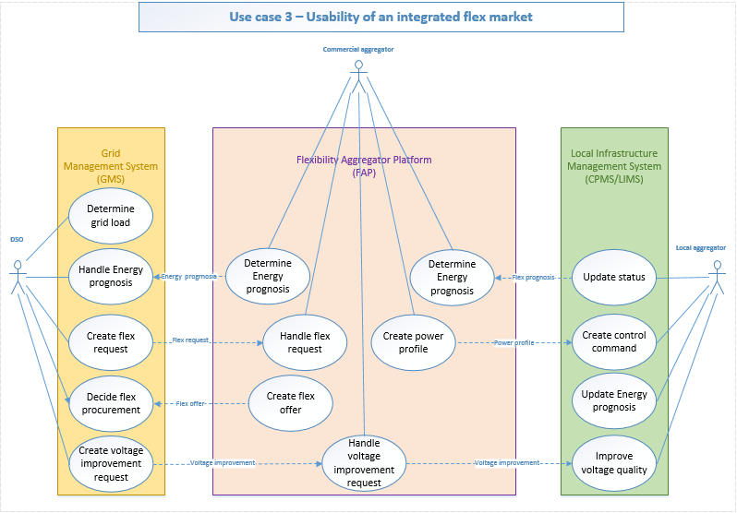
Figure 1: Functions and service provided.

The customers are the main success- and risk factor in this project. For recruiting these EV customers the experience from the commercial aggregator is used. Also, the municipality of Eindhoven, who has a big interest in this project is involved. Together with the local community of Strijp-S the recruitment is started in September 2018.

Table of content

1. Introduction 9
2. Recruitment 10
2.1. Proposition to EV drivers 10
2.2. EV driver recruitment process 10
3. Agreements between actors in the flexible market 13
3.1. Roles in the market. 15
3.1.1. DSO. 17
3.1.2. Local aggregator EV and DER 19
3.1.3. Commercial aggregator EV and DER 20
3.1.4. DER owner 21
3.2. Financial operating model. 22
3.2.1. Financial operating model Flex between DSO and CA 23
3.2.2. Financial operating model Variable capacity between DSO and LA 23
3.2.3. Financial operating model Flexibility between CA and LA 23
3.2.4. Financial operating model Flexibility between LA and DER owner 23
3.3. Contracts. 24
3.3.1. Contract Flexibility between DSO and CA 24
3.3.2. Contract Flexibility between DSO and LA 24
3.3.3. Contract Flexibility between CA and LA 25
3.3.4. Contract Flexibility between LA and DER owner 25
3.3.5. Agreement with EV drivers 26
4. Conclusion 26
5. Outlook 26
6. AppendiCes 29
6.1. Appendix 1 Master Flex & VI/VC Purchasing Agreement. 29
6.1. Appendix 2 Terms and Conditions CA EV (Jedlix). 29
6.1.1. What do we do? 29
6.1.2. Bonus 29
6.1.3. Method of calculation and bonus pay out 29
6.1.4. Savings 30
6.1.5. Pay out 30
6.1.6. Donate / transfer savings 31
6.1.7. Terminate participation 31
6.1.8. User Settings 31
6.1.9. Disclaimer 31
6.1.10. Privacy 32
6.1.11. Remaining 32

List of Figures

Figure 1 – Functions and service provided. 4
Figure 2 - Buildings Strijp-S 12
Figure 3 – Functions and service provided. 14
Figure 4 – Roles, systems and communications 14
Figure 5 – Variable capacity 17
Figure 6 – Financial implications 22
Figure 7 – Financial implications outlook. 27

list of tables

Table 1 - List of acronyms 8
Table 2: Roles, systems and communications 15
Table 3: Value Add 22
Table 4: DSO and CA metrics 24
Table 5: DSO and LA metrics 25
Table 6:CA and LA metrics 25

Notations, abbreviations and acronyms
The table below provides an overview of the notations, abbreviations and acronyms used in the document.
Table 1 - List of acronyms
BRP | Balance Responsible Party
CA | Commercial Aggregator
CPMS | Charge Point Management System
CPO | Charge Point Operator
DSO | Distribution System Operator
DER | Distributed Energy Resources
ESCO | Energy Service Company
EC | European Commission
EC-GA | European Commission Grant Agreement
EFI | Energy Flexibility Interface
EU | European Union
EV | Electrical Vehicle
EVSE | Electrical Vehicle Supply Equipment
FAP | Flexibility Aggregator Platform
GA | General Assembly
GMS | Grid Management System
GWP | General Work Package
ICT | Information Communication Technology
KPI | Key Performance Indicator
LA | Local Aggregator
LIMS | Local Infrastructure Management System
OCPI | Open Charge Point Interface
PC | Project Coordinator
POC | Point Of Connection
PTU | Program Time Unit
PV | Photo Voltage
SC | Steering Committee
SSU | Smart Storage Unit
TC | Technical Committee
TD | Technical Director
TNO | Nederlandse Organisatie voor toegepast-natuurwetenschappelijke kennis (Netherlands Organisation for Applied Scientific Research)
TSO | Transmission System Operator
USEF | Universal Smart Energy Framework
VC | Variable Capacity
VI | Voltage Improvement
WP | Work Package
WPL | Work Package Leader

Introduction
InterFlex aims to develop the next generation of smart distribution networks in Eindhoven and elsewhere in Europe to speed up the energy transition. 95% of all renewable energy sources are connected to the distribution grid. Governments in Europe are giving priority to millions of charging points and stations to facilitate an increase of electric transport in the coming decades. Behaviour of consumers and technology change rapidly. In this context, the grid must be able to count on a system that addresses local needs and developments.

The main focus for the Interflex pilot in the Netherlands is to enable a flexibility market so that EV charging is not limited by constraints of the low voltage network. For reference, the scope of the Interflex project is mentioned in the document ‘Use Case planning, District architecture requirements and tested innovations Version 1.0, 25-10-2017’.

This document describes the customer recruitment and contractual procedures for the Interflex demonstration. Additionally, the customer recruitment methods and contractual procedures are applicable for a roll-out scenario.

Chapter 2 presents the customer recruitment, which focusses on the recruitment of EV-drivers for smart charging. These customers should benefit from the flexibility market that is created to avoid congestion problems on the LV network and get optimal charging conditions for charging their vehicle.

In Chapter 3 we discuss the contractual procedures concerning the different roles and actors in the Interflex project. The described contractual procedures are between the following roles:
- The local aggregator and the commercial aggregator
- The local aggregator and the DSO
- The commercial aggregator and the DSO
- The local aggregator and de DER owner

Within the Interflex project, the roles are fulfilled by several market parties, namely:
- Jedlix, EV commercial aggregator
- Sympower, DER commercial aggregator
- TNO, EV commercial aggregator and DER commercial aggregator
- CroonWolter&Dros, DER local aggregator
- ElaadNL, EV local aggregator
- Enexis Netbeheer, DSO

Recruitment
Interflex integrates several flexibility sources in the pilot: smart storage unit (SSU), electric vehicle charge points (EVSEs) and solar PV. The smart storage unit and the solar PV are single installations, that do not require a specific customer recruitment. The flexibility potential of the EVs, however, can only be used when EVdrivers decide to charge their car at one of the EVSEs that is part of the pilot. And only when they decide to smart charge at one of the designated EVSEs. This means that we have to actively recruit EV drivers to use the smart charging solution. The smart charging solution is provided by a commercial aggregator, because their possibility to trade flexibility on the flexibility market depends on their ‘smart charging customers’. To this end, the commercial aggregator of EVs is involved in the customer recruitment process. They have a lot of experience in the EV market with the smart charging solution they already offer to EV drivers.

Proposition to EV drivers
This section describes the proposition to the EV drivers that smart charge their EV in Strijp-S. The EV commercial aggregator offers a smart charging service to EV drivers, which can be activated by users after downloading a free application for smart phones. After filling in the charging pass number, users can fill in their leaving time and start charging at one of the electric vehicle supply equipments (EVSEs) in Eindhoven, Strijp-S,which are managed by the EV local aggregator. The EV commercial aggregator determines the smart charging schedule and charges the EV until the battery is full. The charging session of the EVSE is influenced by Open Charge Point Interface (OCPI). For InterFlex the commercial aggregator and the local aggregator have implemented an adapted model of OCPI that enables the aggregator to control the charging session. When the charging session is completed, users receive a financial reward for offering their flexibility to the commercial aggregator EV. Users can disable the smart charging function at any moment in time.

The commercial aggregator EV, Jedlix, is able to connect some brands of EVs, i.e. Tesla and Renault, which offer an extra feature for users. One advantage of this so-called connected-car feature is that the state-of-charge of the EV is updated automatically in the application. For public chargers it is not obligatory to connect their EV, but in case users connect their EV it offers this extra feature.

EV driver recruitment process
Several types of marketing activities will be used to recruit new users for the Jedlix Smart Charge application. The main goal of these activities is to onboard as many EV drivers as possible for smart charging at EVSEs that are part of the Interflex pilot. A secondary goal is to inform people who live and work in the Eindhoven Strijp-S area about this project. The elaboration of which marketing strategies to be used for this pilot takes place in May-July 2018. Therefore, we describe a number of potential marketing activities below:
- Landing page
As part of the website for the InterFlex Eindhoven pilot, there will be a landing page with information about the project and a call to EV drivers to participate by smart charging their EV. EV drivers have the possibility to read more information about what it means to participate in the pilot. The page will also enable people to subscribe themselves as a test user. The landing page will be equipped with online tools, which collect and measure all data traffic on this page. Examples of such tools include Google Analytics, Mailchimp opt-in and Hotjar.
- Newsletter subscription
On the website, people who are interested in the progress of the project can subscribe to the Interflex Project newsletter. This newsletter updates subscribers about the project on a regular basis and particularly aims to stimulate the subscribers with an EV to become a test user in the recruitment phase of the project and to stay involved.
- Special invite for EV drivers
All EV drivers in the pilot area can receive a ‘personal’ invitation to become part of the project and start benefitting from smart charging. This invitation will provide instructions for downloading and using the app to enable a smart charging session. This invitation also provides more general information on the InterFlex project. There are several ways to reach out to EV drivers with a ‘personal’ invitation. One of them is to place a ‘special invite flyer’ on the EVs that are parked in the pilot area. Other possibilities include contacting the EV drivers through local ambassadors, such as the business- and inhabitant community.
- Getting in touch at public EVSEs
There are a number of public EVSEs in the pilot area. These are perfect locations to draw attention to the project and the opportunity to start smart charging. Some options for these locations are:
  - Direct ‘sales’-team
  - Stickers on the EVSE with a call to participate
  - Flyer/brochure attached to the EVSE or put under wipers
  - Old-school paper with the url of Interflex landingspage
- SX LED Wall
The side wall of the SX building in Strijp-S is covered with an impressive LED wall. Every day thousands of people pass this wall and many of them work or live in Strijp-S. This wall can help to increase the awareness of the Interflex Project. A clear message about the project can be shown on the screen, in combination with a call to action to visit the landing page.
- Make contact via local communities
Most employees and inhabitants of Strijp-S are part of a Strijp-S community, as described below. The EV commercial aggregator can connect with these communities and inform them about the Interflex pilot and the possibility to become a test user.
- Targeting specific buildings and companies
Some buildings and companies in Strijp-S are interesting to target. The map below shows the locations of current EVSEs. It is likely that the target group works in one of these buildings or visits them regularly (e.g. for lunch). The companies and locations around these EVSE locations can be contacted directly about the smart charging possibilities and the Interflex pilot. Possible marketing activities to recruit EV drivers in these buildings are: intranet, internal newsletter, posters and/or flyers. The relevant locations are indicated in figure 2.

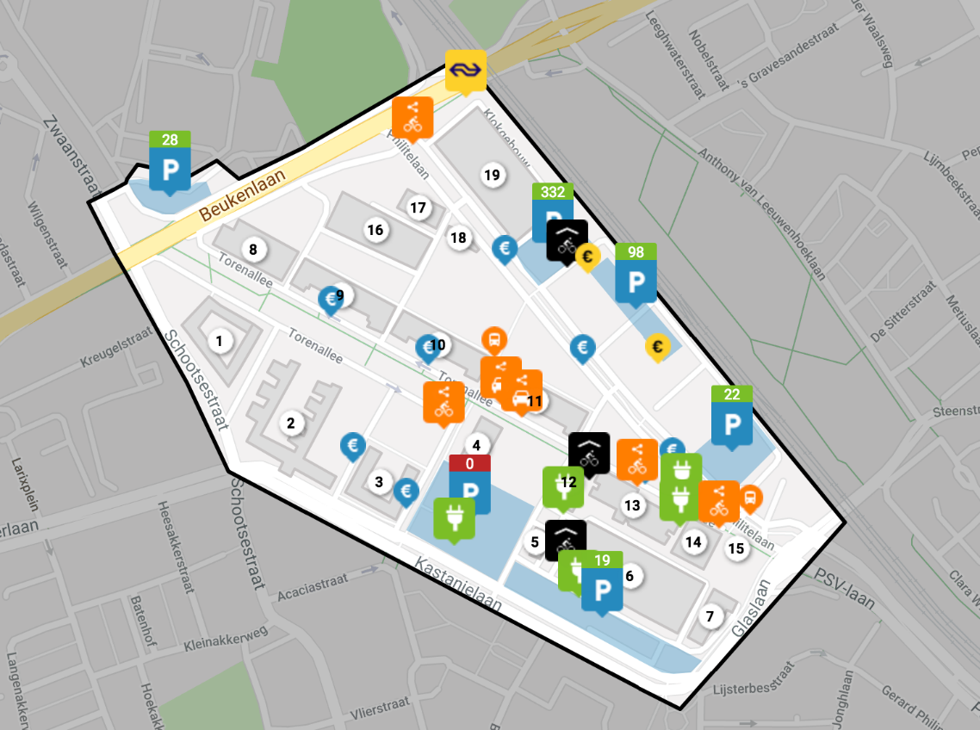
6) Micro Lab
8) The Veem Market
9) Ice cream shop
12) Glasgebouw
13) VideoLab
14) Gebouw SX
15) Portierloge/Mobility-S
18) Ketelhuis
Figure 2: Buildings Strijp-S

Agreements between actors in the flexible market
The EVSE in Strijp-S are operated and managed by a local aggregator EV. The energy is supplied by an energy supplier that has a contractual agreement with a commercial aggregator EV. This is necessary because the aggregator will affect the charging pattern of the charging session, thus the related BRP should be informed about the charges in order to maintain balance on the grid. The local aggregator EV and the commercial aggregator EV have an interface to communicate the charging signal. In addition, the commercial aggregator EV and the user also have an agreement. The commercial aggregator EV charges the battery before the leaving time of the user and the user receives a financial reward in return for offering their flexibility to the commercial aggregator EV.

The Smart Storage Unit (SSU) is operated bij the local aggregator DER. The SSU is connected with a Modbus interface to the local Interface management system (LIMS). The LIMS can manage the SSU for charging and de-charging on request for offer flexibility to the commercial aggregator. For this purpose, the Local aggregator has a standardized connection based on the EFI protocol directly to the Commercial aggregator. This protocol is enhanced with extra features for this purpose.
For the variable capacity on the SSU connection, no specific interface is needed. This is done on a user interface base on the LIMS system were the DSO can manage the variable capacity in relation with the contractual procedures.

The DSO has an Universal Smart Energy Framework (USEF) interface that is used to sedt out a flexibility request to the different commercial aggregators that are contracted. The Commercial aggregators send their daily D-prognose over the same interface. This USEF interface is also enhanced with extra features. Payment of the delivered flexibility is done through the company own payment systems.

The different functions and service provided by the actors on a system basis are described in Figure 3. Figure 4 describes the roles, systems and communication on an actor level.

Figure 3: Functions and services provided.

Figure 4: Roles, systems and communications.

Roles in the market.
Several players are active in the flexibility market, each having a distinctive role.
The descriptions of the roles are important in the market chain that are to be tested in the Interflex project. In their roles, the players use dedicated platforms to act on the flexibility market. Contracts are defined between the different roles. These contracts define the services each role must offer and the payment settlement between the different parties. These roles, platforms and contracts are described in the table below.

Table 2: Roles, systems and communications
Actor Name | Actor description | Further information | Equipment Manufacturer | Contracts
DSO | The Distribution System Operator is responsible for the planning, operation and maintenance of the distribution networks | The DSO performs load management of its grid and acts in case of an (forecasted) emergency.  The DSO pays for requested flexibility in the net. | GMS, own development | - Flexibility with CA  - Variable capacity with LA
CA | The Commercial Aggregator is responsible for the demand service provider that combines multiple short-duration flexibility sources for sale or auction in organized energy markets. This can be for example flexibility for DSO, TSO, BRP, or energy trade on day-ahead or intraday market). The flexibility is obtained through contracts with Technical (local) aggregators. | Within the Eindhoven demonstration project, the general term for a CA ICT-system is FAP (Flexibility Aggregation Platform). This is the system that on one side aggregates flexibility from LAs and on the other side offers that aggregated flexibility to flexibility market parties. | CA, own development | - Flexibility with DSO  - Flexibility with LA  - In case of Electric Vehicles:  - Agreement with drivers.
LA | The Local Aggregator is responsible for collecting and bundling (geographically) local flexibility into a bigger aggregated flexibility offering, and to provide this to a commercial aggregator (which in turn exploits the flexibility’s value on energy- and flexibility markets | Within the Eindhoven demonstration, we use two different names for the ICT-system of a LA. The generic term is LIMS, a Local Infrastructure Management System. Additionally, we also use the term CPMS, which is exactly the same as a LIMS but dedicated to managing charge points for EVs. This is done because CPMS is a widely accepted system acronym and using LIMS in the charge point context could cause confusion. The role charge point operator is a specialisation of the role local aggregator, dedicated to managing local infrastructure of type charge point for EVs. | LA, own development | - Flexibility with CA  - Variable capacity with DSO  - Flexibility with DER Owner  - Variable capacity with DER owner
DER Owner | The Distributed Energy Resource owner is the owner of the DER or flexibility source (for example, but not limited to, smart storage unit, solar PV, charge points). |  | Actual DER’s, battery, solar etc. | - Flexibility with LA  - Variable capacity with LA

DSO
The role of the DSO is to operate, maintain, and where necessary develop the distribution system in its territories, including the interconnections to the higher-level systems. This includes ensuring the availability of sufficient grid capacity and making sure the system’s stability criteria are met.

Within Interflex, the DSO will participate on a local flexibility market, to procure flexibility for grid management purposes. Through the GMS the DSO interacts with the systems of the commercial aggregators, and accesses the local flexibility market.

Flexibility agreement between DSO and CA.

For trading on the flexibility market between the DSO and CA the following is agreed:

- Grid load per congestion point/PTU (15 minutes) is calculated based on grid measurement and energy prognosis per congestion point/PTU (15 minutes) are received from the commercial aggregators.
- Congestion calculation is based on these two forecasts. If congestion, a flexibility decision is made and if flexibility needed flexibility requests are sent to the commercial aggregators that are active on that specific congestion point. A flexibility request contains info per PTU (15 minutes): quantity of flexibility needed, max price, min sanction price, power max and power min.
- Based on the flexibility offers received from the commercial aggregator(s) with per PTU the quantity to be provided, the price and sanction price; the DSO will decide which flexibility offer(s) will be procured via a flexibility order.
- After the flexibility moment, the DSO receives the flexibility amounts supplied from the commercial aggregator and every week a flexibility settlement message is sent. This will be the basis for the invoice the DSO will receive from the commercial aggregator, which will be payed in flex coins.

Variable capacity agreement between DSO and LA.

The agreements concerning the procurement of flexibility via a variable capacity mechanism can be arranged in different ways. Within the scope of InterFlex in Eindhoven, this is a variable capacity on the point of connection (POC). The variable capacity could provide a DSO with an alternative to the local flexibility market and/or a long-term contract with a CA, ensuring a certain ‘flexibility’ by specifying a capacity profile as a function of time (i.e. throughout a day).

To enable this, four parameters are introduced: the maximal off- and on-peak capacity, the time of starting the capacity reduction, and the period of capacity reduction (e.g. number of hours). The figure below illustrates the concept of variable capacity in relation to the time. The maximum off- and on peak capacity is contractually defined. The period also. Only the starting point of the period can be flexible.

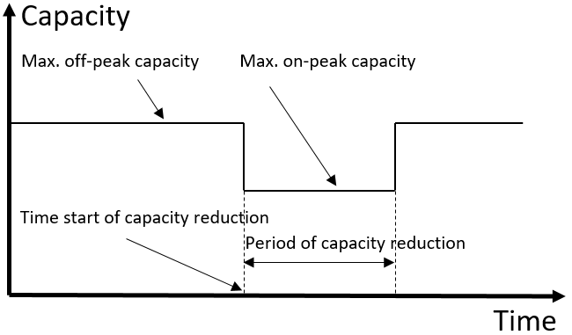
Figure 5: Variable capacity.

Within Interflex Eindhoven, the concept of variable capacity will be implemented in two stages, namely a static variable connection capacity and a dynamic variable capacity.

In case of the static variable connection capacity, the period of capacity reduction and time of the star of capacity reduction are fixed to a daily, static profile. An example could be setting the on-peak capacity for an interval of three hours, starting at 17:00.

In case of a dynamic variable connection capacity, the period of capacity reduction (a number of successive program time units) is set fixed, however the starting time of the capacity reduction varies from day to day (i.e. is dynamic). An example could be setting the period of capacity reduction to two hours per day, and providing a daily update on the starting time. To make sure the dynamic variable connection will not conflict with the flexibility market the DSO will communicate the variable profile 24 hours before the beginning of the particular day. There will be no adjustments to the flexibility market as a result of the introduction of the variable connection capacity.

Further characteristics to consider are the following:
- Directly between DSO and POC
The variable connection capacity is an agreement directly between the DSO and a POC. No intermediate parties (e.g. aggregators) are involved as it’s an addition to the current agreement between the DSO and POC. Though it is possible for the POC to communicate the profile to an aggregator.
- Daily occurrence
On those connections with a variable connection capacity, that reduction will be implemented on a daily basis, based on the static and/or dynamic profile negotiated. After-all, a DSO should remain non-discriminatory, thus providing the same opportunities everywhere and always.
- Obligatory nature
The idea behind the variable connection capacity is to give connected parties the choice between a contract with a static capacity profile, or a contract with a variable capacity profile (irrespective of the way a DSO is organizing the monetary values of such contracts). However, when a contract with a variable capacity profile is chosen, abiding by this profile is mandatory.
- Contractual agreement
The technical connection can be realised as if it is the off-peak capacity. A connected party is responsible for reducing the profile during the on-peak hours. This can for example be evaluated afterwards, by analysing the measurement data. Furthermore, the contract could state a penalty clause, incentivising connected parties to abide by the reduction.

Within Interflex Eindhoven the variable connection capacity will be implemented only on the connection of the smart storage unit. Furthermore, the time before which the starting time of a dynamic variable connection capacity reduction should be communicated should be aligned with the closure times of wholesale energy - and local flexibility markets.

Operational obligations.

This section describes the various duties, activities to be performed by the various parties involved and their (financial) compensation models applied for the rendering and/or delivery of those tasks, services and activities.

Obligations:
- One of the daily obligations of the DSO is the daily processing of power profiles and the daily determining and making updates of the energy prognosis in GMS;
- Based on this outcome (from 1), the DSO will determine in GMS the daily, short- & long-term grid load required;
- Depending the grid load requirements (from step 2), the DSO will set out requests to purchase extra flex demand on daily-, short- & long-term basis;
- Per response to its requests, the DSO will purchase Flex at intraday conditions as proposed by the CA in FAP and/or by the LA in LIMS;
- Depending on 2 and 3, and 4 (when required) the DSO will set out request for voltage-improvement(VI); and process such request in the GMS system.

Financial & Contractual Flows:
- DSO will issue daily settlements of actual received (purchased) Flex for monthly payment to the GMS Service Provider;
- Contract to be issued between the DSO (buyer) – GMS Service Provider (seller) for purchasing Flex & VI/VC (example template enclosed for review)

Local aggregator EV and DER
The role of the local aggregator is to collect and bundle (geographically) local flexibility into a bigger aggregated flexibility offering, and to provide this to a commercial aggregator,which in turn exploits the flexibility’s value on energy- and flexibility markets. In order to obtain flexibility sources for its asset portfolio, the LA has interactions and contracts with DER and EV owners.

Within the Eindhoven demonstration, we use two different names for the ICT-system of a LA. The generic term is LIMS, a Local Infrastructure Management System. Additionally, we also use the term CPMS, which is exactly the same as a LIMS but dedicated to managing charge points for EVs. This is done because CPMS is a widely accepted system acronym and using LIMS in the charge point context could cause confusion.
The role charge point operator is a specialisation of the role local aggregator, dedicated to managing local infrastructure of type charge point for EVs. For more information, see LA.

Flexibility agreement between LA and CA
For trading on the flexibility market between the LA and CA the following is agreed:

- The local aggregator reads the relevant data from the DER.
- A forecast is calculated and sent to the commercial aggregator
- Actual DER status is sent to the commercial aggregator
- Flexibility command(s) is/are received from commercial aggregator and translated to a DER command.
- A command is sent to the relevant DER(s)
- Actual DER status is sent to the commercial aggregator

Variable capacity agreement between LA and DSO.

Information on the variable capacity agreement between LA and DSO can be retrieved from section 3.1.1.

Operational obligations.

This section describes the various duties, activities to be performed by the various parties involved and their (financial) compensation models applied for the rendering and/or delivery of those tasks, services and activities.

Obligations:
- Daily management (prognosis) done by the LA of flexibility in LIMS and provide updates in FAP via LIMS;
- Based on th outcome from point1, determine the daily, short- & long-term local energy prognosis and the related daily-, short- & long-term LIMS;
- Depending on 2, make offer(s) to supply Voltage Improvements (‘variable capaciteit’) on a daily-, short- & long-term basis to DSO;
- Daily processing of Voltage Improvement requests in LIMS;

Financial & Contractual Flows:
- Daily settlement of actual supplied (sold) VI/VC for monthly invoicing to the LIMS Service Provider.
- Contract between LA (seller) – LIMS Service Provider (buyer) for selling VI/VC.

Commercial aggregator EV and DER
The role of the commercial aggregator is described as a demand service provider that combines multiple short-duration flexibility sources for sale or auction in organized energy markets. This can be for example flexibility for DSO, TSO, BRP, or energy trade on day-ahead or intraday market). The flexibility is obtained through contracts with local aggregators.
Within the Eindhoven demonstration project, the general term for a CA ICT-system is FAP (Flexibility Aggregation Platform). This is the system that on one side aggregates flexibility from LAs and on the other side offers that aggregated flexibility to flexibility market parties.

Flexibility agreement between CA and DSO/LA

For trading on the flexibility market between the CA and DSO/LA the following is agreed:

- The commercial aggregator receives per DER actual status info from the local aggregator and uses this as input for their own energy prognosis for the related congestion point. The own prognosis is sent to the DSO.
- For the flexibility requests received from the DSO a calculation is made to see if it is profitable to send a flexibility offer. If so, a price and sanction price is defined per PTU. Possibly the wholesale market has a better price for the same PTU. An updated energy prognosis is sent to the DSO.
- If the flexibility offer is ordered by the DSO, the commercial aggregator will send a flexibility command to the local aggregator.
- The day after, the flexibility supplied is sent to the DSO. And every week a flexibility settlement message is received. If the commercial aggregator agrees with the settlement an invoice will be sent to the DSO, otherwise a dispute process will be started. This means that the DSO will be contacted.

A difference for EV is that the commercial aggregator also calculates the energy prognosis per DER (i.e. charge point) and not the local aggregator. Also, the commercial aggregator needs consent from the EV driver to take part in the project and use their charging info.

Operational obligations.

This section describes the various duties, activities to be performed by the various parties involved and their (financial) compensation models applied for the rendering and/or delivery of those tasks, services and activities.

Obligations:
- Daily management of various flex requests in FAP;
- Based on teoutcomefrom1, determine the daily, short- & long-term energy prognosis and the related daily-, short- & long-term flex requirements in FAP;
- Depending on 2, and taking into account the local energy prognosis updates made from LIMS into the FAP, make offer(s) to supply flex on a daily-, short- & long-term basis;
- Daily processing of Voltage Improvement (VI) requests in FAP;

Financial & Contractual Flows:
- Daily settlement of actual supplied (sold) Flex for monthly invoicing to the FAP Service Provider.
- Contract between CA (seller) – FAP Service Provider (buyer) selling Flex

DER owner
This is the owner of the DER or flexibility source (for example, but not limited to, smart storage unit, solar PV, charge points). The DER owner is responsible for strategic scheduling, and getting a contract with a local aggregator to ensure exploitation of the flexibility sources.

Financial operating model.
The objective of this section is to have those operational flows (including but not limited to activities such as entering of purchase requests in a system, tasks such as the daily processing of prognosis profiles in a system and all other operations that lead to a ‘Deliverable’ and/or ‘Service’ performed by one particular party for- and that is being financially compensated by another party (and/or stakeholder).

The Financial model is based on the added value of the different parties, and the way that it contributes to society as a whole.
This holistic approach is illustrated in the table below:

Table 3: Added value of the different parties, and the way that it contributes to society as a whole.
Added value
Society as a whole
+ Enables a stable and reliable flexmarket via regulation, which contributes to a stable and sustainable future and achievement CO2 goals.
DSO | CA | LA | DER Owner
+Manages congestion in the Net. | +Delivers the Flex commercially.  +Keeps the CA platform available and it’s performance up to standard. | +Delivers the flex physically.  +Keeps the LA platform available and it’s performance up to standard.  +Technical support | +Makes the DER’s available for the Flexmarket.  +Keeps the DER available and it’s performance up to standard.

The financial implications between parties are detailed in the sections below.

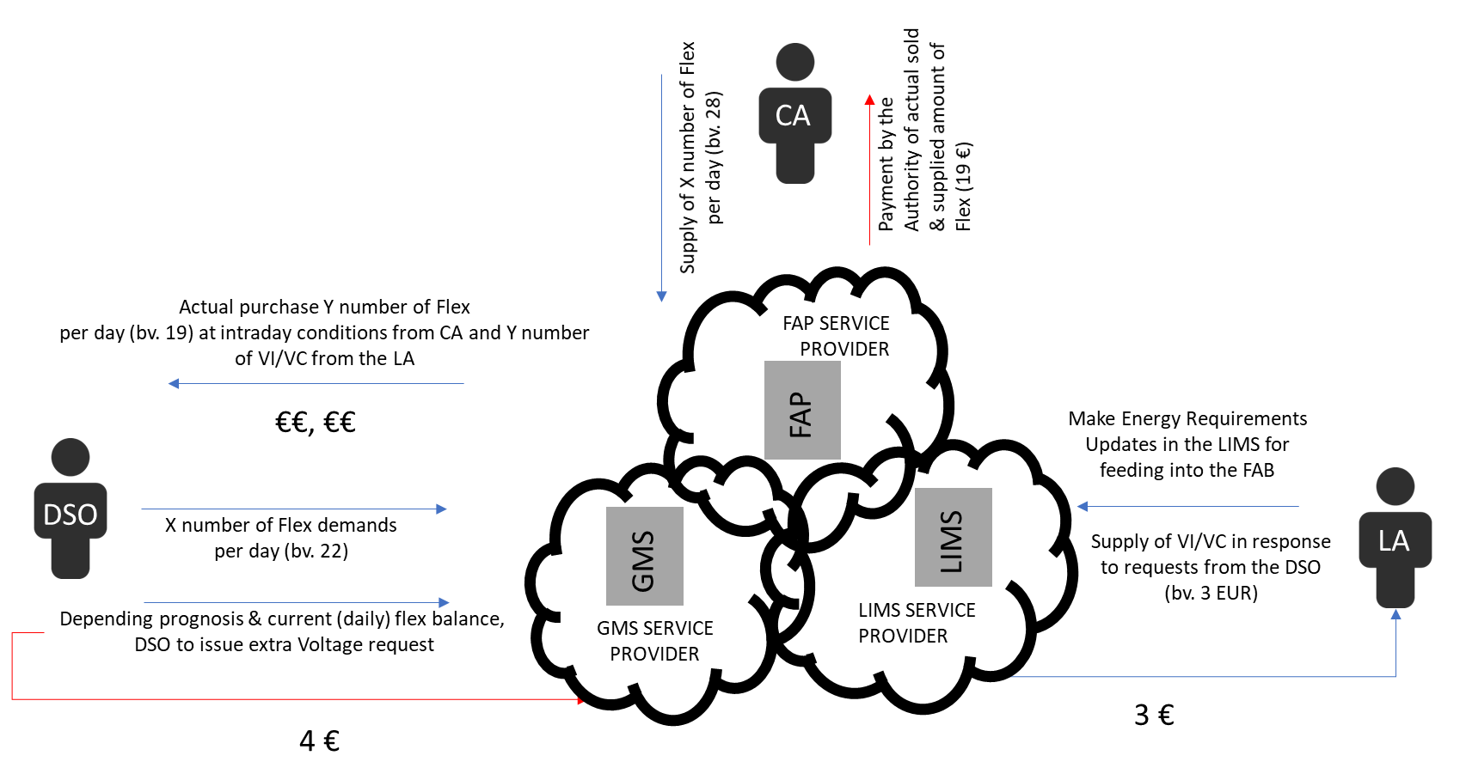
Figure 6: Financial implications

Financial operating model Flex between DSO and CA
The DSO will need to compensate the CA for the value it adds:
+Delivers the Flex commercially.
+Keeps the CA platform available and its performance up to standard.

This can be financially modelled in different ways, but it should include the following components:

- A fixed fee on a monthly basis for the availability of the system and its performance up to standard. This is a unilateral compensation only for the CA.
- A variable fee for actually commercially delivered Flex or penalties.

Financial operating model Variable capacity between DSO and LA
In case of the variable capacity market the DSO will directly reduce capacity directly via the LA. The DSO will need to compensate the LA for the value it adds:
+Delivers the flexibility physically.
+Keeps the LA platform available and its performance up to standard.
+Technical support
This can be financially modelled in different ways, but it should include the following components:

- A fixed fee on a monthly basis for the availability of the system and its performance up to standard. This is a unilateral compensation only for the LA.

Financial operating model Flexibility between CA and LA
The CA will need to compensate the LA for the value it adds:
+Delivers the flexibility physically.
+Keeps the LA platform available and its performance up to standard.
+Technical support

This can be financially modelled in different ways, but it should include the following components:

- A fixed fee on a monthly basis for the availability of the system and its performance up to standard. This is a unilateral compensation only for the LA.
- A variable fee for actually physically delivered Flexibility or penalties.

Financial operating model Flexibility between LA and DER owner
The LA will need to compensate the DER Owner for the value it adds:
+Makes the DER’s available for the Flexmarket.
+Keeps the DER available and its performance up to standard.

This can be financially modelled in different ways.

- A fixed fee on a monthly basis for the availability of the system and its performance up to standard. This is a unilateral compensation only for the DER owner.

Even though the DER Owner does not add value by actively controlling flexibility, a
variable fee for actually physically delivered Flexibility makes sense as this would fit well in the overall financial model.

Contracts.
Objective of this section is to have each stakeholder’s obligations listed and described, together with the terms and conditions for the stakeholder.

Contract between DSO and CA
The contract contains:
- A fixed fee for the availability of the system and its performance up to standard.
- A variable fee for actually physically delivered Flexibility.

It can therefore have the form of a Service Level Agreement (SLA). A service-level agreement defines the level of service the CA provides, laying out the metrics by which service is measured. Remedies or penalties for not achieving service levels should be defined in the SLA.

For typical contract content, we refer to attachment “Master Flex & VI/VC Purchasing Agreement” as per enclosed. This is a draft for discussion purposes pending legal review and approval.

The following metrics should be considered:

Table 4: DSO and CA metrics
Metric | Actually delivering requested Flexibility
Measurement / proof | Can be checked via near-realtime data in the USEF+ communication
Metric Value | To be agreed on %, outside of maintenance windows.

Metric | Availability of the system and its assets.
Measurement / proof | Can be checked via near-real time data in the USEF+ communication
Metric Value | To be agreed on %, outside of maintenance windows.

Contract between DSO and LA
The contract refers to the variable capacity agreement and contains:
- A fixed fee for the availability of the system and keeping its performance up to standard.

It can therefore have the form of a Service Level Agreement (SLA). A service-level agreement defines the level of service the LA provides, laying out the metrics by which service is measured. Remedies or penalties for not achieving service levels should be defined in the SLA.

For typical contract content, we refer to attachment “Master Flex & VI/VC Purchasing Agreement” as per enclosed. This is a draft for discussion purposes pending legal review and approval.

The following metrics should be considered:

Table 5: DSO and LA metrics
Metric | Performance of the system
Measurement / proof | Can be checked via near-realtime data dedicated communication link.
Metric Value | To be agreed on %, outside of maintenance windows.

Metric | Availability of the system.
Measurement / proof | Can be checked via near-realtime data dedicated communication link.
Metric Value | To be agreed on %, outside of maintenance windows.

Contract between CA and LA
The contract contains:
- A fixed fee for the availability of the system and its performance up to standard.
- A variable fee for actually physically delivered flexibility.

It can therefore have the form of a Service Level Agreement (SLA). A service-level agreement defines the level of service the LA provides, laying out the metrics by which service is measured. Remedies or penalties for not achieving service levels should be defined in the SLA.

For typical contract content, we refer to attachment “Master Flex & VI/VC Purchasing Agreement” in the appendix. This is a draft for discussion purposes pending legal review and approval.

The following metrics should be considered:

Table 6:CA and LA metrics
Metric | Actually delivering requested Flexibility
Measurement / proof | Can be checked via near-real time data in the EFI+ communication
Metric Value | To be agreed on %, outside of maintenance windows.

Metric | Availability of the system and its assets.
Measurement / proof | Can be checked via near-real time data in the EFI+ communication
Metric Value | To be agreed on %, outside of maintenance windows.

Contract Flexibility between LA and DER owner
The contract contains:
- DER owner makes the DER available for the flexibility market.
- DER owner keeps the DER available and its performance up to standard.

It can therefore have the form of a Rental Agreement.

Agreement with EV drivers
An EV driver is a special case of DER owner, as they are individual consumers. Their individual user experience and privacy is paramount. This can be handled by a set of terms and conditions which users must accept to take part in the pilot project.

Conclusion
In this document the customer recruitment plans were described. The customers are the main success- and risk factor in this project. For recruiting these EV customers the experience from the commercial aggregator is used. Also, the municipality of Eindhoven, who has a big interest in this project is involved. Together with the local community of Strijp-S the recruitment is started in September 2018.

This document also presents concepts for the agreements and contracts between the actors in the flexibility market. Defining the roles and responsibilities of the different actors in the flexibility market is an essential issue for the success of the project. The communications needed between the different parties is standardized in this project to make it scalable for others. The conceptual definition of the contracts and the financial operating model additionally contribute to the shaping of a scalable and transparent flexibility market.

Outlook
For scalability the financial model could develop to a model where a in depended third parties is named as a governance parties. This party is responsible for the contracts on the flexibility market.

DSO.

Obligations:
- Daily process power profiles and determine & update energy prognosis in GMS;
- Based on this outcome determine the daily, short- & long-term grid load required in GMS;
- Depending the grid load requirements, set out request to purchase extra flexibility demand on daily-, short- & long-term basis;
- Daily purchase of Flexibility at intraday conditions as proposed by the CA in FAP and/or by the LA in LIMS;
- Depending on 2 and 3, and when required set out request for voltage-improvement(VI); and process such request in GMS.

Financial & Contractual Flows:
- Daily settlement of actual received (purchased) Flexibility for monthly payment to the Flexibility Authority;
- Contract DSO (buyer) - Authority (seller) for purchasing Flex & VI/VC (example template enclosed for review)

CA.

Obligations:
- Daily management of various flexibility requests in FAP;
- Based on the outcome from 1, determine the daily, short- & long-term energy prognosis and the related daily-, short- & long-term flexibility requirements in FAP;
- Depending on 2, and taking into account the local energy prognosis updates made from LIMS into the FAP, make offer(s) to supply flexibility on a daily-, short- & long term basis;
- Daily processing of Voltage Improvement (VI) requests in FAP;

Financial & Contractual Flows:
- Daily settlement of actual supplied (sold) Flexibility for monthly invoicing to the Flexibility Authority.
- Contract between CA (seller) - Authority (buyer) selling Flexibility

LA.

Obligations:
- Daily management (prognosis) of Flexibility in LIMS and provide updates in FAP via LIMS;
- Based on the outcome from1, determine the daily, short- & long-term local energy prognosis and the related daily-, short- & long-term LIMS;
- Depending on 2, make offer(s) to supply Voltage Improvements (‘variable capaciteit’) on a daily-, short- & long-term basis to DSO;
- Daily processing of Voltage Improvement requests in LIMS;

Financial & Contractual Flows:
- Daily settlement of actual supplied (sold) VI/VC for monthly invoicing to the Flexibility Authority.
- Contract between LA (seller) - Authority (buyer) for selling VI/VC.

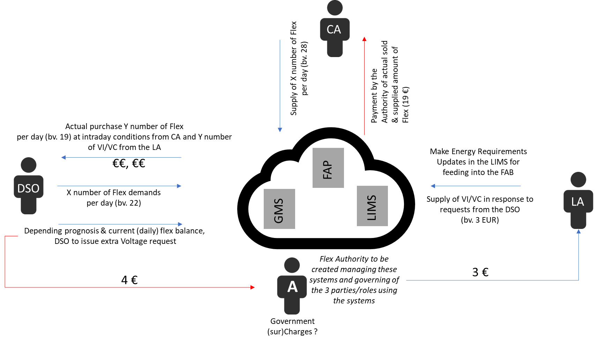
Figure 7: Financial implications outlook.

AppendiCes

Appendix 1 Master Flex & VI/VC Purchasing Agreement.
This is a draft for discussion purposes pending legal review and approval.

Appendix 2 Terms and Conditions CA EV (Jedlix).

What do we do?
We calculate an optimal charging plan for an electric vehicle based on user settings and our own integration with for example a dynamic price curve based on the energy market and the current supply of renewable energy.
The user therefore charges his car at more favourable moments; this is beneficial for the sustainability of the energy mix and could optionally also lead to a pay out of the realised saving (the 'bonus').

Bonus
The user can opt in for a pay out of the realised saving; the bonus. The bonus is calculated by Jedlix.
The method of calculating the bonus can by adjusted by Jedlix for future charging sessions without prior notice.
The payout option of the bonus can be terminated by Jedlix without prior notice. Previously accumulated savings is thereby retained.

Method of calculation and bonus pay out
At the start of a charging session we provide an estimation of the to be realised bonus to the best of our knowledge.
This estimation is based on the data at that time known to us. The actual realised bonus is subject to various variables. The user can as a result not derive any rights from this estimation.
The to be realised bonus is dependent on:
- Market prices energy
- Demand & supply of (renewable) energy
- Vehicle characteristics (such as battery size, charging load, climate control settings)
- Charging station characteristics (load speed)
- Weather conditions (extreme temperatures can cause the vehicle to charge slower than usual)
- Selected departure time (level of flexibility)
- Selected minimum load percentage (level of flexibility)
After each charging session, the bonus is provisionally determined based on the data generated by the app. Afterwards there will follow another verification. Based on this verification (for example with a smart meter or charging station management system of a third party) the bonus is finalized.
The user is entitled to a pay out of the final bonus.

Savings
After each charging session the provisionally determined bonus is added to any previously accumulated savings.
The user has insight in the app regarding the status of the savings and transactions of the savings.
The right to pay out, donation or transfer of the balance does arise:
- The moment Jedlix has determined the final bonus
- With regards to a previously accumulated balance, once this has reached a reasonable threshold to be determined by Jedlix.
The accumulated credit will automatically expire after a period of 12 months.
Jedlix has no interest due to the user on the outstanding balance.

Pay out
The user can choose to pay out after reaching a reasonable threshold to be determined by Jedlix. The balance will be paid within a few days on the user specified IBAN. The user is responsible for the correct entering of his data.

Donate / transfer savings
The user can choose to donate his accumulated savings to a charity or cause, to be designated by Jedlix. Also, the user can choose the amount to be transferred to a to be appointed by Jedlix partner (for example for charging balance).

Terminate participation
User can participate in the service temporarily stop using the app. For permanent termination of participation needs to send you an e-mail feedback@jedlix.com. Not yet paid balance expires at permanent discontinuation of service.
Jedlix reserves the right to terminate use of the app by the user at any time.

User Settings
The user is responsible for the data he entered (e.g. departure time). The user ensures Jedlix that he is the card holder of the charging card entered in the application.

Disclaimer
All obligations of Jedlix as part of the downloading and using of the app include an obligation of effort.
Jedlix does not guarantee that any savings can be realized.
No rights can be derived from the calculation of the optimal charging plan.
Subject to limitations set by law thereto, Jedlix bears no liability whatsoever for any direct, consequential or incidental damages that the User or any third party suffers as a result of downloading and / or using the app, including (but not limited to):
- The input of incorrect data in the Jedlix application
- Any following the use in another way than the normal use of the application
- Any disruption in the data connection between Jedlix and / or the Jedlix application and / or the electric vehicle and / or the charging station management system.
- Any damages resulting at the user due to that the electric vehicle is not or charging differently than expected, for example (but not limited to) as a result of weather conditions or the different than expected operation of the charging system or electric vehicle.
Notwithstanding the foregoing, and subject to limitations to this law enables the liability of Jedlix always to be limited to an amount of € 5000, - per damaging event.

Privacy
User authorized Jedlix to process his or her (personal) data, for the purpose of:
- Calculating an optimal loading plan for the electric vehicle of the user in the Jedlix application.
- The calculation and pay out of the bonus to the user if this right arises according to the agreement between the Jedlix and user.
- Analyzing the anonymous data of the user for research purposes and sharing with third parties.
Jedlix bears no liability for the loss or abuse of these (personal) data unless such loss or abuse is due to non compliance with the Data Protection Act.

Remaining
For questions or complaints about the services of Jedlix one can contact Jedlix via email: feedback@jedlix.com.
These terms shall be governed by Dutch law. The court in Rotterdam shall have exclusive jurisdiction over any disputes arising from downloading and / or using the app.

