D7.3 Innovative solutions to be tested in the use cases

Version 1.0
28-06-2018

Deliverable D7.3

ID & Title : | D7.3 Innovative solutions to be tested in the use cases
Version : | V1.0 |  |  |  | Number of pages : |  | 34
Short Description
Deliverable 7.3 describes the design of the flexibility market that is implemented in Interflex Eindhoven, the physical test set-up and the different scenarios that are used to evaluate the innovative solutions in the use cases that are defined for Interflex in the Netherlands.
The test scenarios are based on the use cases that describe the deployment of a stationary battery, the use of a smart charging concept for electric vehicles and the development of a market mechanism that enables a DSO to buy flexibility to avoid congestion on the low voltage grid. The test scenarios are used in the demonstration period from Jun 2018 until Jun 2019 to validate the ICT system integrations and test the flexibility market mechanism.
Revision history
Version | Date | Modifications’ nature |  |  | Author
V0.1 |  | First draft
V0.2 | 22-02-2018 | Add text Design of the flexibility market; from Bob and Rik |  |  | Olga Westerlaken
V0.3 | 09-03-2018 | Changes text Design of the flexibility market; from Bob and Rik |  |  | Olga Westerlaken
V0.5-0.6 | 14-03-2018 | Review changes
V0.7 | 22-03-2018 | Editing & text review |  |  | Daphne Geelen, Olga Westerlaken and Marcel Willems
V0.8 | 10-04-2018 | Editing & text review |  |  | Bob Ran, Daphne Geelen
V0.9 | 29-05-2018 | Review version E.ON
V1.0 | 28-6-2018 | Final version |  |  | Marcel Willems
Accessibility
☒Public | ☐ Consortium + EC |  | ☐ Restricted to a specific group + EC |  | ☐ Confidential + EC
Owner/Main responsible
Name(s) | Function |  |  | Company | Visa
Marcel Willems | Sr. project manager |  |  | Enexis
Author(s)/contributor(s): company name(s)
Ton van Cuijk : Enexis Netbeheer
Rik Fonteijn: Enexis Netbeheer
Daphne Geelen: Enexis Netbeheer
Joost Laarakkers: TNO
Patrick Rademakers: ElaadNL
Bob Ran: TNO
Olga Westerlaken: Enexis Netbeheer
Marcel Willems: Enexis Netbeheer
Klaas van Zuuren: ElaadNL
Kees van Zwienen: Enexis Netbeheer
Reviewer(s): company name(s)
Company |  |  |  |  |  | Name(s)
E.ON. |  |  |  |  |  | Pauline Ahlgren  Peder Kjellen
Approver(s): company name(s)
Company |  |  |  |  |  | Name(s)
Enedis.
Work Package ID | WP 07 | Task ID |  |  | T3

Executive summary

This report describes the design of the flexibility market that is implemented in Interflex Eindhoven. The primary aim of this market is to enable congestion management on distribution network level by making use of energy flexibility from the demand side of the energy system. Additionally, this document presents the physical test set-up and the different scenarios that are used to evaluate the innovative solutions in the use cases that are defined for Interflex in the Netherlands.

The use cases are:
- Enabling ancillary services, congestion management, voltage support for PV integration using centralized, grid-connected storage systems to improve grid observability of prosumers, promoting batteries in multi-service approach.
- Enabling the optimal activation of all available local flexibilities offered by the locally installed EVSE’s for congestion management. This is done by allowing the DSO, who monitors the grid, to send flexibility requests to commercial aggregators. These commercial aggregators can, after a price agreement with the DSO and in cooperation with the Charge Point Operator (CPO), adapt charging schedules on EVSE’s, thus providing the flexibility requested by the DSO.
- Validating technically, economically and contractually the usability of an integrated flexibility market based on a combination of static battery storage and EVSEs.

Design of the flexibility market
The design of the flexibility market on a DSO level is based on mechanisms used in the TSO market. From the three different TSO services, i.e. the ancillary services, energy market and capacity market, only the ancillary services and energy market are used in this project.

The system design is based as much as possible on existing technology that has proven its value on the market. Newly developed functionalities will make use of open standards and protocols, such as USEF, EVI and OCPI.

The workflow of the flexibility trading between an aggregator and a DSO is based on the workflow defined by the Universal Smart Energy Framework (USEF) initiative. The five phases of the USEF workflow, as shown in the figure below, were elaborated specifically to enable an Interflex flexibility market.
Additionally, an extra mechanism called variable connection is worked out for use case 1.

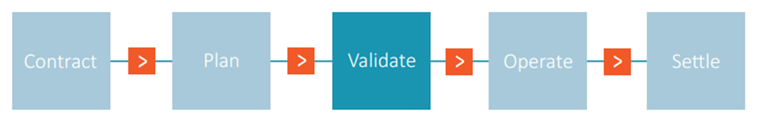

Physical test set-up
The physical test set-up is defined by the flexibility sources, the grid topology, congestion points and measurement equipment that are used for the validation of the use cases.
The flexibility sources are the EVSEs, the smart storage unit and the PV installation. The grid topology of MV distribution network is typically ring-shaped, connecting various MV/LV substations and operated radially. The grid in the Strijp-S area, where the demonstration takes place, includes two substations. Four congestion points are defined: the two substations and one feeder at each substation that connects the EVSEs. Given that the current network is overdimensioned, we assume smaller size transformers than their actual power rating during the testing of the congestion management solutions, given that congestion problems are not expected, nor desirable in a test situation, with the current transformers.

Measurement equipment is installed on the transformer (LV side) and on all outgoing LV feeders of the substations. Furthermore, bidirectional energy throughput, and total harmonic distortion are measured.

Innovative solutions in the use cases
Test scenarios were defined to test the innovative solutions of the use cases. Stepwise, these scenarios increment the complexity of the flexibility market:
- Scenario 1: Day-ahead market
- Scenario 2: Day-ahead market + static variable connection capacity
- Scenario 3: Day-ahead market + dynamic variable connection capacity
- Scenario 4: Day-ahead & intraday market + dynamic variable connection capacity

The relation between the tested innovations and the test scenarios is:
Tested Innovations | Scenario 1 | Scenario 2 | Scenario 3 | Scenario 4
Electricity storage in batteries for congestion management (section 1) | X | X | X | X
Electric vehicle charging for congestion management (section 1) | X | X | X | X
Local flexibility market day-ahead & intraday (section 1) | X | X | X | X
Split roles commercial and infrastructure aggregator and single role per party (section 2.1) | X | X | X | X
Certainty profile sanction pricing (section 2.3.3) | X | X | X | X
Local flexibility market with multiple aggregators per congestion point (section 2.1) | X | X | X | X
Local flexibility market in combination with static variable connection capacity (section 2.4) |  | X
Local flexibility market in combination with dynamic variable connection capacity (section 2.4) |  |  | X | X
Multi-iteration intra-day market (section 2.1) |  |  |  | X

The scenarios are compared for the flexibility KPI. Within the Eindhoven demonstration, we propose to measure flexibility on four levels:
- The share of flexibility available in the field compared to the theoretically available flexibility.
- The share of flexibility employed on the markets compared to the flexibility available in the field.
- The share of flexibility traded with the DSO compared to the flexibility employed on the markets.
- The share of flexibility traded with the DSO compared to the flexibility requested by the DSO.

Besides this KPI also other measurement variables are registered, such as:

- Amount of shifted energy, per time unit (e.g. day)
- Peak load at the different congestion points
- Amount of time that the DSO needs to use congestion management for a certain congestion point (for a certain time period: year, month, day)
- Flexibility value, if feasible per type of flexibility (EV, SSU)
- Forecasting is a crucial function in the system (mainly aggregator and DSO) therefor we want to measure forecasting quality (EV, PV, system, ….)
- Ability to integrate intermittent energy (PV, wind)

Table of content

1. Introduction 11
1.1. Scope of the document 11
1.2. Tested innovations 11
2. Design of the flexibility market 13
2.1. Applications for energy flexibility 13
2.2. Design principles of the flexibility market 15
2.3. Design of the Interflex flexibility market 15
2.3.1. The workflow of flex trading between aggregator and DSO 17
2.3.2. Timing 19
2.3.3. Sanction pricing schemes 19
2.3.4. Price of offers 20
2.4. Variable connection capacity in the Dutch Interflex demonstration 20
3. Physical test setup 23
3.1. Flexibility sources 23
3.2. Location flexibility sources 23
3.3. Grid topology 25
3.4. Congestion points 26
3.5. Measurement equipment 27
4. Test Scenarios 29
4.1. Tested innovations 29
4.2. Scenarios 29
4.2.1. Scenario 1: Day-ahead market 29
4.2.2. Scenario 2: Day-ahead market + static variable connection capacity 30
4.2.3. Scenario 3: Day-ahead market + dynamic variable connection capacity 30
4.2.4. Scenario 4: Day-ahead & intraday market + dynamic variable connection capacity 30
4.3. KPIs and other necessary measurements 31
4.3.1. KPI Flexibility 31
4.3.2. Other indicators 32
5. Outlook 33
6. References 33
7. AppendiCes 35
7.1. Appendix I: Relevant KPI flexibility description from deliverable D2.2 35

List of Figures

Figure 1: Time constants of different balancing mechanisms [10] 11
Figure 2: The role-based model of USEF 14
Figure 3: The five phases of flexibility trading in the USEF framework 15
Figure 4: D-prognosis and FlexRequest message 16
Figure 5: FlexOffer and Updated D-prognosis message 17
Figure 6: Variable Capacity 19
Figure 7: Location of the flexibility sources on Strijp-S 22
Figure 8: Visualisation of the demo site 22
Figure 9: Generic overview of Dutch MV networks, distinguishing MV transmission and distribution cables, and MV substations & (MV/LV) distribution stations. Figure from [13]. 23
Figure 10: Overview of feeder connections to substation 1 24
Figure 11: Overview of feeder connections to substation 2 24

List of TABLES

Table 1: List of Acronyms 10
Table 2: Peak loads per substation split for each type of connected load. The maximum peak illustrates the maximum possible peak of the day, taking time of occurance into account 27
Table 3: Overview of tested innovations in relation to the tested scenarios 29

notations, abbreviations and acronyms
The table below provides an overview of the notations, abbreviations and acronyms used in the document.

Table 1 List of Acronyms
BRP | Balance Responsible Party
CP | Charge Point
CPO | Charge Point Operator
DR | Demand Response
DSO | Distribution System Operator
ESCO | Energy Service Company
EC | European Commission
EC-GA | European Commission Grant Agreement
EU | European Union
EV | Electric Vehicle
EVSE | Electric vehicle supply equipment
GA | General Assembly
GWP | General Work Package
IT | Information Technology
KPI | Key Performance Indicator
LV | Low Voltage
MV | Medium Voltage
NOP | Normally Open Point
OT | Operational Technology
PC | Project Coordinator
PoC | Point of Connection
PV | Photo Voltaic
SC | Steering Committee
SSU | Smart Storage Unit
TC | Technical Committee
TD | Technical Director
TSO | Transmission System Operator
WP | Work Package
WPL | Work Package Leader
USEF | Universal Smart Energy Framework

Introduction
Interflex aims to develop the next generation of smart distribution networks in Eindhoven and elsewhere in Europe to speed up the energy transition. 95% of all renewable energy sources are connected to the distribution grid. Governments in Europe are giving priority to millions of charging points and stations to facilitate an increase of electric transport in the coming decades. Behaviour of consumers and technology change rapidly. In this context, the grid must be able to count on a system that addresses local needs and developments.

With Interflex we develop and test ways to unlock energy flexibility locally for distribution system operators. Energy flexibility, i.e. the ability of a load to adjust its power demand/supply in time, is relevant for mitigation of congestion and power quality issues in the distribution networks. The two solutions Interflex looks into are a flexibility market and variable capacity agreements. On a flexibility market the distribution system operator can purchase flexibility from local flexibility sources (e.g. electric vehicles and smart storage units) via aggregators. Variable capacity contracts can be used by the distribution system operator to stimulate customers to comply with a specific load profile that is beneficial to local congestion management in the network.

This document describes the physical test set-up and test scenarios for the evaluation of the innovative solutions implemented for Interflex. The tested innovations are based on the three use cases formulated in document ‘Use Case planning, District architecture requirements and tested innovations. Version 1.0, 25-10-2017’ [1]. These are:

- Enabling ancillary services, congestion management, voltage support for PV integration using centralized, grid-connected storage systems to improve grid observability of prosumers, promoting batteries in multi-service approach.
- Enabling the optimal activation of all available local flexibilities offered by the locally installed EVSE’s for congestion management. This is done by allowing the DSO, that monitors the grid, to send flexibility requests towards commercial aggregators that will, through interacting with the CPO, end up as adapted charging schedules on EVSE’s, making the necessary flexibility happen.
- Validating technically, economically and contractually the usability of an integrated flex market based on a combination of static battery storage and EVSEs.

In the mentioned document the conceptual IT and OT infrastructure, the roles and responsibilities of the different parties are described. This IT infrastructure is built in the period January 2018 – June 2018. The OT infrastructure was installed between August 2017 and May 2018. The testing of the use cases is embedded in as different scenarios. In these test scenarios, the individual parts of the IT and OT system and the flexibility market are tested.
In chapter 2 we describe the design of the Interflex flexibility market, based on open standards and protocols to facilitate scalability. The process of forecasting, requesting, bidding for, and accepting flexibility is worked out in this chapter. Furthermore, the concept of variable capacity is explained.

The physical test set-up is worked out in chapter 3.

Chapter 4 describes the test scenario’s that will be implemented in the demonstration period from June 2018 until June 2019. This chapter also presents the KPI Flexibility and other measurements relevant to evaluate the performance of the innovative solutions in relation to the various test scenarios.

Design of the flexibility market

Applications for energy flexibility
Energy flexibility can be used for several purposes in the energy system. To describe these applications, we first provide the definition of flexibility used in the Dutch Interflex demo and then describe the different applications that are used to create an energy flexibility market.

Definition of Energy Flexibility:
“Flexibility can be defined as a power adjustment sustained at a given moment, for a given duration, from a specific location within the network.”[2]

Given the fact that the energy system should always be in a balanced state, meaning that the amount of supply should be equal to amount of consumption, the presence of energy flexibility is key for a stable energy system. Since the level of flexibility on the supply side is likely to decrease with the introduction of higher penetration rates of uncontrollable renewables in the system, the necessity of energy flexibility on the demand side will rise. Therefore, the value of demand side flexibility will increase.

To maintain a stable state, the electricity system consists of multiple balancing markets. The main difference between the markets is the time basis. Figure 1 depicts the different balancing mechanisms and their time basis.

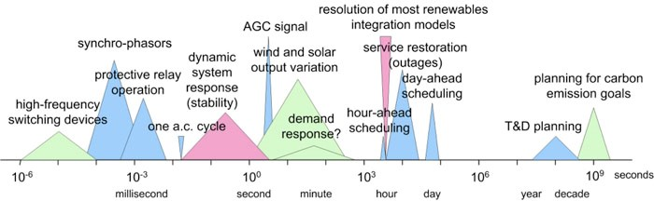
Figure 1: Time constants of different balancing mechanisms [10]
On the left side the short-term balancing mechanisms can be found operating within milliseconds to seconds, the markets that are operational in these time windows are the Ancillary Services Markets. In the middle of Figure 1 the Energy Markets such as Day-Ahead and intraday can be found, these markets typically operate within time windows of one hour to a few days. On the right-hand side of the figure the capacity markets are depicted. These are the long-term markets for buying and selling (options on) large amounts of energy.

Relatively new applications for flexibility can be found in the distribution networks. Currently developing services for congestion management and local ancillary services, such as voltage control, are likely to become part of a DSO’s daily operational activities, using (aggregated) demand side flexibility.

Various methods to unlock flexibility are described in literature. One of the main research areas so far has been demand response (DR). Two variations exist, namely implicit and explicit DR. The definitions from reference [3] are adopted. Implicit DR, also known as price-based DR, is defined as the possibility of users to respond to price signals that reflect network load and market variability. With implicit DR, the user must decide to respond to a price signal. Explicit DR, also known as incentive-based DR is defined as a committed, dispatchable demand-side flexibility that can be traded on one or more energy markets. Central for explicit DR is unit commitment and dispatch, flexibility is thus scheduled.

Among this research, new and/or adjusted tariff structures, such as capacity payments, time of use, and critical peak pricing have been considered. An example of a pilot project in this field is the project Jouw Energie Moment (Your Energy Moment) (JEM) in the Netherlands. In JEM, the changes in energy consumption of household as a result of a price signal have been investigated [4].

Flexibility can also be unlocked by applying direct control. In case of direct control, a connection or an appliance at the customer premises (behind the meter) is influenced directly. This has been done for decades already in some countries. An example of such an application is direct control of residential water boilers [5]. More recent projects also apply this method. This is for example the case in the project NiceGrid. Direct control is used for peak reductions by shifting the energy consumption of residential heaters while maintaining the required comfort level of residents [6].

For any flexibility method to work, there have to be appliances that can provide demand flexibility. Various appliances have been evaluated in this context, in both academic and in pilot settings [4], [7], [8]. Examples are battery storage systems (home batteries and large-scale centralized batteries), electric vehicles, photovoltaic, heat pumps, and household appliances, such as washing machines.

Recently, in the Netherlands two similar projects have been demonstrated using the universal smart energy framework (USEF) as the basis of their markets. These projects are Energiekoplopers in the city of Heerhugowaard, and the project Smart Solar Charging in Lombok, a district in the city of Utrecht. In both projects, a flexibility market is used to manage network congestion.

The pilot project in Utrecht implements a day-ahead flexibility market, with a single aggregator [8]. The pilot in Heerhugowaard implements both a day-ahead and an intraday flexibility market. The intraday market is limited to a single cycle throughout the day, rather than making continuous market iterations [6]. Furthermore, the roles of aggregator and BRP are implemented by the same actor, giving a single actor multiple roles [9]. This makes the flexibility trading and settlement processes less complicated, as less parties are involved, and a single party is responsible for both flexibility and supply. However, in an open market environment, these roles can also exist in a single-actor, single-role manner.

In order to learn how to cope with the market’s potential single-role single-actor environment, Interflex adapts this principle. Furthermore, conceptually, a flexibility market consists of multiple aggregators. Within Interflex, flexibility is traded with multiple aggregators, adding insights on market behaviour and liquidity compared to previous research. Finally, in order to give every flexibility source an equal chance, and reduce the risk of congestion closer to real time, Interflex implements the intraday market with multiple iterations and decision moments (i.e. each PTU).

Design principles of the flexibility market
For Interflex a new flexibility market is designed. The primary aim of this market is to enable congestion management on distribution network level by making use of energy flexibility from the demand side of the energy system. The main aim for the project is to create and validate a flexibility market that is mature enough to continue its operations after the pilot is finished. The design principles followed to design this market are the following:

Use existing technologies as much as possible:
Interflex can be a project with a high TRL (technology readiness level), because many smart grid technologies have already been created in former projects. The aim is to use the lessons learned and the existing technologies as much as possible. As a result, the flexibility market within Interflex will be as mature as possible.

Use open standards as much as possible:
The flexibility market designed in Interflex should be designed in such a way that it can be widely used after the demonstration period. Therefore, the flexibility market should enable a level playing field for parties desiring to operate in the market. To do so, the use of existing open standards is an important design principle for the Interflex flexibility market.

Compatible with the existing roles in the energy system:
In order to be usable after the Interflex project, the flexibility market should be compatible with the existing roles in the energy system. This means that the new role of the aggregator should be integrated in a way that its functionality does not interfere with the existing roles, such as: DSO, TSO and BRP.

Design of the Interflex flexibility market
The design of the InterFlex flexibility market is based on the Universal Smart Energy Framework (USEF) [11], because USEF fulfils the four design principles stated in the previous section. This opensource framework is initiated by the USEF foundation, a group of companies that joint forces to accelerate the entry of the independent aggregator in the energy system. To facilitate this, the role of the aggregator is introduced in such a way that it can reside adjacent to the existing roles in the energy system. How the aggregator is positioned within USEF is shown in Figure 2.

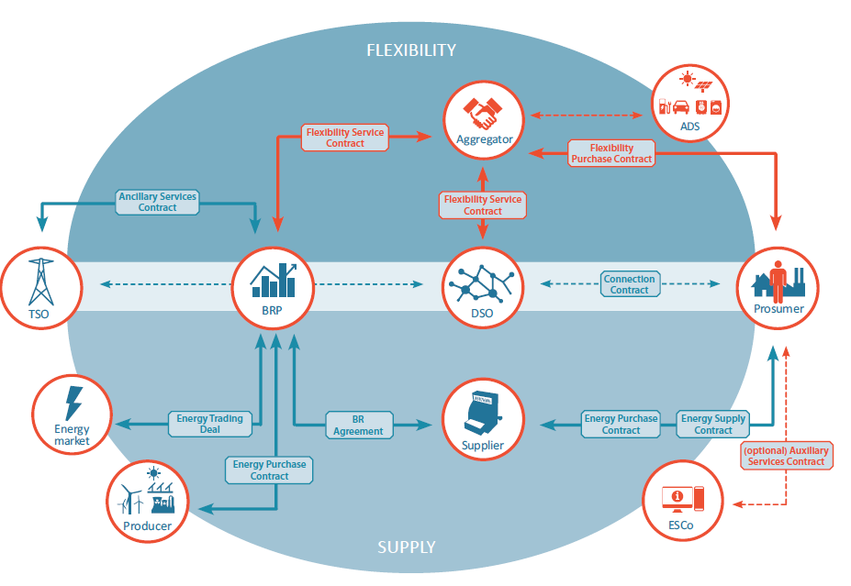
Figure 2: The role-based model of USEF
The Interflex flexibility market mechanism differs from the USEF market mechanism in two main ways. Firstly, the Interflex market is a market between aggregator and DSO only, while USEF describes a mechanism between aggregators, DSO, BRP and TSO. The latter two roles are not in scope for Interflex. Furthermore, InterFlex introduces a new concept called sanctions (see also section 2.3.3).

Conceptually this market will be setup such that the DSO contacts commercial aggregators when flexibility is needed for DSO purposes. Commercial aggregators try to maximize their profits and will trade on various markets. This means that the DSO must compete for flexibility with wholesale-level market and the TSO. When a DSO requests flexibility, commercial aggregators will take this in consideration, and, if the price-range is right, will provide the DSO with a flexibility offer. There is however no guarantee that flexibility will be offered. This is in line with one of the consortium’s research questions, which validates whether (and to what extent) a DSO will be able to compete for flexibility with other market parties [9].

The local flexibility market will be designed primarily to validate congestion management via a market mechanism. This is initially done in a day-ahead setting. In a later stage, an intraday component will be added to the local flexibility market. The flexibility product that will be traded, is based on active power, in 15-minute intervals. Once this initial application for the local flexibility market is up and running, a secondary application of this market can be validated, namely voltage support. Voltage support on (PV dominated) LV feeders can potentially also be arranged with flexibility, thus applying this in the demonstration is desirable (within the limits of the demonstration setup).

Further characteristics of the Interflex flexibility market design are the following:
- Market exposure
For this project we are evaluating the exposure of the DSO’s flexibility needs to the whims of the market. When the DSO needs flexibility, it is put out as a request to the market.
- Active power & energy trading
During Interflex, active power per 15-minutes (thus energy) is traded. The price is set for providing in this flexibility (i.e. energy-based fee), not for reserving a certain capacity (i.e. capacity fee).
- Gate closure times
Gate closure times of both the day-ahead and intraday flexibility markets will be aligned with the higher-level wholesale market, such that participating in these markets does not influence the normal operational process of aggregators.
- No emergency regime
In some market implementations or frameworks (i.e. USEF), an opportunity for an emergency regime exists. Within this regime, a DSO can enforce flexibility activations to ensure grid stability (in such case the alternative is a blackout). This will not be within the scope of Interflex in The Netherlands. For Interflex, the unavailability of flexibility will be logged, and an analysis of the logged events will show how often this situation arises. Since the networks are safely dimensioned, such situations will not endanger security of supply.
- Selected flexibility sources
While the overall market design will be designed to be scalable, the local flexibility market demonstrated in Interflex focuses on the following flexibility sources: smart storage unit, EVSEs, and solar PV. Please note: the smart storage unit is also exposed to a variable connection capacity. This variable connection capacity will pose constraints on the availability on the flexibility market (and not the other way around).

The workflow of flex trading between aggregator and DSO
This section describes the workflow of the trading of flexibility between an aggregator and a DSO. This workflow is based on the workflow defined by the USEF initiative. It comprises 5 phases:
Figure 3: The five phases of flexibility trading in the USEF framework
Contract Phase
The first phase is the contract phase in this phase the contract between the DSO and the aggregator is set up.

Plan Phase
The second phase is the plan phase, this phase is relevant in case the aggregator is one of the type independent aggregator. This means that the aggregator operates as an independent entity with respect to a BRP. If this is the case, the plan phase can be used to trade flexibility between the aggregator and one or more BRPs. However, this is out of scope for the Dutch demo since the aggregators are responsible for the BRP role as well.

Validate Phase
In the validate phase flexibility can be traded between aggregator and grid operator for congestion management purposes. This phase is a vital part of the Interflex flexibility market and is described in detail in the following section.

Operate Phase
In the operate phase the aggregator is responsible for executing the desired behaviour resulting from the plan and validate phases.

Settle Phase
The settle phase comprehends the validation of behaviour (power measurements) and the resulting financial settlement between the aggregator and the DSO.

Validate Phase detailed description
As introduced in the previous paragraph the validate phase is an important part for the Interflex flexibility market. In this phase the DSO can request flexibility from aggregators at congestion points within its grid. If a DSO expects a congestion at congestion point Y, it can request flexibility from the aggregators operating in that area to prevent the congestion from happening. To accomplish this the following messages will be exchanged.

The first message that is send is originating from the aggregator and is named D-prognosis. In this message the aggregator provides its load prognosis per PTU (program time unit) for every congestion point in a DSO’s grid. The message(s) is send towards the DSO and is later used to validate the behaviour of the aggregator. An example of the information in the D-prognosis message for one congestion point is depicted in Figure 4.

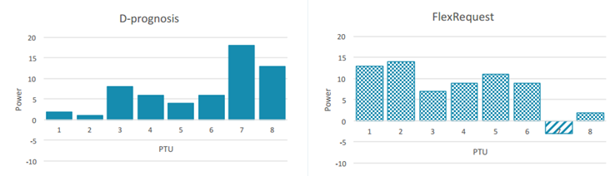
Figure 4: D-prognosis and FlexRequest message
After receiving all D-prognosis messages from the aggregators operating in the DSOs area the DSO will forecast the expected capacity at every congestion point in its grid. If at one or more areas a congestion is expected to occur, the DSO can request aggregators to adapt their capacity at these points. To do so a DSO sends a FlexRequest message to the aggregators operational in the relevant area(s). An example of a FlexMessage is depicted in Figure 4. In this example the DSO request to reduce load in PTU 7 and the DSO indicates that there is capacity left in the other PTUs. So that an aggregator can shift its load from PTU 7 to one of the PTUs with capacity.

After receiving the FlexRequest message from the DSO an aggregator can evaluate whether it is capable of (partially) fulfilling the request of the DSO. If so, the aggregator formulates an offer towards the DSO in the form of a FlexOffer message (the primary information of a FlexOffer is depicted in Figure 5). In this message the aggregator proposes a deviation on its D-prognosis resulting in (partial) solution for the congestion indicated by the DSO. This offer includes a price to pay by the DSO. If the DSO accepts the offer it sends a FlexSettlement message to the aggregator. Afterwards the aggregator updates its D-prognosis and sends this to the DSO. With this, the expected congestion is resolved.
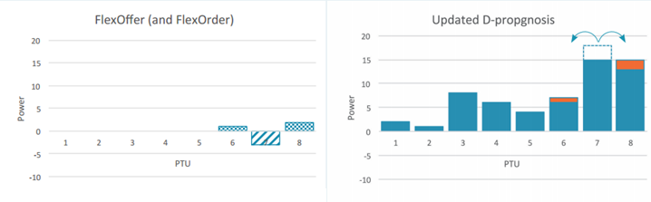
Figure 5: FlexOffer and Updated D-prognosis message

Timing
The previous section describes the message communication between the DSO and aggregator that is needed to purchase flexibility to avoid congestions. The timing, when the messages are sent, is not yet discussed. Within the Interflex flexibility market it is decided to align the trading of flexibility with the trading on the wholesale markets. This results in two time-schedules for flex trading. The first is day-ahead trading, where flex trading is done before the day-ahead gate closure time (12:00 AM in the Netherlands). The second is intra-day trading, where the trading is done before the intra-day gate closure time (at last 5 minutes before delivery in the Netherlands). To have enough time for all parties to process the flexibility trading this will be done well before the gate closure time of the markets. Within the demo we aim to learn how many minutes is sufficient.

The implementation of the demo will be done in two phases. In the first phase the day-ahead time schedule will be implemented, in the second phase the intra-day time schedule will be implemented. Furthermore, the demo will be used to learn what the feasible timing schedules are for flex trading.

Sanction pricing schemes
Since it is not guaranteed that the offered flexibility is delivered by the aggregator during operation the sanction price is introduced in the Interflex flexibility market. This is a deviation from, or addition to, the USEF flex market principle. The idea behind the sanction price is that it is an enabler for aggregators to bid in flexibility where the guarantee on delivery is not 100% guaranteed. For instance, if an aggregator operates a limited set of charge stations, it is impossible to accurately predict the available flexibility capacity day-ahead. However, it might be useful to have this uncertain flexibility available on the market as well. A sanction price describes the penalty given by the DSO if the flexibility is not delivered. It could be used in two ways:

Sanction provided by DSO
The sanction could be provided by DSO together with the FlexRequest. Depending on how high the sanction price is an aggregator could decide to offer a FlexOffer. If for instance the sanction is high, an EV aggregator is likely not to offer highly uncertain flexibility. If on the other hand the sanction is low, the EV aggregator might offer its flexibility. An alternative here is that the DSO sends a finite array of possible sanctions, an aggregator can choose the appropriate sanction from the array based on the level of guarantee it can provide the flexibility.

Sanction provided by Aggregator
A sanction could be provided from the aggregator as well, which entails that an aggregator can decide about its own penalty for not providing the offered flexibility. The sanction is then treated as a means to describe the level of guarantee an aggregator provides on its flexibility offer. For example, an aggregator with a large battery can have a 100% guarantee on the availability of flexibility and can express this guarantee in terms of a high sanction price. The EV aggregator with uncertain flexibility can also provide an offer but will add a low sanction price, and most likely asks a lower price for flexibility. After receiving both offers the DSO itself can decide how much he is willing to pay for the availability guarantee of flexibility.

Hybrid
A third option is a hybrid solution of the two options above. In this scenario a DSO provides a maximum sanction price with the FlexRequest. And in the FlexOffer the aggregators decide their sanction and price which should be between zero and the maximum sanction price. This option is chosen to be implemented in Interflex.

Price of offers
The price of the offered flexibility is determined by the aggregator while composing a FlexOffer. The price can be based on a number of components, such as:
- Marginal costs of flexibility
- Costs for the deviation on it expected (and traded) energy behaviour
- Missed profits on energy markets
- Etc.
The profits earned by the aggregator are likely to be shared with the owners of the assets that deliver the energy flexibility. How this is done is agreed upon in the contract between the aggregator and the prosumer, defining these contracts is not in scope of Interflex in The Netherlands.

Variable connection capacity in the Dutch Interflex demonstration
The learning goals of Interflex in Eindhoven aim at unlocking flexibility for grid management purposes in the distribution network, in order to research alternative solutions to grid reinforcements in case of congestions and (long-term) voltage violations [12]. This is done by exploring market solutions. Flexibility markets can be arranged in various ways, for example as a local flexibility market. This is described in this chapter. Contractual agreements can be arranged as part of such market. Within Interflex, a contractual agreement in the form of a variable connection capacity is implemented to enhance the day-ahead and intraday flexibility markets.

Variable capacity could provide a DSO with an alternative to the local flexibility market and/or a long-term contract with a Commercial Aggregator, ensuring a certain ‘flexibility’ by specifying a capacity profile as function of time (i.e. throughout a day). In Interflex the local flexibility market will be evaluated in relation to variable connection capacity. The goal is to identify to what extent the variable connection capacity can complement the flexibility market.

A variable capacity mechanism can be arranged in different ways. Within the scope of Interflex, this is a variable capacity on the point of connection (POC). Variable capacity in this concept means that the POC commits to a maximum capacity level that varies in time, as illustrated in the figure below. The maximum capacity is reduced for periods of peak loads in the network. Four parameters are introduced: maximum off-peak capacity, maximum on-peak capacity, the starting time of the capacity reduction, and the period of capacity reduction (e.g. a number of hours).

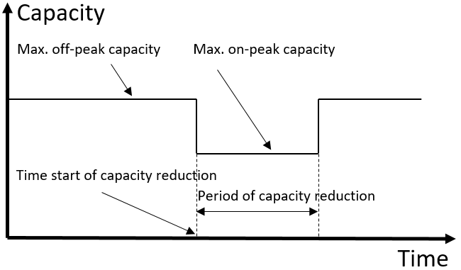
Figure 6: Variable Capacity

Within Interflex, the concept of variable capacity will be implemented in two stages, namely as a static variable connection capacity and a dynamic variable capacity.

In case of the static variable connection capacity, the period of capacity reduction and the starting time of capacity reduction are fixed to a daily and static profile. For example setting the on-peak capacity for an interval of three hours, starting at 17:00.

In case of a dynamic variable connection capacity, the period of capacity reduction (a number of consequent program time units) is set fixed, however the starting time of the capacity reduction varies from day to day (i.e. is dynamic). An example could be setting the period of capacity reduction to three hours per day and providing a daily update on the starting time.

Further characteristics to consider are the following:
- Directly between DSO and PoC
The variable connection capacity is an agreement directly between the DSO and a PoC. No intermediate parties (e.g. aggregators) are involved as it’s an addition to the current agreement between the DSO and PoC. Though it is possible for the PoC to communicate the profile to an aggregator.
- Daily occurrence
On those connections with a variable connection capacity, that reduction will be implemented on a daily basis, based on the static and/or dynamic profile negotiated. After-all, a DSO should remain non-discriminatory, thus providing the same opportunities everywhere and always.
- Obligatory nature
The idea behind the variable connection capacity is to give connected parties the choice between a contract with a static capacity profile, or a contract with a variable capacity profile (irrespective of the way a DSO is organizing the monetary values of such contracts). However, when a contract with a variable capacity profile is chosen, abiding by this profile is mandatory.
- Contractual agreement
The technical connection can be realised as if it is the off-peak capacity. A connected party is responsible for reducing the profile during the on-peak hours. This can for example be evaluated afterwards, by analysing the measurement data. Furthermore, the contract could state a penalty clause, incentivising connected parties to abide by the reduction.

Within Interflex the variable connection capacity will be implemented only on the connection of the smart storage unit. Furthermore, the time before which the starting time of a dynamic variable connection capacity reduction should be communicated should be aligned with the closure times of wholesale energy - and local flexibility markets.

Physical test setup
This chapter first gives a brief description of the flexibility sources considered within InterFlex, then describes the area on Strijp-S where these flexibility sources will be installed. From this, the proposed grid topology (including flexibility sources) is presented, including an overview of the implications of the aforementioned proposal. Finally, a brief conclusion is provided.

Flexibility sources
Three types of flexibility sources can be distinguished within Interflex in The Netherlands, namely EVSEs, a large-scale central battery (smart storage unit, SSU), and solar photo-voltaic (PV) installation [1].

EVSEs
Thirteen CPs will be installed for the purpose of the Interflex in Eindhoven Strijp-S, which is the maximum amount that is physically possible on this location. Each CP will have connection capacity for two electric vehicles (EVs). The capacity on the point of connection (PoC) is 3x63A.

Smart storage unit
The SSU is a large-scale central battery, installed in a 20ft container. The energetic capacity of the SSU is 315kWh, with a maximum invertor power of 255kVA. Harmonics are controlled with a passive (LCL) filter. The capacity on the PoC is 3x250A (approximately 173kVA), and can limited according to the applied variable capacity. Further information about variable capacity can be found in Chapter 2.4.

PV installation
An existent PV installation in the Strijp S area will be included in Interflex. The orientation of the PV panels can be controlled remotely. Thereby, the output power of the installation can be adjusted in response to requests for flexibility.

Location flexibility sources
The flexibility sources within Interflex will be centred to the area around three apartment buildings (‘Blok 59’, ‘Blok 61’, and ‘Blok 63’) and a parking garage ‘Spoorzone’ (see Figure 7). These apartment buildings include 156, 96 and 102 apartments respectively. See Figure 8 for a visualisation of the demo site.

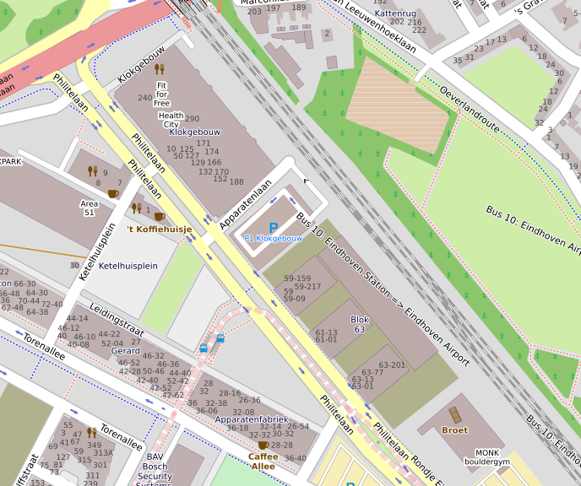
Parking garage
Blok 63
Blok 61
Blok 59
Figure 7: Location of the flexibility sources on Strijp-S

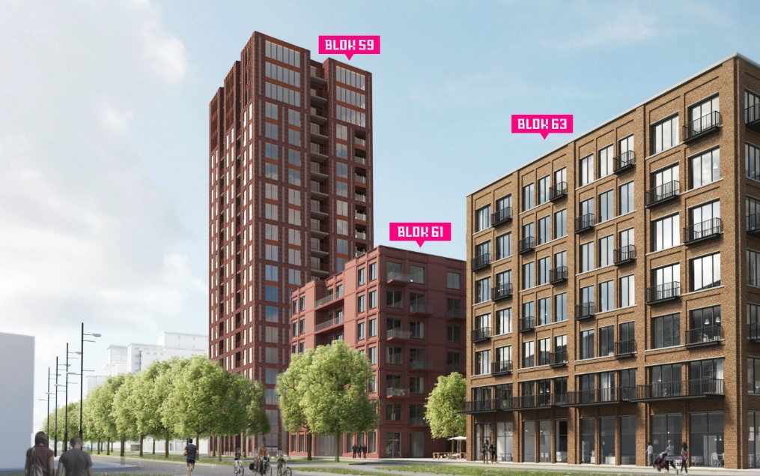
Figure 8: Visualisation of the demo site

Grid topology
Medium voltage (MV) distribution networks in the Netherlands are typically ring shaped, connecting various MV/LV substations. The rings are opened using normally open points (NOPs). Resulting, MV networks are operated radially [13]. Figure 9 illustrates this typical MV network topology in a schematic overview.

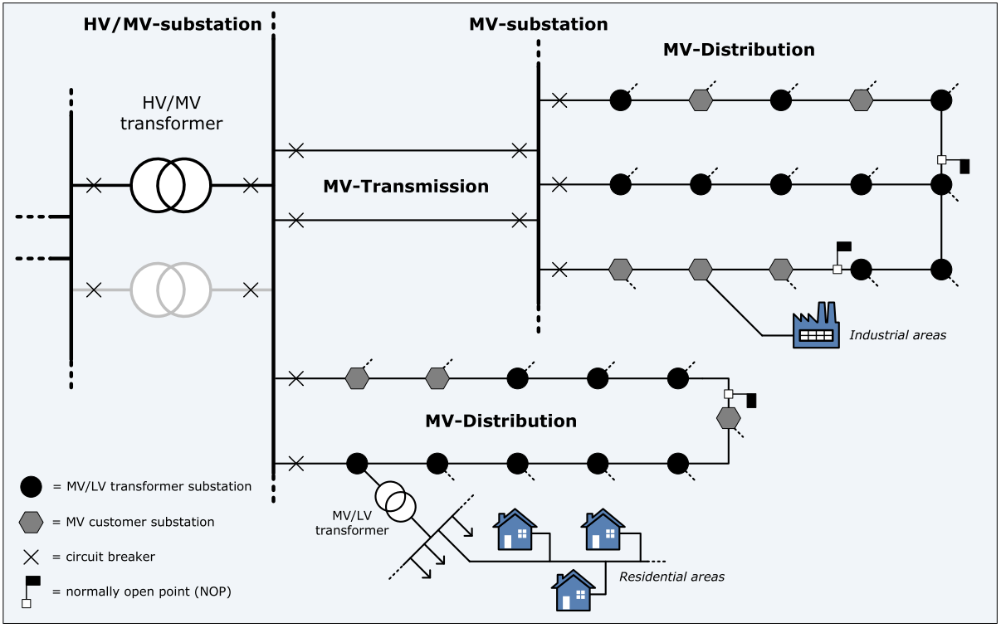
Figure 9: Generic overview of Dutch MV networks, distinguishing MV transmission and distribution cables, and MV substations & (MV/LV) distribution stations. Figure from [13].

The substations that are included in Interflex at Strijp-S consist of a MV/LV transformer and several LV feeders for customer connections. Substation 1 connects 198 apartments (two buildings), spread over four LV feeders. A separate feeder is used for the apartment building’s shared facilities (e.g. elevators, lighting). Three feeders are connected to the parking garage, on which the PV installation (two feeders) and 7 CPs (one feeder) are connected. A schematic overview of the substation with connected loads is provided in Figure 10.

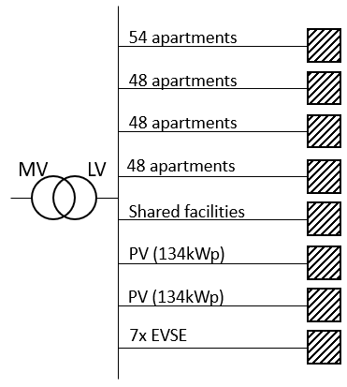
Figure 10: Overview of feeder connections to substation 1

Substation 2 connects 152 apartments (one building), spread over four LV feeders. A separate feeder is used to connect the building’s shared facilities. Furthermore, street lighting is connected to one feeder, and 6 CPs are connected to another. The eighth feeder connects the SSU to the distribution network. A schematic overview of the substation with connected loads is provided in Figure 11.

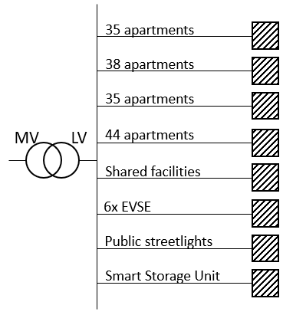
Figure 11: Overview of feeder connections to substation 2

Congestion points
Dutch DSOs dimension their distribution networks based on a coincidence factor. Considering this coincidence factor, the peak load per household on transformer level is 1.4 kVA for Strijp-S, excluding load growth over the lifetime of the distribution network. Household peak loading in the Netherlands is based on an evening peak, typically between 17:00 and 20:00 [12]. The coincidence factor for (future) CPs is assumed to be 50%. Due to the physical placement of the CP, a peak in the afternoon and/or early evening is to be expected.

Within the demonstrator, four congestion points are distinguished. The two MV/LV transformers (substation 1 & 2) both provide one congestion point. Both transformers have a rated power of 630kVA. The feeder with the CPs of substations 1 & 2 provides the other two congestion points. Both feeders have a current rating of 3x250A (approximately 173kVA).

The peak load per source per substation is computed and visualised in Table 2. The maximum peak is defined as the maximal possible peak of the day, based on time and occurrence (i.e. the peak of PV and the peak of households do not occur simultaneously).

Table 3: Peak loads per substation split for each type of connected load. The maximum peak illustrates the maximum possible peak of the day, taking time of occurance into account
 | Substation 1 | Substation 2
Households | 277kVA | 218kVA
SSU | - | 173kVA
CPs | 173kVA | 173kVA
PV | 268kVA | -
Maximum peak | 450kVA | 564kVA

The transformers in the distribution network are dimensioned such that a physical congestion problem is not occurring. This mitigates the DSO’s risk of not obtaining necessary flexibility during the pilot. For the testing of the congestion management solutions we will assume a smaller size transformer.

The congestion level is set to 250kVA for substation 1, and to 400kVA for substation 2. Based on these congestion levels, the total charging power of the CPs behind substation 1 will be limited significantly during evening peak hours. For an extreme case, we can attempt to postpone all charging activities for the duration of the peak. At substation 2, the flexibility sources dominate the peak, which can occur through a broader time-window. Here, up to 164kVA of flexibility is needed in the worst-case scenario.

Measurement equipment
Measurement equipment is installed on the transformer (LV side) and on all outgoing LV feeders of substations 1 & 2. The measurements consist of 15-minute averaged values per phase of the voltage, the current, and the active & reactive power. Furthermore, bidirectional energy throughput, and total harmonic distortion are communicated. Every 15 minutes, the measurements are sent to a central database every 15 minutes. Interflex Deliverable D7.1/D7.2 [1] provides a more elaborate overview of the available measurement locations, equipment and data.

Test Scenarios

Tested innovations
In the Eindhoven demonstration, a number of innovations will be tested. These innovations will be tested based on four scenarios (described in section 4.2). The table below provides a concise overview of these innovations, and their relation to the four scenarios. Per tested innovation is indicated in which section the innovation is addressed in this document.

Table 4: Overview of tested innovations in relation to the tested scenarios
Tested Innovations | Scenario 1 | Scenario 2 | Scenario 3 | Scenario 4
Electricity storage in batteries for congestion management (section 1) | X | X | X | X
Electric vehicle charging for congestion management (section 1) | X | X | X | X
Local flexibility market day-ahead & intraday (section 1) | X | X | X | X
Split roles commercial and infrastructure aggregator and single role per party (section 2.1) | X | X | X | X
Certainty profile sanction pricing (section 2.3.3) | X | X | X | X
Local flexibility market with multiple aggregators per congestion point (section 2.1) | X | X | X | X
Local flexibility market in combination with static variable connection capacity (section 2.4) |  | X
Local flexibility market in combination with dynamic variable connection capacity (section 2.4) |  |  | X | X
Multi-iteration intra-day market (section 2.1) |  |  |  | X

Scenarios
The innovations described in the previous section are tested through the course of four scenarios. These four scenarios will integrate the different stages of the local flexibility market and variable connection capacity gradually.

The four scenarios provide valuable insights in the potential of the tested innovations, and the combinations of the local flexibility market and variable connection capacity. To this end, each scenario builds on the previous one, adding new functionality.

Scenario 1: Day-ahead market
In scenario 1, a day-ahead flexibility market is implemented. On a daily basis, the DSO will evaluate its need for flexibility, and send out a request for flexibility. The commercial aggregators will trade the available flexibility with any interested party, without the obligation to offer flexibility to the DSO when the DSO sends a request.

It can be expected that, at times of congestion, the prices for flexibility offered by other market parties are higher than the price offered by the DSO, or that flexibility is unavailable altogether. With this scenario we will evaluate whether a day-ahead flexibility market can be used to adequately solve a congestion problem and whether a DSO can compete with other market parties.

Scenario 2: Day-ahead market + static variable connection capacity
Scenario 2 builds upon scenario 1, with addition of new functionality. One of the flexibility sources (the SSU) participating in the local flexibility market is now provided with a static variable connection capacity. During off-peak hours, the capacity of the SSU remains at 173kVA, while during on-peak hours the connection capacity will be reduced. The on-peak capacity will be determined based on measurement data.

The expectation is that part of the congestion problem will be solved with an enforced capacity limit on the SSU, while the remainder of the congestion is resolved through the market. Overall, the need for the flexibility market is expected to be lower.

Scenario 3: Day-ahead market + dynamic variable connection capacity
Due to the share of flexibility in the overall load, the peak loads in the distribution network become less time-dependent. Therefore, the variable connection capacity introduced in scenario 2, is replaced with a dynamic variable connection capacity. The duration of the on-peak interval remains three hours, however, the starting time of this interval is made dynamic. The DSO will communicate the on-peak hours every day at 8:00, for the next day. This timing has to be before the gate closure time of the day-ahead market, as a reduced capacity will put a constraint on the flexibility an aggregator can trade on the markets. By providing the constraint before market gate closure, market parties can still take it into account.

The expected outcome is that a larger part of the congestion problem to be resolved compared to scenario 2, as the peak loading of the network will be matched better by the SSU’s reduction in capacity during on-peak hours.

Scenario 4: Day-ahead & intraday market + dynamic variable connection capacity
The DSO’s congestion problem is so far tackled only with a day-ahead planning. During day-ahead planning, uncertainties about flex availability, network loads, and generation are however higher than when close to real-time. Therefore, in scenario 4 an intraday flexibility market is added. This gives all market parties the opportunity to trade and compensate for their uncertainties between the gate closure of the day-ahead market, and the near real-time gate closure of the intraday market.

It is expected that the DSO will shift part of the trading to the intraday market to correct for the day-ahead uncertainty in forecasting. Additionally, the intraday market provides an opportunity for the commercial aggregators to provide flexibility, which has a lower certainty in a day-ahead setting (e.g. EV).

KPIs and other necessary measurements
The scenarios will be evaluated and compared based on a number of criteria. Examples of these criteria are:
- the ability of the DSO to obtain flexibility,
- the certainty this flexibility is available at the agreed time and location,
- the cost of flexibility,
- the complexity of the solution.

Congestions can vary in frequency, duration and/or size. It is therefore important that the evaluation criteria are put into perspective with the kind of congestion, such that the right solution can be picked for each kind.

To make these evaluations, the KPI flexibility (section 4.3.1), and other measurements and data (section 4.3.2) are required.

KPI Flexibility
As defined in deliverable D2.2 [15], the Eindhoven demonstration will measure the KPI Flexibility. An overview of the relevant aspects of this KPI for the Eindhoven demonstration is presented in Appendix I. Within the Eindhoven demonstration, this KPI can be measured on various levels in the system. We propose to measure flexibility on four levels.

The first level on which the availability of flexibility can be measured is by computing the ratio between the total flexibility installed in the field (or the total theoretically available flexibility) and the amount of flexibility the local aggregator (LA) offers to the commercial aggregator (CA). This KPI is computed based on equation 1.

$${Flexibility}_{\% available field}= \frac{∑ P_{flexibility offered by LA to CA}}{∑P_{Total theoretically available flexibility}}*100$$ | (1)

Then, the share of flexibility traded on the market (any market) can be determined, by computing the ratio between the flexibility employed by the CA and the flexibility offered by the LA. This can be evaluated based on equation 2.

$${Flexibility}_{\% traded markets}= \frac{∑ P_{flexibility employed on markets by CA}}{∑P_{flexibility offered by LA to CA}}*100$$ | (2)

As the CA can offer flexibility on not only the local flexibility market, but also the ancillary service markets and wholesale markets, it is important to determine the share of flexibility traded with the DSO. This can be done with equation 3.

$${Flexibility}_{\% traded DSO}= \frac{∑ P_{flexibility traded with DSO}}{∑P_{flexibility employed on markets by CA}}*100$$ | (3)

Furthermore, it is important to evaluate the amount of flexibility the DSO has been able to trade with the market in relation to the requested flexibility. This will be done based on equation 4.

$${Flexibility}_{\% obtained DSO}= \frac{∑ P_{flexibility traded with DSO}}{∑P_{flexibility requested by DSO}}*100$$ | (4)

Other indicators
The previous section lists the main KPI Flexibility. But more indicators will help to judge the system performance. A preliminary set of these indicators has been defined to monitor the system performance. For the demonstration in Eindhoven, the Netherlands, the starting point for measuring are the:
- Amount of shifted energy, per time unit (e.g. per day or week)
  - Shifted energy with energy market but without congestion market
  - Shifted energy with energy market and with congestion market
  - (If measurable) the total amount of energy that could have been shifted (maximum flexibility)
  - Total amount of energy use (from flexible and non-flexible loads)
- Peak load at the different congestion points (e.g. per day or week)
  - Peak load without energy market or congestion market
  - Peak load with energy market but without congestion market
  - Peak load with energy market and with congestion market
This enables the calculation of local peak load reduction as a percentage of decrease on ratio power peak divided by power average at MV feeder level. More specifically, this will be measured on the basis of 15-minute values (highest value of the day, and the average of all 15 min intervals of the day)
- Amount or percentage of time that the DSO needs to use congestion management for a certain congestion point (for a certain time period: year, month, day)
- Flexibility value, (if feasible) per type of flexibility source (EV, SSU)
  - For the DSO flexibility will be a cost, but reflects a value in their business case to delay or prevent infrastructure investments: what is the value they are willing to spend (per congestion point per year)
  - The flexibility sold by aggregators to the DSO provides an income for the aggregators, but likely reduces the value of an aggregator’s total portfolio: what is that market value of the flexibility for aggregators?
Depending on business model definition and available pilot data these values can be defined in detail and measured.
- Forecasting quality. This is the deviation from actual load compared to forecasted load (EV, PV, system etc.) for a certain time period. Forecasting is a crucial function in the system (mainly for aggregator and DSO).

Outlook
In this document the design of the flexibility market for Interflex in Eindhoven, The Netherlands, was described. Furthermore, the physical test set-up was explained, which enables the testing of the flexibility market as well as the other innovations that are implemented for this project. Four test scenarios were defined that enable a systematic testing of the innovations.
The next steps for this project are to test these designs and make it a working system that enables us to draw lessons about the performance of the implemented systems and the flexibility that can be achieved in practice.

For the actual marketplace testing we are defining contractual agreements between the different actors/roles in the Interflex flexibility market. Furthermore, the recruitment process for EV drivers to provide flexibility via smart charging is elaborated. See also deliverable 7.4 ‘Customer recruitment and contractual procedures for the demonstrations’.

References
[1] R. Fonteijn, D. Geelen, P. Klapwijk, J. Laarakkers, P. rademakers, B. Ran, O. Westerlaken and M. Willems, “Use Case planning, District architecture requirements and tested innovations”. Version 1.0, 25-10-2017.
[2] C. Eid, P. Codani, Y. Perez, J. Reneses, and R. Hakvoort, “Managing electric flexibility from Distributed Energy Resources: A review of incentives for market design,” Renew. Sustain. Energy Rev., vol. 64, pp. 237–247, 2016.
[3] SEDC, “Explicit and Implicit Demand-Side Flexibility Complementary Approaches for an Efficient Energy System,” 2016.
[4] E. A. M. Klaassen, “Demand response benefits from a power system perspective,” Eindhoven University of Technology, 2016.
[5] E. Klaassen, S. Member, Y. Zhang, and I. Lampropoulos, “Demand Side Management of Electric Boilers,” 2012 3rd IEEE PES Innov. Smart Grid Technol. Eur. (ISGT Eur., pp. 4–9, 2012.
[6] GRID4EU, “Final Report - Grid4EU project,” 2016.
[7] Alliander, Essent, IBM, ICT, NRG031, and Heerhugowaard, “De flexibiliteit van huishoudelijk stroomverbruik : Een nieuwe markt met kansen,” 2016.
[8] E. Coster, H. Fidder, M. Broekmans, and C. Koehler, “Capacity Management of Low Voltage Grids Using Universal Smart Energy Framework,” in CIRED 2017, 2017, no. June, pp. 12–15.
[9] C. Eid et al., “Market integration of local energy systems: Is local energy management compatible with European regulation for retail competition?,” Energy, vol. 114, pp. 913–922, 2016.
[10] D. Geelen, “Onderzoeksplan Interflex.” Interflex, 2017.
[11] https://www.usef.energy/
[12] Regional Transmission Organizations, https://www.e-education.psu.edu/eme801/node/535 lex, 2017.
[13] P. van Oirsouw, Netten voor distributie van elektriciteit. Arnhem: Phase to phase, 2011.
[14] M. O. W. Grond, “Computational Capacity Planning in Medium Voltage Distribution Networks,” Eindhoven University of Technology, 2016.[
[15] T. Gross, S. Hes, M. Willems, A. Eriksmo, L. Hernandez, and T. Drizard, “Minimal set of use case KPIs and measurement methods to perform the technical and economic analysis of the resulting definitions.” Interflex Deliverable D2.2, 2017.
[16] InterFlex NL, Use_case_WP7_1_V10, 2017
[17] InterFlex NL, Use_case_WP7_2_V10, 2017
[18] InterFlex NL, Use_case_WP7_3_V10, 2017

AppendiCes

Appendix I: Relevant KPI flexibility description from deliverable D2.2
BASIC KPI INFORMATION
KPI Name |  |  | Flexibility |  |  |  |  |  |  |  | KPI ID |  |  |  | WP2.2_KPI_1
Strategic Objective |  |  | Flexible power that can be used for balancing specific grid segment.
KPI Description |  |  | The available power flexibility in a defined period (e.g. per day) that can be allocated by the DSO at a specific grid segment. Measured in MW. This in relation with the total amount of power in the specific grid segment in the same period.
KPI Formula |  |  | $${Flexibility}_{\%}= \frac{∑ P_{Available flexibility}}{∑P_{Total in area}}*100$$  ${Flexibility}_{\%}$ - percentage of flexible power used available in reporting period  $P_{Available flexibility}$ – power in MW of available flexibility in reporting period  $P_{Total in area}$ – total power in MW of flexibility used in DEMO grid segment
Unit of measurement |  |  | % of flexible power
Expectations |  |  | Amount of power that can be uses in case of congestion problems on the LV network
Reporting Period |  |  | Once a month
Relevant Standards |  |  | None
Reporting Audience and Access Rights |  |  | PUBLIC |  |  | INTERFLEX PARTNERS |  |  | DEMO PARTNERS |  |  |  |  | OTHER (please specify)
KPI CALCULATION METHODOLOGY
DEMO Netherlands
KPI Step Methodology ID [KPI ID #] |  |  |  | Step |  |  |  |  |  |  |  |  |  |  | Responsible
WP2.2_KPI_1_Enexis_1 |  |  |  | Inventory of available resources in the grid segment in a specific period |  |  |  |  |  |  |  |  |  |  | Aggregator
WP2.2_KPI_1_Enexis_2 |  |  |  | Inventory of available power the resources can deliver in the grid segment in a specific period |  |  |  |  |  |  |  |  |  |  | Aggregator
WP2.2_KPI_1_Enexis_3 |  |  |  | Forecast of expected load in the grid segment in a specific period |  |  |  |  |  |  |  |  |  |  | Enexis
WP2.2_KPI_1_Enexis_4 |  |  |  | Allocation of the expected amount of flexible power in the grid segment in a specific period |  |  |  |  |  |  |  |  |  |  | Enexis
KPI DATA COLLECTION
DEMO Netherlands
Data | Data ID | Methodology for data collection |  |  | Source/Tools/Instruments for Data collection |  |  | Location of Data collection |  | Frequency of data collection |  | Minimum monitoring period |  |  |  | Data collection responsible
Power | P | Measurement |  |  | DA/Dali |  |  | Sub stations |  | 15 min |  | constant |  |  |  | Enexis
Power | P | Measurement |  |  | Local measurement |  |  | PV and battery |  | 15 min |  | constant |  |  |  | Aggregator
DEMO Netherland
Source of Baseline Condition |  |  | LITERATURE VALUES |  |  |  | COMPANY HISTORICAL VALUES |  |  |  |  |  | VALUES MEASURED AT START OF PROJECT
Details of Baseline
Responsible

The maximal peak load on any point in the distribution network (e.g. transformer) is smaller than the sum of all customer’s capacities at the point of connection. The coincidence factor compensates for this.
The local aggregator (LA) is responsible for collecting and bundling (geographically) local flexibility into a bigger aggregated flexibility offering, and to provide this to a commercial aggregator (which in turn exploits the value of the flexibility offers on energy- and flexibility markets). See also Deliverable 7.4 and Deliverable 7.1/7.2 for more information.

