D7.7 Raw demonstration results
based on the KPI measurements of the Dutch demo
Version 1.1
2019-12-11

Deliverable D7.7

ID & Title: | D7.7 Raw demonstration results based on the KPI measurements..
Version: | V1.0 |  |  |  | Number of pages: |  | 74
Short Description
Deliverable 7.7 describes the raw demonstration results, the KPI measurements and evaluation, conclusions and recommendations based on the experience with using energy flexibility in the Dutch Strijp-S InterFlex demonstration.
Revision history
Version | Date | Modifications’ nature |  |  | Authors
V0.1 | 31-10-2018 | Concept |  |  | MMW
V0.2 | 2-8-2019 | Initial version |  |  | MMW, JL,
V0.3 | 7-10-2019 | Updated version |  |  | MMW, JL, DP, MZ
V0.4 | 06-11-2019 | Comments review |  |  | MMW, JL, DP, MZ, …
V1.0 | 8-11-2019 | Review version E.ON |  |  | MMW
V1.1 | 11-12-2019 | Final version |  |  | MMW
Accessibility
☒Public | ☐ Consortium + EC |  | ☐ Restricted to a specific group + EC |  | ☐ Confidential + EC
Owner/Main responsible
Name(s) | Function |  |  | Company | Visa
 |  |  |  | Enexis
Author(s)/contributor(s): company name(s)
Enexis, TNO, ElaadNL, Croonwolter&dros, Jedlix, Sympower
Reviewer(s): company name(s)
Company |  |  |  |  |  | Name(s)
E.ON |  |  |  |  |  | Jörgen Rosvall
Approver(s): company name(s)
Company |  |  |  |  |  | Name(s)
E.ON |  |  |  |  |  | Jörgen Rosvall
Work Package ID | WP 07 | Task ID |  |  | 7

Executive summary

This report describes the overall results for the Dutch Interflex demo on the following subjects:
- Overall flexibility on congestion points
- KPI results
- Flexibility from smart charging
- Technical description GMS and validation of the architecture
- Main demonstration results LIMS
- Main demonstration results FAP-TNO
- Main demonstration results FAP-EV
- Business case viability

The overall flexibility needs and the performance of the two congestions points (battery + EV street and PV + EV parking) is explained.

The predefined KPI’s are:
ID | Title | Description
KPI_WP7_1 | Availability | % of time during which the storage is available
KPI_WP7_2 | Efficiency | Battery-based storage efficiency
KPI_WP7_3 | Impact on the grid | % of shifted energy, Contribution to load shedding, Contribution to ancillary services
KPI_WP7_4 | Potential to shift demand | Share of energy/power displaced for each type of flexibility
KPI_WP7_5 | Local peak load reduction | % of decrease on peak load after congestion management at LV transformer level
Table 1 Predefined KPI’s

Besides these 5 KPI’s an overall flexibility KPI is calculated on flexibility available in the field, flexibility traded on the markets, flexibility traded by the DSO and flexibility obtained by the DSO.

The conclusion on this is that PV curtailment and battery flexibility are ‘easy’ to obtain and forecast, but EV flexibility is difficult to forecast, to control, to measure, to obtain (EV users need to participate). But the other side of this coin is that PV curtailment and SSU flexibility costs are not low or neglectable. But EV flexibility price can be close to zero if EV users understand what is happening and the system work flawless. So, reliability/predictable also has its price.
The main demonstration results of the different system shows that the systems do what was initially designed. On a technical system level it can concluded that although the implementation is complex it benefits from an architecture with a clear separation of concerns of the different stakeholders and by using often used protocols and/or standards. Further standardization of these type of protocols is required. At least on EU level, preferably world-wide.

The basic business model with DSO and aggregators using the local flexibility market is viable and seem positive. This can be concluded from the Cost KPI. But more validation is required, to be sure under which circumstances this is the case, after that first real contracting can be considered.

Overall conclusions on regulation and customer acceptance show that there are still things to do.
Regulation needs to be adapted (or latest regulation needs to be applied also in The Netherlands) to make a more optimum use of the current and future electricity system possible.
Customer acceptance by EV drivers is depending on the incentive that is offered. But for further flex source think of heat pumps, air conditioners, stationary batteries in home. What are the propositions/services consumers like and will accept? In this study also drivers for consumers besides financial ones need to be studied (e.g. CO2 friendliness/footprint, gamification, …).
At the end future steps are defined, the most important step can be centred around the key question:
“Are more simple business models and technical systems feasible?”

Of course, these systems need to be also effective and after adaptation fit for a future scaling up.

Table of content

1. Introduction 8
1.1. Scope of the document 9
1.2. Notations, abbreviations and acronyms 9
1.3. Overview of Electricity Markets for trading flexibility 10
1.3.1. Day-ahead market 10
1.3.2. Intra-day market 11
1.3.3. Balancing markets 12
2. Validation approach 13
2.1. Field test set-up 13
2.1.1. Market performance validation based on messages between actors 14
3. Results 16
3.1. Raw demonstration results 16
3.2. Simulated reference scenario 19
3.3. Overall flexibility: Need and performance 20
3.3.1. Congestion Point: Battery+EV street 20
3.3.2. Congestion point: PV+EV parking 24
3.4. KPI results 27
3.4.1. KPI 1 - Flexibility Available in Field 28
3.4.2. KPI 2 - Flexibility Traded on Markets 30
3.4.3. KPI 3 - Flexibility Trade by DSO 31
3.4.4. KPI 4 - Flexibility Obtained by DSO 33
3.4.5. KPI 7.1 - Storage Availability 34
3.4.6. KPI 7.2 - Storage Efficiency 34
3.4.7. KPI 7.3 - Impact on the grid 34
3.4.8. KPI 7.4 - Potential to shift demand 36
3.4.9. KPI 7.5 - Local peak load reduction 36
3.4.10. KPI 7.6 - Cost DSO 37
3.5. Flexibility from smart charging 39
3.6. Technical description GMS and validation of the architecture 47
3.7. Main demonstration results LIMS 51
3.8. Main demonstration results FAP-TNO 52
3.9. Main demonstration results FAP EV 59
3.10. Business case viability 61
3.10.1. Grid reinforcement costs estimates 61
3.10.2. Flexibility costs and Cost KPI 62
4. Conclusions 63
4.1. Technical system conclusions 63
4.2. Business model conclusions 64
4.3. Regulation conclusions 64
4.4. Consumer acceptance conclusions 65
5. Recommendations and future steps 65
5.1. Technical system recommendations 65
5.2. Business model recommendations 65
5.3. Regulation recommendations 66
5.4. Consumer acceptance recommendations 66
5.5. Future steps 67
6. Reference list 68
7. AppendiCes 69
7.1. Appendix 1: GMS interfaces intra-day process 69
7.2. Appendix 2: D prognose EV logic 74

List of Figures

Figure 1 Example of day-ahead prices (25-09-2019). MTU= Market time unit (Hour for APX) 11
Figure 2 Example of German intra-day prices (25-09-2019) . 12
Figure 3. Dutch pilot in Strijp-S including two congestion points, A- CP: Battery+EV street, B- CP: PV+EV parking 14
Figure 4. Load Forecast (A) and D-prognosis of EV (B) and PV (C) for the period of 1st September till 15th September on CP: PV + EV parking 17
Figure 5. Load Forecast (A) and D-prognosis of EV (B) and SSU (C) for period of 1st September till 15th September on CP: Battery + EV street 17
Figure 6. Total load profile (RED) and inflexible load forecast (BLUE) for period of 1st September till 15th September on CP: PV + EV parking 18
Figure 7. Total load profile (RED) and inflexible load forecast (BLUE) for period of 1st September till 15th September on CP: Battery + EV street 18
Figure 8 Basic electricity system used in simulation 19
Figure 9. Flex Request/Offer/Order/Settlement per PTU on average for the period of 15th September till 15th October on CP: Battery + EV street 22
Figure 10. Daily comparison between Flex Request/ Flex Order/ Flex Settlement for the period of 15th September till 15th October on CP: Battery + EV street 23
Figure 11. Flex Request/Offer/Order/Settlement per PTU on Average for period of 15th September till 15th October on CP: PV + EV parking 26
Figure 12. Daily comparison between Flex Request/ Flex Order/ Flex Settlement for the period of 15th September till 15th October on CP: PV + EV parking 26
Figure 13 The overall usage of the charge points at Strijp-S increases gradually, with exceptions to the trend in October 2018 (probably linked to the event Dutch Design week) and July 2019 (summer holidays) 41
Figure 14 Development of number of Electric vehicles in the Netherlands (source: Rijksdienst voor Ondernemend Nederland). The usage of the chargers at Strijp-S is consistent with this overall growth of EV’s 41
Figure 15 Overview of arrival and departure times of all charging events at the Interflex charge points 42
Figure 16 Flexibility potential based on available time (in percentage) listed per hour of arrival 43
Figure 17 Arrival and departure times of the Smart sessions in Interflex 44
Figure 18 The power demand in kW for Regular and Smart, showing a different distribution of power between the two groups 45
Figure 19 The power demand of only the sessions that started charging between 8:00 and 12:00am. No difference is visible between the Smart and Regular sessions 45
Figure 20 Distribution of flexibility potential for the two groups of EV charging sessions 46
Figure 21 Distribution of connection times for the two groups of charging events. Regular has an average connection time of 6.8 hours, Smart of 4.4 hours 47
Figure 22 GMS interface per congestion point, for day-ahead process 48
Figure 23 The LIMS with its connections to DERs and FAP 51
Figure 24 PHOTOVOLTAIC GEOGRAPHICAL INFORMATION SYSTEM 52
Figure 25 Monthly average day prices per month for a future high renewable scenario 53
Figure 26 TNO's aggregator UI view on a congestion point, showing the day when that a congestion management trade is done and the next day (for which is trade is done) before flexibility is ordered 54
Figure 27 TNO's aggregator UI view on a congestion point, showing the day when the trade is done and the next day (for which is trade is done) after flexibility has been ordered 55
Figure 28 TNO's aggregator UI view on a USEF trade, showing the D-Prognosis in blue, the request in black and the offer (that was ordered) in red. 56
Figure 29 USEF FAP EV average values per PTU per message type 60
Figure 30 Visual display of the forecast / decision and trades made, including price, for the intra-day process 69
Figure 31 Message tree showing the newest USEF messages for this congestion point 70
Figure 32 Decision history, showing the full history for each time unit per congestion point (per day) 70
Figure 33 Mutation history, showing details for each intra-day mutation and connected USEF messages 71
Figure 34 Timeline, all important decisions and trade interactions in chronological order 71
Figure 35 Notifications, configurable notifications for data analyses to raise attention 72
Figure 36 Logging, an overview of all jobs and schedules actions that have occurred within the system, for debugging and analyses 72
Figure 37 Schedules, showing all scheduled events with different intervals 73

Introduction
The overall goal of the InterFlex project, with five DSOs (CEZ distribuce, ERDF, EON, Enexis, Avacon) associated with power system manufacturers, electricity retailers and power system experts, is to perform six demonstrations with the key aim at validating the enabling role of DSOs in calling for flexibility sources according to local, time-varying merit orders. In the Dutch demo also the increased level of aggregation to validate the plausibility of local flexibility markets with both distributed generation and controllable loads is being validated.
More specifically the objectives in the Dutch demo are that the DSO ENEXIS provides merit orders for flexibility coming from local generation/consumption, where load areas may vary dynamically,
- enabling ancillary services, congestion management, voltage support for PV integration using centralized, grid-connected storage systems to improve grid observability of prosumers, promoting batteries in multi-service approach (Use case #1)
- enabling the optimal activation of all available local flexibilities, using interactions between the DSO and the Charge Point Operator in the role of aggregator using local installed EVSE’s for congestion management /voltage control (Use case #2)
- validating technically, economically and contractually the usability of an integrated flex market based on a combination of static battery storage and EV (Use case #3)

Future smart grids rely on flexibility of energy production and consumption to compensate for the increasing numbers of renewable energy sources (RES) and to prevent congestion in the grid. These renewable energy sources are far less predictable and controllable than traditional power plants, this requires to use more flexibility in the electricity system. The required flexibility must also come from smart devices in households, small medium enterprises, office buildings, electric vehicles (EVs), storage, etc. These are connected mostly to the low voltage grid of the DSO. This project investigated how this flexibility can be unlocked and be used on different electricity markets, and in parallel can be used by a DSO to prevent local grid congestion. The feasibility of an initial technical mechanism and the business case for the local flexibility market have been validated.

This document is the final deliverable of the Dutch demo of the EU H2020 InterFlex project. It contains the demonstration results, not only qualitative but also quantitative in numbers and figures, KPI measurements, leading to conclusions and recommendations.

In earlier InterFlex deliverables the architecture, flexibility market, use cases, customer interaction and initial lessons learned are described.
In deliverable D7.1-D7.2 [Interflex D7.1-D7.2 2017] the system architecture for InterFlex in the Netherlands is described based on the requirements of three use cases. The grid architecture of the demo site in Strijp-S is explained in relation to these use cases. Furthermore, a detailed description of the actors involved (e.g. aggregators), roles and functions of the different components is included in that document.
Deliverable D7.3 [Interflex D7.3 2018] describes the design of the flexibility market that is implemented, the physical test set-up (with a large battery: Smart Storage Unit (SSU) and Electric Vehicles connected to Electric vehicle charge points and the different scenarios that are used to evaluate the innovative solutions that were defined for the Interflex use cases in the Netherlands.
Deliverable D7.5 [Interflex D7.5 2019] describes initial lessons learned in use case 1: it demonstrates the applicability of large-scale centralized storage units at substation or street level for demand side management.
Deliverable D7.6 [Interflex D7.6 2019] describes the systems and interactions that were implemented to realize use case 2 and 3 and provides the initial lessons learned. For use case 2 it concerns the systems and interactions necessary to achieve a stable grid through flexibility that can be provided by adjusting charging profiles of electrical vehicles (EVs). For use case 3 it concerns the usability of an integrated flexibility market based on a combination of static battery storage and EV chargers.

Scope of the document
The flexibility market that is implemented for Interflex takes place in the broader context of electricity markets in The Netherlands. Therefore, chapter 1 provides a short description of different electricity markets where also flexibility has value and is being traded.
Chapter 2 describes the validation approach, starting with the goals of the field test, the research approach, a description of the field test set-up, and an overview of the most important research questions.
Chapter 3 describes the results. This starts with a simulated reference scenario followed by the raw demonstration results, so these can be better compared. It also describes several KPIs and the results of these KPIs for different parts of the system.
The final chapters describe the conclusions, recommendations and future steps.

Notations, abbreviations and acronyms
The table below provides an overview of the notations, abbreviations and acronyms used in the document.

ACM | Authority Consumer and Market
AF | Acceptance factor
APX | Amsterdam Power Exchange
BAU | Business as Usual
CA | Commercial Aggregator
CP | Charge Point
CPMS | Charge Point Management System
CPO | Charge Point Operator
CS | Charging session
DER | Distributed Energy Resources
DSO | Distribution System Operator
EC | European Commission
EFI | Energy Flexibility Interface
EFI+ | Energy Flexibility Interface extend version, designed for Interflex
EPEX | European Power Exchange
ESCo | Energy Service Company
EU | European Union
EV | Electric Vehicle
EVSE | Electric Vehicle Supply Equipment/ ChargePoint
FAP | Flexibility Aggregation Platform
FCR | Frequency Containment Reserve
GMS | Grid Management System
KPI | Key Performance Indicator
LA | Local Aggregator
LIMS | Local Infrastructure Management system
LV | Low Voltage
MV | Medium Voltage
MW | Mega Watt
MWh | Mega Watt hour
OCPI | Open Charge Point Interface
PC | Project Coordinator
PTU | Programmable Time Unit
PV | Photovoltaic
RES | Renewable Energy Sources
RFID | Radio-frequency identification
SC | Steering Committee
SME | Small and medium-sized enterprises
SSU | Smart Storage Unit
TC | Technical Committee
TSO | Transmission System Operator
UI | User Interface
USEF | Universal Smart Energy Framework
USEF+ | Adapted version of USEF, designed for Interflex
VAT | Value Added Tax
WP | Work Package
WPL | Work Package Leader
Table 2 List of abbreviations

Overview of Electricity Markets for trading flexibility
Within the Dutch energy market landscape there are two important markets suitable for the trading of flexibility on electricity. The first market type concerns the spot markets, where electricity as a commodity is being traded on different time scales. From these spot markets the day-ahead and intra-day markets are interesting because of their price volatility and relatively easy market access. The second type of market concerns the balancing or ancillary services markets, operated by the TSO (Transmission System Operator), which are responsible for activating fast responding reserves in order to balance the electricity system. All these markets are operating in different time windows and have different requirements for participation, which even vary from country to country.

Day-ahead market
The day-ahead market is the market with the highest trading volume. Up to one day electricity can be traded in advance on this market. The market functions via an auction system and is operated by EPEX (European Power Exchange). Until 12:00 hours on the day prior to the actual delivery, market participators can commit their bids. After this, supply and demand will be matched and market prices will be determined. The electricity is traded in blocks of one hour. An aggregator will try to produce energy during periods of high market prices and consumes energy during periods of low market prices, and in this way valorise its flexibility. The figure below shows an example of energy prices on the day-ahead market.
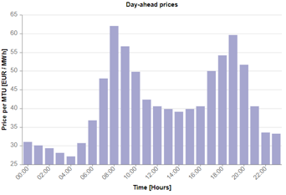
Figure 1 Example of day-ahead prices (25-09-2019). MTU= Market time unit (Hour for APX)

Intra-day market
Electricity trading on the day of delivery takes place on the intra-day market. This market is also operated by EPEX. The intra-day market allows for trading up to 5 minutes before the moment of actual delivery. While the day-ahead is an auction-based market, the intra-day market is a continuous market. This means that prices for the different PTUs (Program Time Units) are updated after every trade. In Germany already much more RES are part of the system, therefore the figure below shows an example of energy high, low and average prices on the German intra-day market. Although the volume on the intra-day market is lower, the value per unit of energy can be substantially higher than the day-ahead market and is therefore very attractive for aggregators to valorise their flexibility.

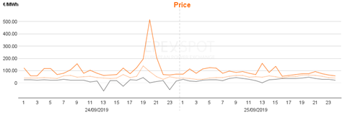
Figure 2 Example of German intra-day prices (25-09-2019) .

Balancing markets
Since aggregators will also be active on balancing markets, we describe these markets and the relative high pricing of these markets also, since this can have an effect on the pricing from aggregators to the requested flexibility from the DSO.

Balancing market: Frequency Containment Reserve
The Frequency Containment Reserve, or FCR market is the first primary market to take effect within 30 seconds after a frequency disruption in continental Europe. This market is managed by the European network of Transmission System Operators for Electricity (ENTSO-E) and the associated TSOs. Irrespective of the country in which the disruption occurs, all connected countries will, according to their capacity, contribute to stabilizing the synchronously linked high-voltage grid. If this does not happen, this can lead to a shutdown of electricity and ultimately a blackout. The table below shows the average value for 1 MW of flexibility available for one week.

Year | Average price (€/MW) | Maximum (€/MW) | Minimum (€/MW)
2015 | 3687 | 5376 | 2990
2016 | 2741 | 5445 | 911
2017 | 2536 | 3733 | 1989
Table 3 Prices of the FCR market expressed per MW power.

Balancing market: Automated Frequency Restoration Reserve
The Automated Frequency Restoration Reserve, or aFRR market exists to maintain balance at the national level. For example, if there is a malfunction in the Netherlands, all the member countries will, according to their capacity, contribute to stabilizing the interconnected European high-voltage network via FCR. The aFRR is then used by TenneT to regain balance within the Netherlands. This also clears the FCR pool for a possible new imbalance in Europe. The table below shows the average value of ramping up and ramping down flexibly for the years 2015, 2016 and 2017.

Year | Average price ramp up (€/MWh) | Number of ramp up PTUs | Average price ramp down (€/MWh) | Number of ramp down PTUs
2015 | € 75 | 21024 | € 10 | 22740
2016 | € 62 | 17988 | € 13 | 20806
2017 | € 71 | 17920 | € 18 | 20542
Table 4 Prices of the aFRR market expressed in € per MWh

Validation approach
In the Interflex Strijp-S demonstration an integrated flexibility market was developed and tested. In this chapter we explain the goals and research approach, followed by a description of the field test set-up.

The main goal of the field test was to validate the performance of the flexibility market from technical and economical perspectives.
The first step in the validation was to monitor whether the flexibility market processes were producing reliable results. The outcomes of these analyses, resulted in adjustments in the systems, e.g. algorithms that produce flexibility requests, settings of the maximum load (demo max) for the congestion points in the field test.

Once the system was running well, analysis could be done with respect to the potential of the market to mitigate congestion and the costs related to flexibility trading. The questions addressed were:
- How much flexibility is needed in the network?
- How much flexibility is available in the network?
- How much flexibility is traded in the network?
- How much flexibility is delivered in the network?
- At what time is the flexibility delivered?
- Which flexibility source is used?
- What are the flexibility costs for that specific period?
- How do the costs for flexibility compare to costs for grid reinforcement?

These questions were addressed per congestion point and per flexibility source. The analysis was based on the messages that are communicated in the trading process, i.e. the flexibility requested by the DSO (Flex Request), the flexibility offered by the aggregators (Flex Offer), the flexibility ordered (Flex Order) and finally the flexibility that was delivered (Flex Settlement). Also a number of KPIs were calculated (see also Deliverable 7. 3 [Interflex D7.3 2018]).
For the flexibility from electric vehicles an additional analysis was done concerning the flexibility potential, given that this potential is very much dependent on the availability of electric vehicles at the charging points.

Please note that in deliverable D 7.3 [Interflex D7.3 2018], we proposed to test four scenarios’ in the field test. In practice, however, it took more time to fine-tune the functioning of the systems and create a stable stream of data for a relevant period of time. Therefore the field test was limited to one scenario, namely the flexibility market based on day-ahead trading.

Field test set-up
In Deliverables 7.5 and 7.6, the pilot in Strijp-S has been described in details [Interflex D7.5 2019] and [Interflex D7.6 2019]. Figure 3 illustrates two congestion points. Each congestion point has flexible and inflexible loads. On one congestion point, Smart Storage Unit (SSU) and EV charging terminals in the street are the flexible loads. This Congestion Point (CP) will be referred to as CP: Battery+EV street. On the other congestion point, PV and EV charging terminals in the parking garage are the flexible loads. This congestion point will be referred as CP: PV+EV parking.

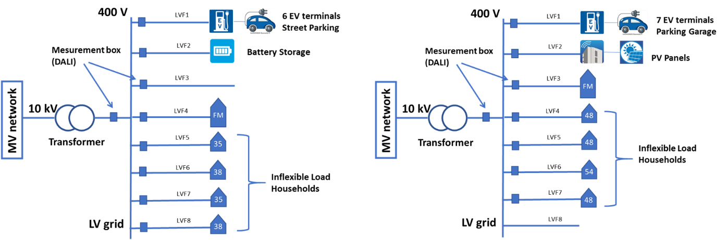
A B
Figure 3. Dutch pilot in Strijp-S including two congestion points, A- CP: Battery+EV street, B- CP: PV+EV parking
It should be noted that the real capacity of the transformers is significantly higher than their loading. Therefore, a demonstration capacity has been defined in order to create virtual congestions. The demonstration capacity at transformer level for both congestion points is set to 100 kW during the period for which this data was collected. An inflexible load forecast has been done by Enexis on LV transformer level. This load forecast, which includes the household customers is done based on real measurements on each LV feeder and the weather forecast data. In order to find the details of the load forecast module, please refer to Deliverables 7.5 and 7.6.
Aggregators are responsible of flexible load forecast including the SSU, PV and EV. Each aggregator needs to send the day-ahead forecast of the asset which is under their control to the DSO. The DSO receives the day-ahead prognosis (D-prognosis) of all flexible assets every morning at 09:30 am. In case of SSU, aggregator sends the schedule of charging/discharging of the battery which is planned for the next day. In case of PV and EV, the prediction is less reliable and more complex compared to the battery. The PV-aggregator is responsible for forecasting the PV-generation profile of the installation by considering several parameters and inputs such as the solar irradiance, temperature and orientation of the solar panels. The EV forecast has a high dependency on EV behaviour and requires sufficient historical data of the area. Considering the small scale of one LV-feeder in, as this pilot, it is difficult and complicated to predict the EV charging profile of the next day.

Market performance validation based on messages between actors
As mentioned above, the questions concerning the performance of the flexibility market, can be addressed with analysis of the messages containing load profiles, which are exchanged between the actors in the market in the trading process. This paragraph explains in detail how the messages are used for the analysis.

The needed flexibility refers to the Flex Request sent by DSO to aggregators. Each day has been divided into 96 PTUs (Programmable Time Units) which indicates 15 minutes time slots. Flex Request consists of two type of PTUs including Requested and Available PTUs. In those PTUs which a congestion is predicted, the amount of requested flexibility is sent, and in those PTUs which there is no congestion, then the amount of available capacity of the transformer is sent. Available PTU is an indicator for the aggregators to reschedule their new load profile. Based on this information, aggregators can shift the load to the other PTUs considering the remaining capacity of the transformer, in order to not make a new congestion. Flex Request message also includes the maximum price that DSO is willing to pay as well as the minimum sanction price that an aggregator needs to undertake. In case that an aggregator fails to deliver the flexibility, then a penalty will be charged by the DSO.
Flex Offers which are sent by the active aggregators on each congestion point, illustrates the available offers in the field. In the Flex Offer message, aggregators send the whole schedule of the next day for the whole 96 PTUs including the price and the penalty.
Based on the match PTUs between the request and offer, a Flex Order on each congestion point can be sent to one aggregator, which refers to the traded flexibility. Best Flex Offer is selected by calculating the Acceptance Factor (AF) of each offer considering the price and the amount of the resolved congestion by that offer. Acceptance factor is elaborated in section 3.5.
Finally, Flex Settlement message is calculated by the DSO based on the received Flex Supply message from the aggregator and then it is sent to aggregators once a week every Monday. The Flex settlement message obtains the actual delivered flexibility based on the real measurements.

Results
In this section, the main demonstration results are presented. The results are divided over different sections, based on the separate analyses that have taken place.

Raw demonstration results
The data of the field tests, including all the USEF, EFI and OCPI messages has been recorded and stored in the Interflex research database. The initial results of field test were illustrated in [Interflex D7.5 2019] and [Interflex D7.6 2019]. Through daily monitoring of the field tests and analysing the data, several design defects and implementation errors have been detected and improved. The raw demonstration results in this section provide an overview of the functioning of the flexibility market for the two congestion points. More specifically, the inflexible load forecast on each congestion point, D-prognosis of each flexibility source and the total load profiles are presented.
Figure 4 illustrates the load forecast and D-prognosis of EV parking and PV for the period of 1st September till 15th September on CP: PV + EV parking. Figure 4-A shows the load forecast of inflexible feeders in blue and the measurements at the transformer station in red colour. Figure 4-B and C show the EV and PV D-prognosis provided by the EV and PV aggregators.

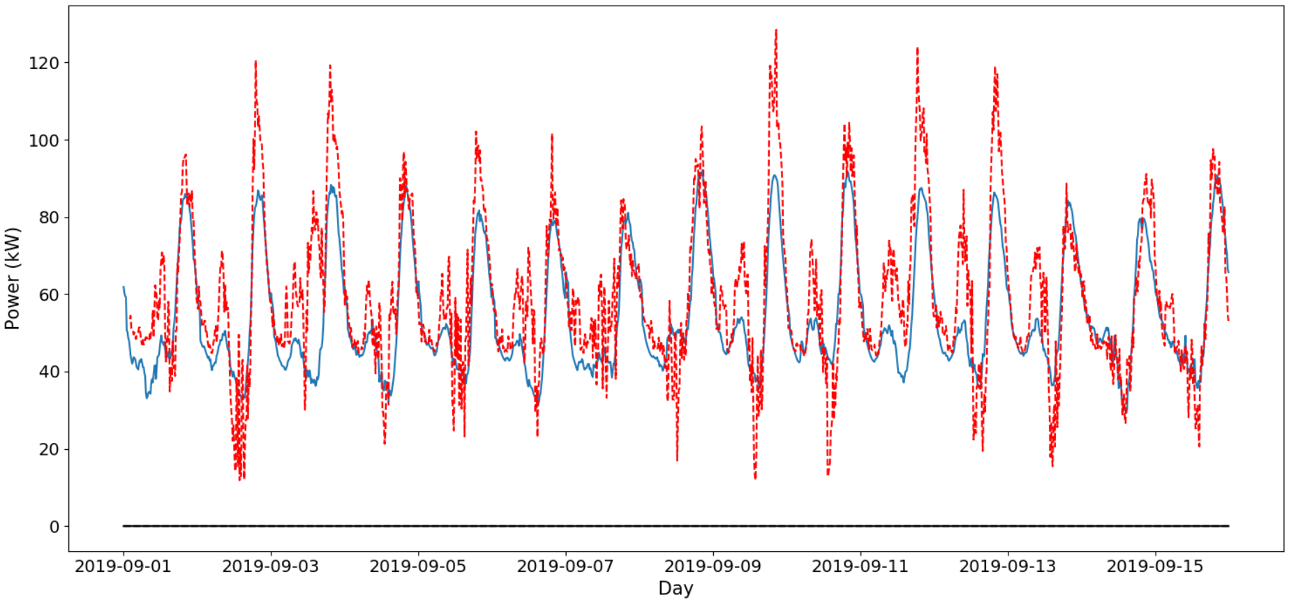
A
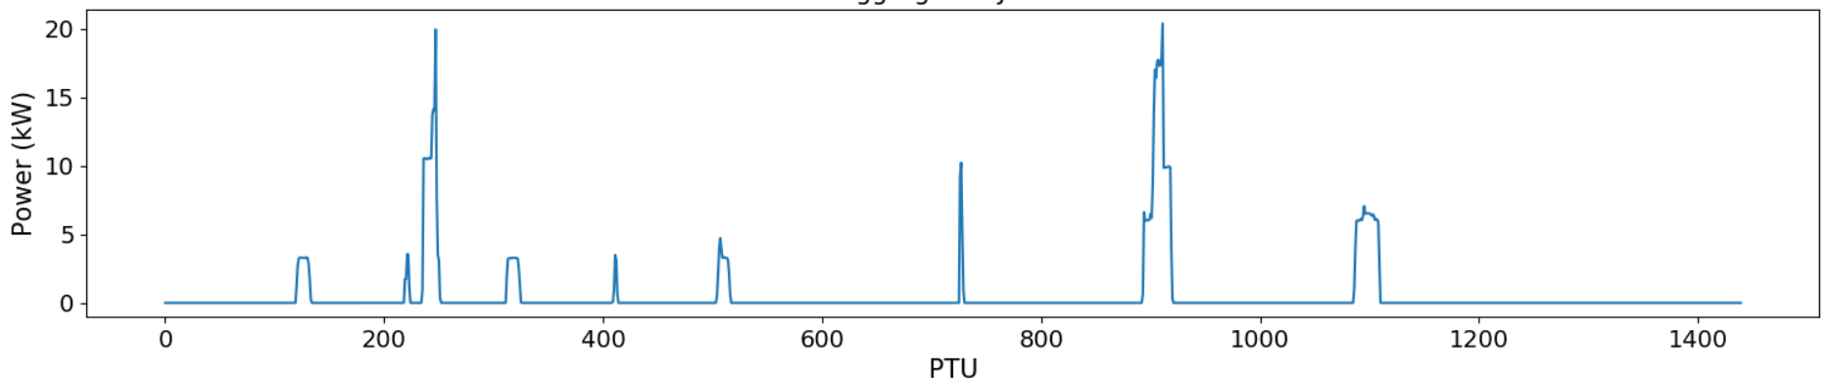
B

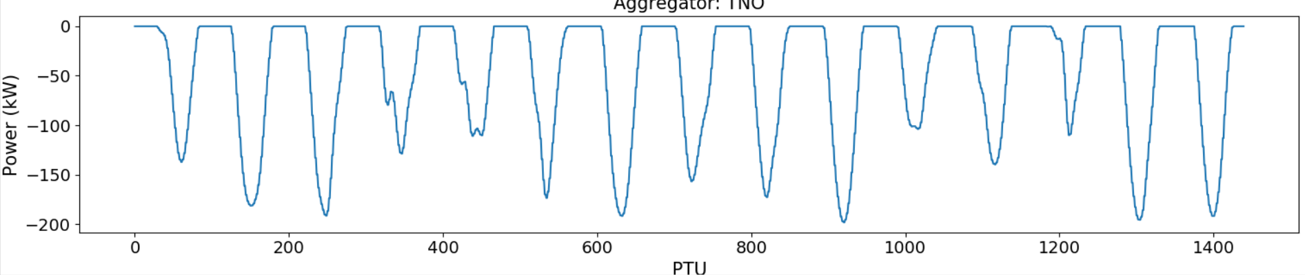
C
Figure 4. Load Forecast (A) and D-prognosis of EV (B) and PV (C) for the period of 1st September till 15th September on CP: PV + EV parking

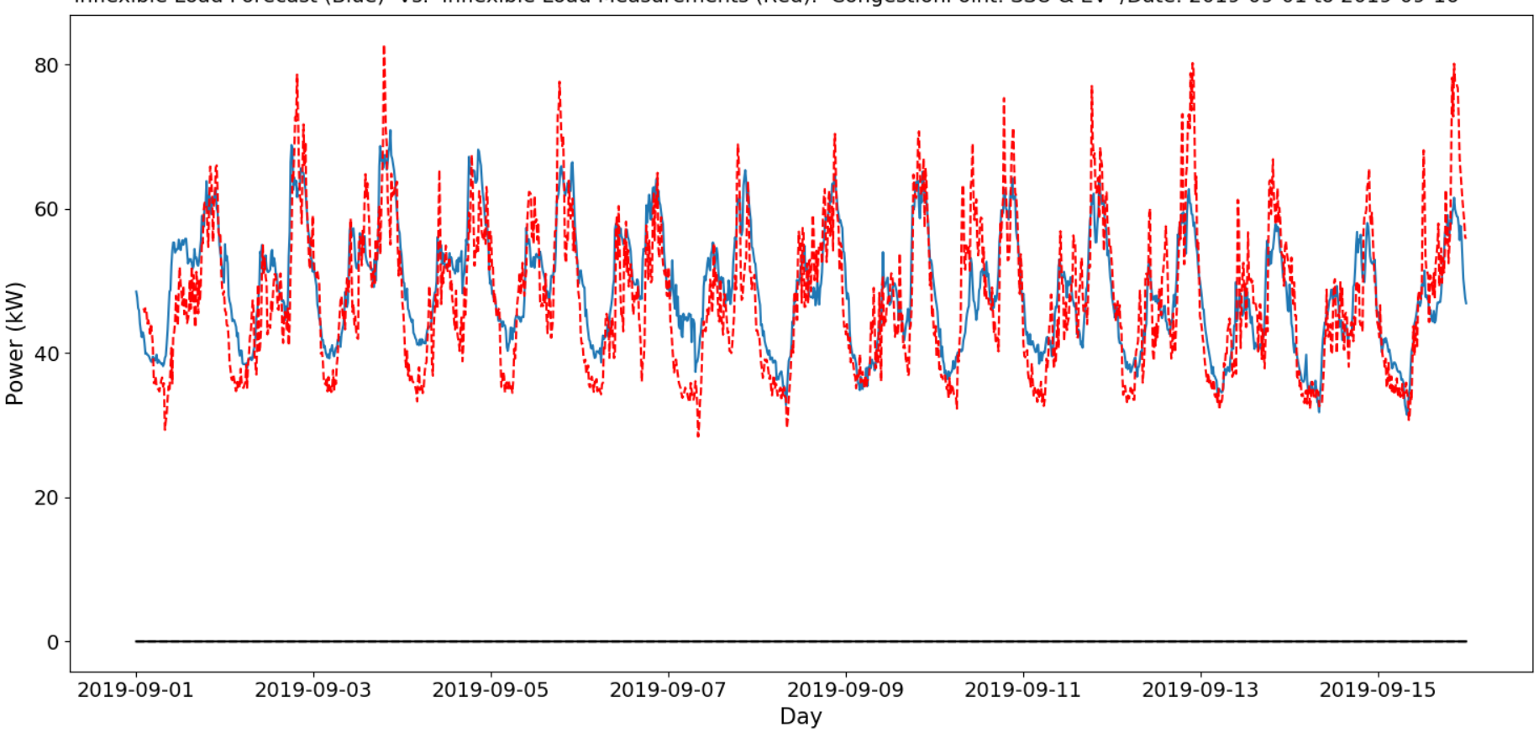
A
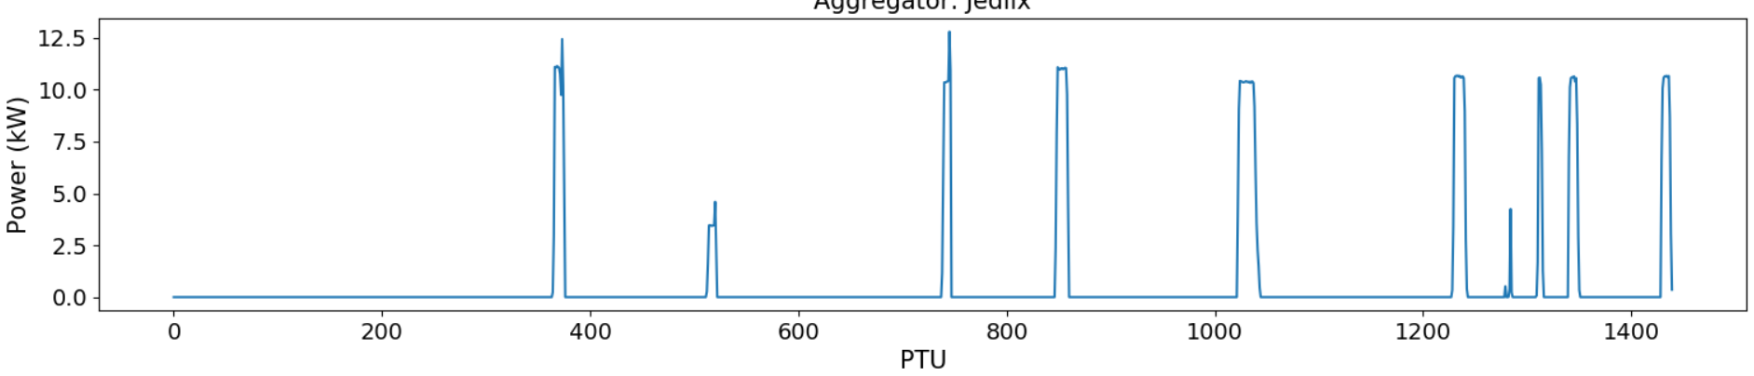
B
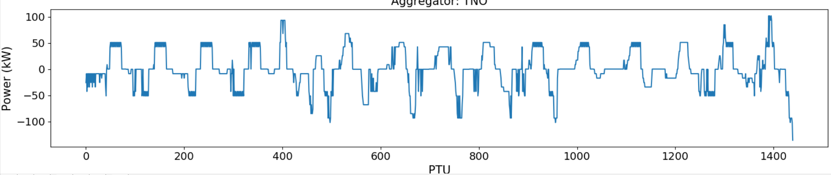
C

Figure 5. Load Forecast (A) and D-prognosis of EV (B) and SSU (C) for period of 1st September till 15th September on CP: Battery + EV street
Figure 5 shows the load forecast and D-prognosis of SSU and EV street for period of 1st September till 15th September on CP: Battery + EV street. Figure 5-A demonstrates the load forecast of the inflexible feeders in blue and the real grid measurements at transformer level in red colour. Figure 5-B and C display the EV and SSU D-prognosis done by EV and SSU aggregators.
Figure 6 and Figure 7 show the total load profile and the inflexible load forecast in red and blue colour, respectively. The demonstration capacity has been plotted by a black line. The intersection between the total load profile and the demonstration capacity creates the daily congestion which is defined as Flex Need in the Flex Decision Module (see Deliverable 7.5 & 7.6 for more information). As can be observed, the total forecast, based on the D-prognosis and the inflexible load forecast, leads to a load profile with sharp peaks and dips (red curve). The amount of congestion and consequently the required flexibility varies a lot, which means there are days with no congestion and also days with a very high congestion.
In section 3.3, the final results of the field test are discussed per congestion point.

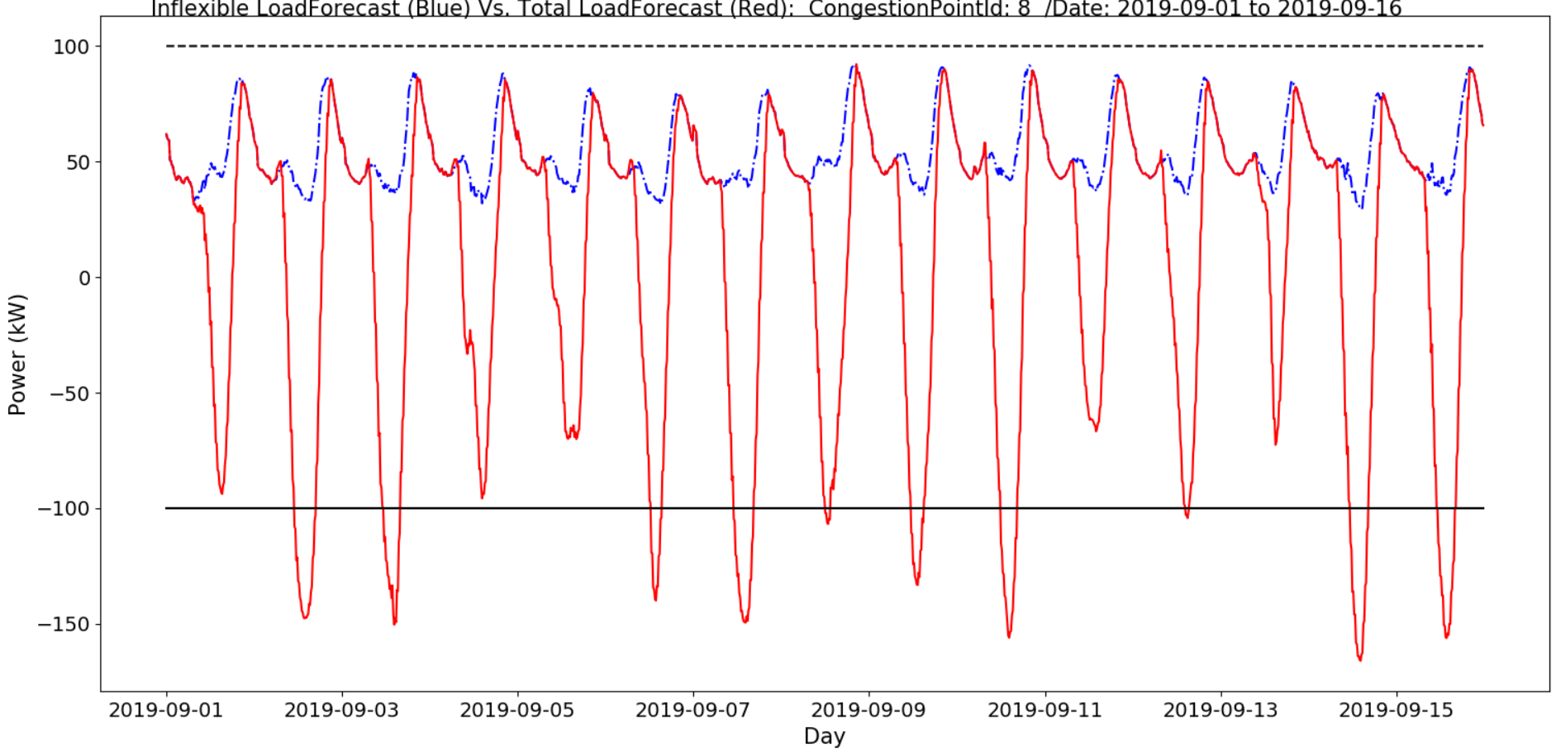

Figure 6. Total load profile (RED) and inflexible load forecast (BLUE) for period of 1st September till 15th September on CP: PV + EV parking
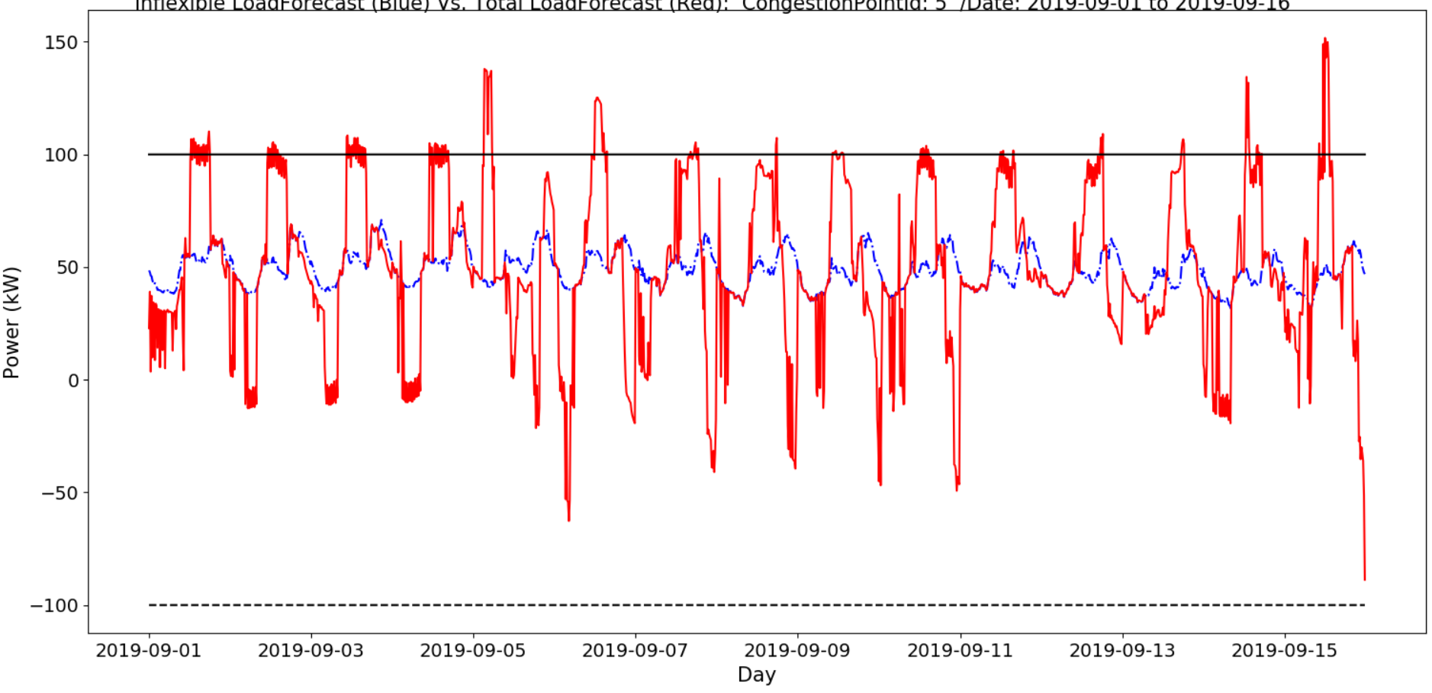
Figure 7. Total load profile (RED) and inflexible load forecast (BLUE) for period of 1st September till 15th September on CP: Battery + EV street

Simulated reference scenario
For better analysis and comparison of the measured data from the demo TNO performed a simulation with a high penetration of variable generation from wind and PV, with a partly flexible demand from EVs and heat pumps.
This was presented in more detail during the InterFlex community meeting in Hannover in October 2018. The electricity system from Figure 8 was simulated.

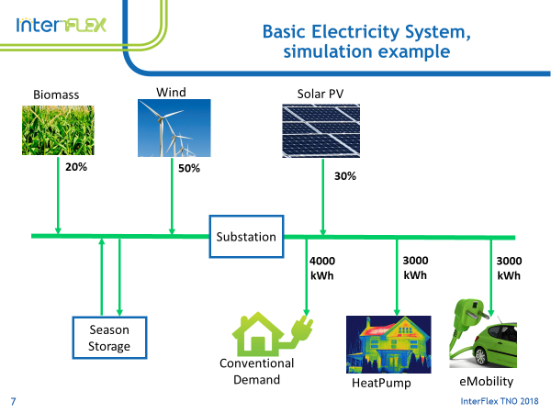
Figure 8 Basic electricity system used in simulation

From the simulation (the details are not described in this document) the following results could be derived.
A standard reference household load as used in this simulation consumes 4.000 kWh and has a peak load of 0,95 kW. The future reference household load consumes 10.000 kWh and has a peak load of 2,45 kW. In case the flexibility of the EV and Heat Pump is exploited on energy market (80% variable renewable) by an aggregator, the peak load increases to 2,73 kW.
In case we take 100% renewable variable energy (from wind and PV) the peak load goes up further to 3,01 kW. In this case some curtailment needs to be considered.
In case the DSO can also negotiate with the aggregators and the energy of the worst day can be made flat (enough flexibility is needed), the peak load decreases to 1,59 kW.
The table below gives an overview of the new expected peak loads for these scenarios and the required reinforcement for these cases.

Simulation results | Consumption | Peak Load | Reinforcement % required
Standard Household | 4.000 kWh | 0,95 kW | 0 %
Household with EV and Heatpump | 10.000 kWh | 2,45 kW | 158 %
With only an aggregator active on energy markets (no local congestion market) | 10.000 kWh | 2,73 kW | 186 %
With 100% renewable variable energy | 10.000 kWh | 3,01 kW | 217 %
Maximum peak reduction via GMS by DSO on the local congestion market | 10.000 kWh | 1,59 kW | 67 %
Table 5 Overview of the expected peak loads for some future scenarios

So worst case the grid needs to be reinforced by around 200%, which likely requires serious changes and reinforcement of the grid. Best case the grid needs to be reinforced by 67%, which likely does not require serious changes and reinforcement of the grid since the current grid has already larger margins, on average around 50% in The Netherlands.

For this simulation KPI2 and KPI3 have also been calculated:
- KPI2 Flex used on market employed /offered = 1565 kWh / 6000 kWh = 26 %
  - current initial measurements range from 14% to 19% for the SSU, this is on the low side likely since the SSU is currently only used on the day-ahead market, further the pilot situation is not the same as the simulated scenario
- KPI3 Flex traded with DSO = 103 kWh /1565 kWh = 6,6 %
  - current initial measurements range from 12% up to 29%, this is much higher, but the grid maximum is set relatively low to get enough congestion for the technical validation of the system. This high KPI likely also results in relative high DSO costs for this scenario.

Overall flexibility: Need and performance
This section presents the analysis results based on all the flex messages exchanged between the DSO and the aggregators. USEF messages are analysed in order to achieve a better insight of the whole process [Interflex D7.5 2019] and [Interflex D7.6 2019]. Two congestion points can be identified. Each congestion point and each flexibility source has been studied separately.

Congestion Point: Battery+EV street

This congestion point consists of two types of flexibility sources: a battery storage and EV charging poles installed on the street. Figure 9 illustrates the results for the whole chain from flexibility request to settlement, and is explained in the text below. All figures show the average values per PTU over the period of one month from 15th September till 15th October.

Figure 9-A shows the Flex Request sent to the active aggregators on this congestion point. Two types of congestion are studied in this pilot, overloading and overgeneration. As can be observed, on this point the main cause of congestion is overloading. Charging of the battery or simultaneous charging of the EVs can lead to overloading. Congestion is expected mainly during daytime between 11 am and 4 pm. This is the period of time that battery aggregator plans to charge the battery. The peak of battery charging/discharging can vary between 10 to 100 kW. In this pilot, battery is the main cause of overloading and EV charging can rarely lead to congestion. The maximum required flexibility on average is about 25 kW between 1 pm and 2 pm.

Figure 9-B shows the Flex Offers received from each aggregator. It is noticeable that the Flex Offer includes both requested and available PTUs i.e., it indicates the new schedule of the aggregator after receiving DSO’s request. Obviously, the battery as the main cause of congestion can be the main solution as well. Hence, the Flex Offer from the battery aggregator complies with the Flex Request very well. From both power and time point of view, the battery Flex Offer can perfectly match the request. The EV Flex Offer is significantly smaller than the requested power, which illustrates the low availability of EV flexibility.

Figure 9-C displays the Flex Order sent to both active aggregators in total and Figure 9-D shows how this order has been distributed among these two aggregators. As it is observable, the combined Flex Orders can comply with the request very well. For most of the PTUs, the order matches the requested power. Looking at Figure 9-D, it can be perceived that flexibility traded with EV aggregator is very limited in comparison with the battery. This is mainly due to the low available capacity of EVs for smart charging. The number of EV drivers who are registered on the aggregator’s application for smart charging is considerably low.

Finally, Figure 9-E and F demonstrate how much flexibility was actually obtained by the DSO. Regardless of the traded flexibility, there is always an uncertainty whether the ordered flexibility will be delivered. In case of the battery storage, it is anticipated to have lower risk and higher reliability. The results of this pilot also verify this assumption, as can be observed in Figure 9-F: the Flex Settlement profile is nearly similar to the Flex Order. On the contrary, the uncertainty of EV charging as a flexibility source is very high. Figure 9-F explicitly shows the actual amount of delivered flexibility by the EV. The difference in delivered power compared to the Flex Order is substantial, which suggests that EV smart charging may not be a reliable source of flexibility for a congestion point on a low voltage feeder.
Nonetheless, it was possible to achieve the maximum power of 20kW for the total delivered flexibility, as shown in Figure 9-E, on this congestion point. As Figure 9-F reveals, the obtained flexibility has been gained mainly through the battery, and the obtained flexibility from EV is negligible in this case study. By comparing Figure 9-A (Flex Request) with Figure 9-E, it can be inferred that the obtained flexibility by DSO on average is about 80% of the requested value from magnitude point of view. Moreover, from the timing point of view, the Flex Settlement pattern can match the Flex Request to a high extent.

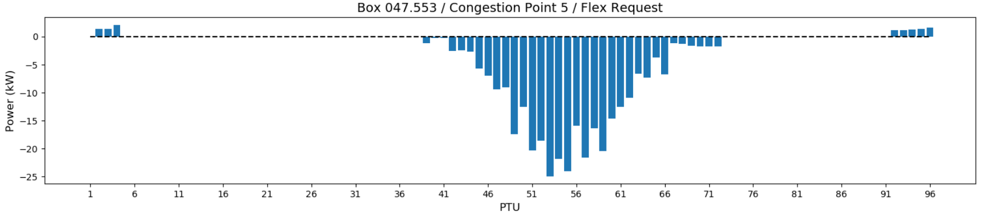
A. Flex Request to both active aggregators
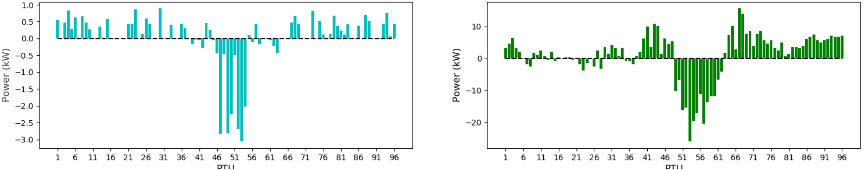
B. Flex Offer from EV aggregator (left) and Battery aggregator (right)

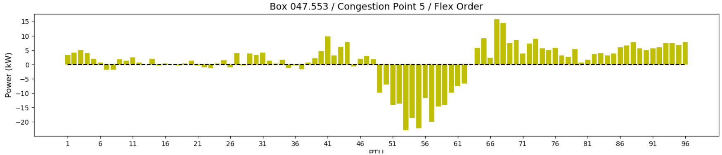
C. Flex Order to both active aggregators
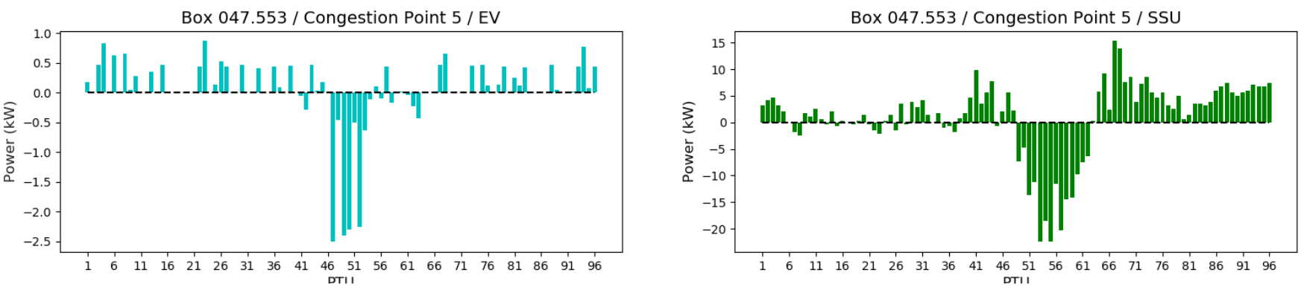
D. Flex Order to EV aggregator (left) and Battery aggregator (right)
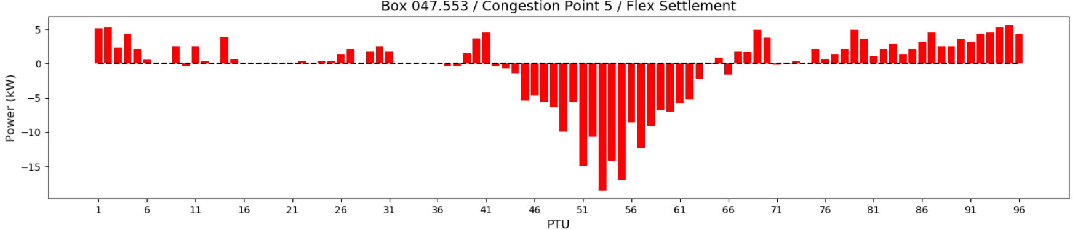
E. Flex Settlement for both active aggregators
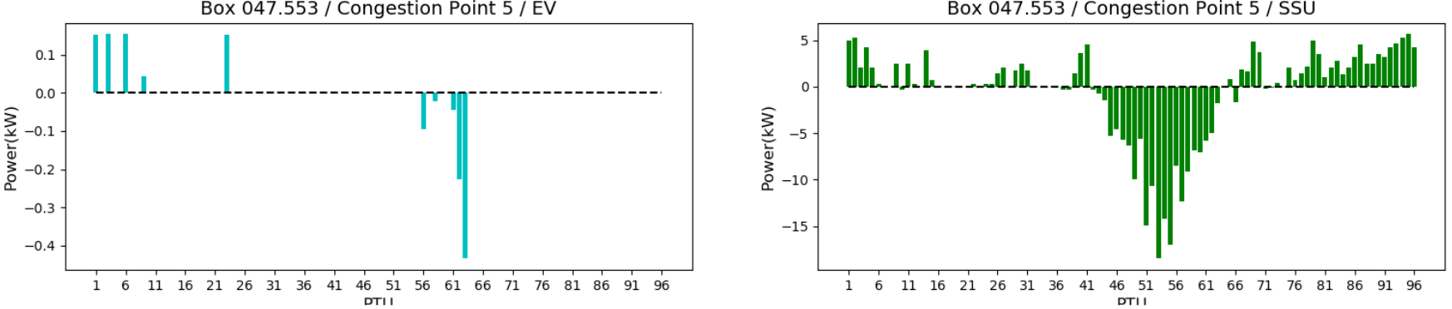
F. Flex Settlement for EV aggregator (left) and Battery aggregator (right)

Figure 9. Flex Request/Offer/Order/Settlement per PTU on average for the period of 15th September till 15th October on CP: Battery + EV street

The previous figures show the average values per PTU. It is also valuable to investigate the situation from a different perspective. It makes the performance of the flexibility market more clear. Hence, the following analysis have been run in order to perceive how Battery and EV can meet the DSO request per day. Figure 10 demonstrates the Flex Request variations and its corresponding Flex Order and Settlement per day for the same period of time as Figure 9. Both the EV and Battery aggregators are active on the same congestion point; therefore, they both receive the same Flex Request as shown by blue bars.
Figure 10-A illustrates that EV aggregator barely receives an order. As it already discussed, the amount of requested power is considerably higher than the available EV capacity for smart charging. Only for the few days (5 days out of 30 days), the EV aggregator was selected for sending an order (depicted by yellow bars); however, according to the recorded data from the field, it was not able to deliver the ordered flexibility, with the exception of 2 days. It is noticeable that in order to draw a conclusion, a bigger set of sample data is required. Therefore, it is not reasonable to infer any concrete conclusions.

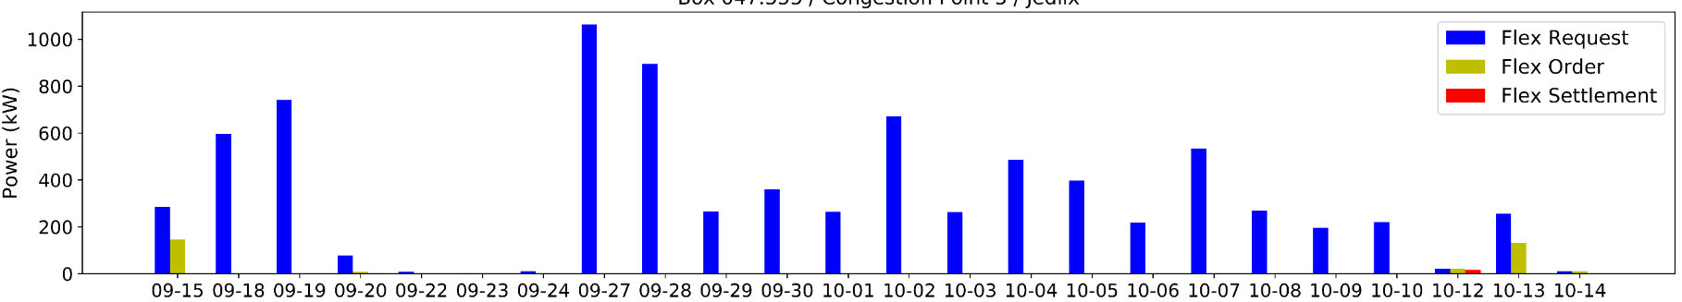
A. EV Aggregator
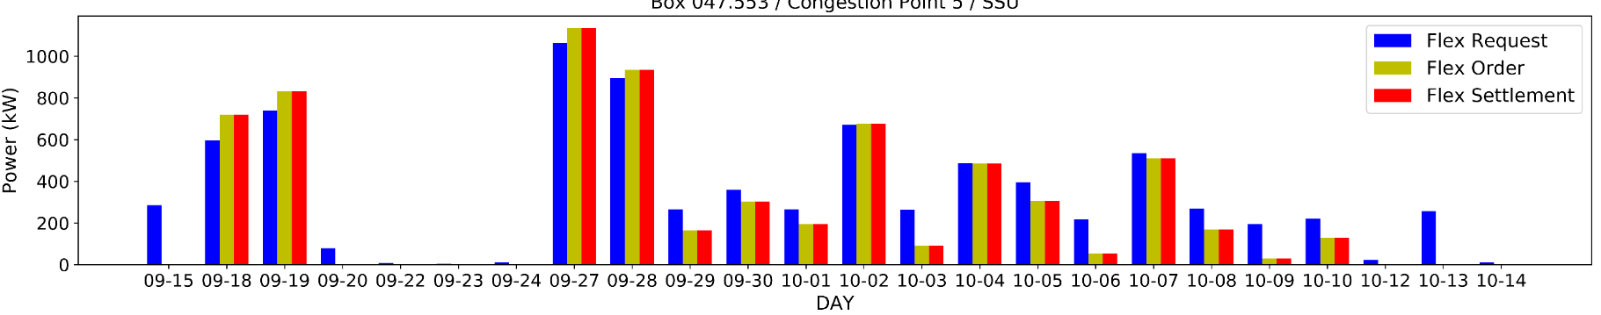
B. Battery Aggregator

Figure 10. Daily comparison between Flex Request/ Flex Order/ Flex Settlement for the period of 15th September till 15th October on CP: Battery + EV street

Figure 10-B compares the Flex Request with the corresponding Order and Settlement. As it can be observed, in majority of days, battery is the flexibility source which receives the order and it is always capable of delivering the exact amount of ordered flexibility. It is noticeable that in some cases, especially days with small congestion, flexibility offered by the battery is lower than the request. Due to this behaviour of the battery aggregator, as it already mentioned, the DSO is able to achieve 80% of the requested flexibility. However, during the days with a high level of congestion, the battery can always meet the complete request, and in some cases even more. Thus, during the days with a high level of congestion and consequently high risk for the DSO, the battery is a reliable source of flexibility.

Note: Flex Order is always equal to the received offer from the selected aggregator. Therefore, the yellow bars (Flex Order) in Figure 10 also represent the offered value by that aggregator.

Congestion point: PV+EV parking
This congestion point consists of two types of flexibility sources: PV solar panels and EV charging poles in a parking garage. Figure 11 illustrates the results for the whole chain from flexibility request to settlement. All figures show the average values per PTU over the period of one month from 15th September till 15th October.

Figure 11-A shows the Flex Request sent to the active aggregators on this congestion point. As it can be observed, on this point the main cause of congestion is the generation of PV solar energy. In case of congestion due to overgeneration, in opposite of overloading (the other CP), the requested flexibility will be positive. This indicates that loading on this congestion point needs to be increased rather than decreased; which implies to reduce the generation. Besides, simultaneous charging of the EVs can also lead to overloading for some PTUs during the evening, however it is negligible in compare to the power generated by the PV solar panels. This overloading occurs with the peak of about 10 kW around 8:30 pm. The critical congestion mainly occurs during the daytime between 11 am and 4 pm. This is the period of time when the solar energy production is at its maximum. The peak of PV generation is quite volatile and highly dependent on weather conditions. Therefore, congestion can rise from zero in one day to 60 kW in the next day. The maximum required flexibility on average is about 50 kW around 2 pm.

Figure 11-B shows the Flex Offers received from each aggregator. PV curtailment is the main available option to mitigate the congestion caused by overgeneration for this congestion point. Obviously, PV as the main cause of congestion can be the main solution as well. On the other hand, EV smart charging can also (partially) solve the problem. However, the Flex Offer from the PV aggregator can comply with the Flex Request better than EV. Even though offered flexibility by PV aggregator on average is almost half of the requested power by DSO. One of the reasons is that PV solar panels have some specific discrete steps for curtailment; therefore, in most of the cases the aggregator needs to decide whether to send an offer above or below the requested amount. The results reveal that the PV aggregator often has opted for the lower step of curtailment. Thus, PV curtailment can offer maximum flexibility of 25 kW during the peak time, and EV offers a maximum peak load shifting of 3 kW.

Figure 11-C displays the Flex Order sent to both active aggregators in total and Figure 11-D shows how this order has been distributed among these two aggregators. From a timing point of view, the Flex Order pattern matches with the request; however, the amount of flexibility that the DSO orders is lower than the requested value. The maximum ordered flexibility on average is about 20 kW which demonstrates, in most of the cases, DSO accepted the PV offer. Figure 11-D shows that the flexibility ordered from the EV aggregator coincides perfectly with the offer. In the other words, Flex Order Decision logic has always ranked the EV offer high enough to be selected. As already discussed in Section 2, Flex Order Decision module, aside from the offered price, also takes into account the proportion between the requested power and the offered power. Hence, in cases that expected congestion is small enough to match the available EV capacity, the acceptance factor of EV offer will be pretty high to be selected over PV offer. It is also noticeable that EV offer is always less costly than PV offer.

Finally, Figure 11-E and F demonstrate how much flexibility could actually be obtained by the DSO. As can be observed, the actual delivered flexibility is considerably lower than the requested value. Looking at figure 8-E, the maximum delivered power is about 15 kW, which is mainly due to PV curtailment, while EV smart charging almost failed to deliver what was ordered. Similar to the other congestion point, EV smart charging as a local asset on a single LV feeder could not provide adequate flexibility during the field test. In case of PV curtailment, higher reliability in delivering the order can be expected. The results of this pilot verify this assumption to some extent. It should be noted that some days, due to technical or communication issues, the PV aggregator was not able to execute the curtailment as planned.

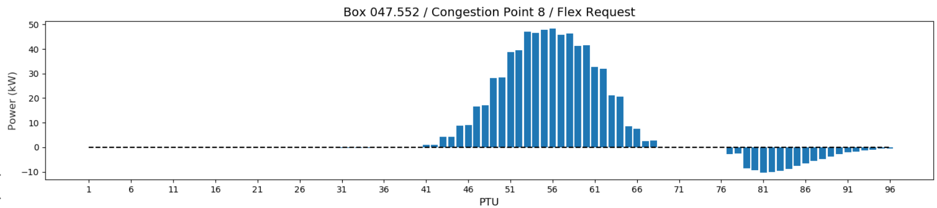
A. Flex Request to both active aggregators

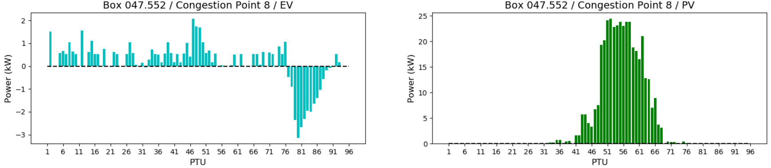
B. Flex Offer from EV aggregator (left) and PV aggregator (right)

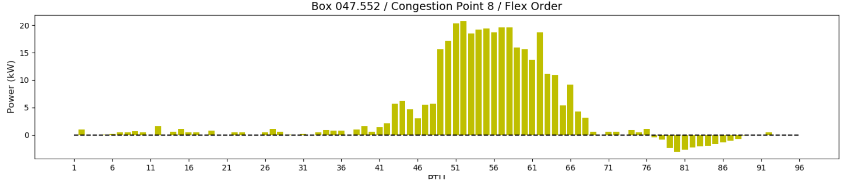
C. Flex Order to both active aggregators

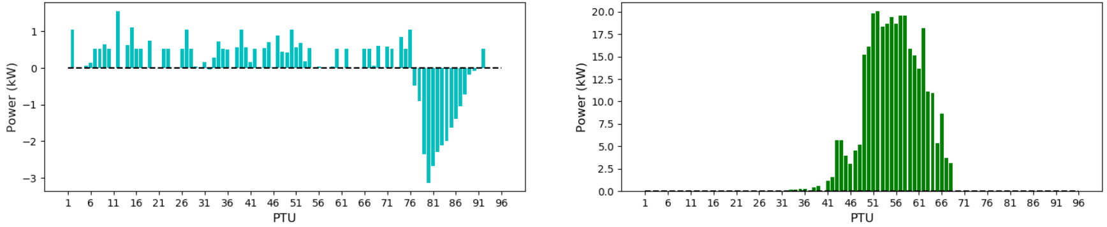
D. Flex Order to EV aggregator (left) and PV aggregator (right)

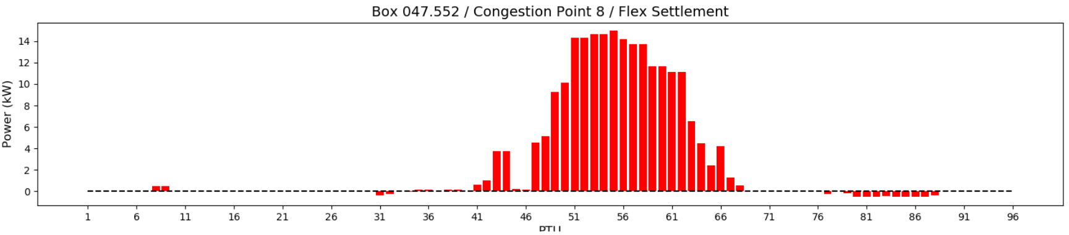
E. Flex Settlement for both active aggregators

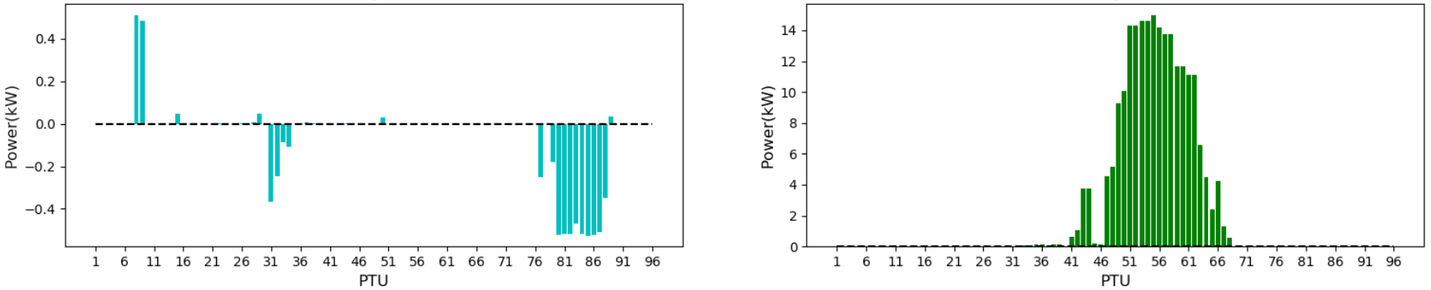
F. Flex Settlement for EV aggregator (left) and PV aggregator (right)

Figure 11. Flex Request/Offer/Order/Settlement per PTU on Average for period of 15th September till 15th October on CP: PV + EV parking

As also discussed, in section 3.3.1, Figure 12 can provide more insight to the performance of the whole process through the daily comparison of the requested flexibility, ordered and settled values for each aggregator individually. During 4 days out of 30, the expected congestion was noticeably higher than usual. In these days, the received offer and consequently the sent order to PV is much less than the requested value. This can considerably affect the results of obtained flexibility by DSO. The reasons that the PV aggregator refuses to send an offer which can comply with the request, while it is highly needed, is not clear. Therefore, it is essential to be further investigated.

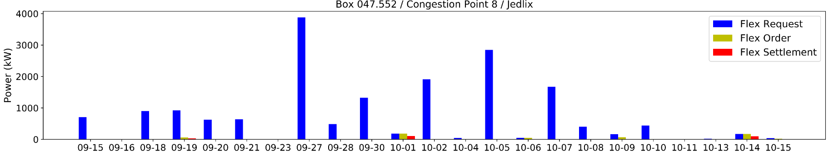
A. EV Aggregator

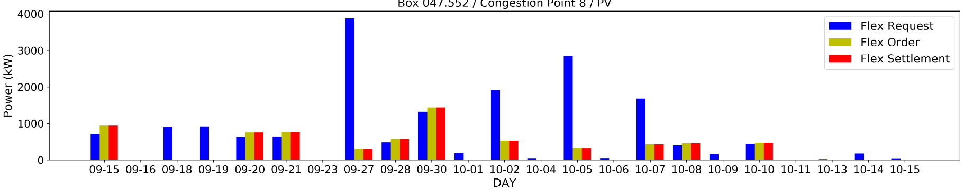
B. PV Aggregator

Figure 12. Daily comparison between Flex Request/ Flex Order/ Flex Settlement for the period of 15th September till 15th October on CP: PV + EV parking

KPI results
In this section, Key Performance Indicators (KPIs) will be presented. As described in D7.3, the overall flexibility KPI is divided into 4 KPIs in order to provide better insight of the flexibility market performance. The following 4 KPIs including Flexibility Available Field (1), Flexibility Traded Markets (2), Flexibility Traded DSO (3), and Flexibility Obtained DSO (4) represent the overall flexibility KPI.

There are 5 additional KPIs for providing further details of the flexibility resources and their impact on the grid which are described in Table 5:
ID | Title | Description
KPI_WP7_1 | Availability | % of time during which the storage is available
KPI_WP7_2 | Efficiency | Battery-based storage efficiency
KPI_WP7_3 | Impact on the grid | % of shifted energy, Contribution to load shedding, Contribution to ancillary services
KPI_WP7_4 | Potential to shift demand | Share of energy/power displaced for each type of flexibility
KPI_WP7_5 | Local peak load reduction | % of decrease on peak load after congestion management at LV transformer level

Table 6 Additional KPIs for providing further details of the flexibility resources

All the KPIs have been defined for each flexibility source at each congestion point. However, in most of the cases, KPIs have been calculated only for PV and the battery. EV is excluded from most of the KPIs due to lack of adequate information. The presented D-prognosis of EV in section 3.1 shows that we do not know how much flexibility is available at each period of time, as these D-prognosis in the current context do not reflect the reality. Besides, the majority of EV charging sessions are done on non-flexible EVs (EVs without Jedlix App). Hence, there is not sufficient data of smart charging available.

The first level on which the availability of flexibility can be measured is by computing the ratio between the total flexibility installed in the field (or the total theoretically available flexibility) and the amount of flexibility the local aggregator (LA) offers to the commercial aggregator (CA) [InterFlex D7.1 D7.2 2017], [Interflex D7.5 2019] and [Interflex D7.6 2019]. This KPI is computed based on equation 1.

$${Flexibility}_{\% available field}= \frac{∑ P_{flexibility offered by LA to CA}}{∑P_{Total theoretically available flexibility}}*100$$ | (1)

Then, the share of flexibility traded on the market (any market) can be determined, by computing the ratio between the flexibility employed by the CA and the flexibility offered by the LA. This can be evaluated based on equation 2.

$${Flexibility}_{\% traded markets}= \frac{∑ P_{flexibility employed on markets by CA}}{∑P_{flexibility offered by LA to CA}}*100$$ | (2)

As the CA can offer flexibility on not only the local flexibility market, but also the ancillary service markets and wholesale markets, it is important to determine the share of flexibility traded with the DSO. This can be done with equation 3.

$${Flexibility}_{\% traded DSO}= \frac{∑ P_{flexibility traded with DSO}}{∑P_{flexibility employed on markets by CA}}*100$$ | (3)

Furthermore, it is important to evaluate the amount of flexibility the DSO has been able to trade with the market in relation to the requested flexibility. This will be done based on equation 4.

$${Flexibility}_{\% obtained DSO}= \frac{∑ P_{flexibility traded with DSO}}{∑P_{flexibility requested by DSO}}*100$$ | (4)

In the rest of this section, the definition of each KPI for each flexibility source as well as the adopted approach to calculate it, will be explained. KPIs will be presented based on monthly period during 3 months from August till October. It is noticeable that some KPIs, especially those related to PV, can be affected by seasonal changes and transition from summer to autumn. On the other hand, it is also interesting to observe that some other KPIs, regardless of the time, maintain consistent values.

KPI 1 - Flexibility Available in Field
$${Flexibility}_{\% available field}= \frac{∑ P_{flexibility offered by LA to CA}}{∑P_{Total theoretically available flexibility}}*100$$ | (1)

KPI 1 for PV:

KPI 1 for PV is defined by the following equation:

$$\frac{PV forecast in kW (available PV offered by LA to CA) }{Theoretical PV Capacity in kW}×100$$

The ratio of forecasted PV to theoretically installed PV capacity is calculated. As it has already been explained, PV forecast (D-prognosis) is done by the local aggregator and then sent to the commercial aggregator.

Approach:

Theoretical PV capacity is equal to 670 kW. The sum of all PV forecast power (kW) for all PTUs divided by the number of PTUs multiplied by 670 kW will result in flexibility available by PV in the field.

Results:
(01/08 till 31/08) | (01/09 till 30/09) | (01/10 till 31/10)
9% | 6.7% | 5.7%
Table 7 results KPI1 for PV

As it was expected, KPI 1 for PV is relatively low. Since on average only a small part of the maximum PV capacity is available for curtailment. By transition from August to October, less sunny days and shorter day time lead to smaller value for KPI 1.

KPI 1 for SSU:

$$\frac{Storage SoC \left(available Capacity of battery in kWh\right) }{Theoretical SSU Capacity in kWh}×100$$

Approach:

Theoretical simulation SSU capacity is equal to 170 kW max power and 350 kWh energy with no upper/lower limit. In one day (24 hours), SSU can theoretically be charged/discharged every hour by max power of 170 kW which results in 4080 kWh.
The Available Capacity of the Battery can be interpreted in two directions, both as charging and discharging capacity. Therefore, the KPI is calculated for both states, i.e. the available capacity to charge the battery and the available capacity to discharge the battery. Then the average value of these two states is obtained.
The measurements which show the capacity of the battery are available. This value represents the available capacity for discharging the battery. By deducting the available capacity of the battery from 350 kWh, the available charging capacity will be obtained. The sum of these values during the whole period of time are divided by the number of days multiplied by 4080 kWh (Theoretical Simulation Battery Capacity per Day). The average of these two states (charging/discharging) will be used for calculation of KPI.
Note: The maximum possible step for charging/discharging of the battery per PTU is equal to $\frac{170kW}{4}=42.5 kWh$; hence, the available charging/discharging capacity in each PTU cannot exceed this value. This is also considered. If the calculated capacity is higher than 42.5 kWh, then it is set fixed at this value.

Results:

(01/08 till 31/08) | (01/09 till 30/09) | (01/10 till 31/10)
81% | 77% | 78%
Table 8 results KPI1 for SSU
KPI 1 for SSU can be 100% but if the battery is close to empty or almost full, then it has lower flexibility. Thus, this value is also in the expected range. As it is observable, KPI 1 for SSU in opposite of KPI 1 for PV, presents relatively consistent values during these 3 months and its variations are negligible.

KPI 2 - Flexibility Traded on Markets
$${Flexibility}_{\% traded markets}= \frac{∑ P_{flexibility employed on markets by CA}}{∑P_{flexibility offered by LA to CA}}*100$$ | (2)
KPI 2 for PV:

$$\frac{PV Curtailment inkW (Instruction Message from CA to LA) }{PV forecast in kW (available PV offered by LA to CA)}×100$$

Approach:

The Instruction Message is sent by CA to LA indicating the PV curtailment percentage per PTU. By multiplying this curtailment percentage by the PV generation forecast, the amount of curtailed power (kW) per PTU can be calculated.

Results:

(01/08 till 31/08) | (01/09 till 30/09) | (01/10 till 31/10)
10% | 11% | 6%

Table 9 results KPI2 for PV
KPI 2 for PV is higher than expected, since normally curtailment is almost never requested on energy markets. This result can be due to the fact that CA follows a certain profile and therefore sometimes curtails PV. On the other hand, it can be due to the low demonstration capacity which results in frequently high congestion because of PV overgeneration. The results actually reflect the specific set-up of the field test where a large PV installation is connected to a LV feeder. Under these conditions, especially during summer time, often DSO needs to request a large amount of PV curtailment. This request of DSO will be transferred through CA to LA. Obviously, the requirement for PV curtailment is higher during summertime than autumn. Nonetheless, it is required to further investigate the cause.

KPI 2 for SSU:

$$\frac{Battery Charge/Discharge (Storage Instruction from CA to LA in kWh) }{Storage SoC (available Capacity of battery in kWh)}×100$$

Approach:

CA sends the Instruction Messages to LA defining the amount of power that the battery needs to be charged/discharged per PTU. This power value is converted to a charging/discharging energy (kWh) per PTU. Similar to KPI 1, the requested charging/discharging energy per PTU cannot exceed the limit of 42.5 kWh. The average value of these two states is calculated to obtain the result for KPI 2.

Results:

(01/08 till 31/08) | (01/09 till 30/09) | (01/10 till 31/10)
19% | 14% | 15%

Table 10 results KPI2 for SSU
KPI 2 for SSU is close to what was expected (above 10%). Since there are always market opportunities for shifting energy, SSU can be regularly used. Similar to KPI 1, SSU shows relatively consistent behavior during these 3 months.

KPI 3 - Flexibility Trade by DSO

$${Flexibility}_{\% traded DSO}= \frac{∑ P_{flexibility traded with DSO}}{∑P_{flexibility employed on markets by CA}}*100$$ | (3)

KPI 3 for PV:

$$\frac{Flex Order to PV from DSO in kW }{PV Curtailment in kW (Instruction Message from CA to LA)}×100$$

Approach:

Sum of all Flex Orders sent by DSO to CA for curtailing the PV is divided by the total PV curtailment instructed by CA to LA for the whole period of time.

Results:

(01/08 till 31/08) | (01/09 till 30/09) | (01/10 till 31/10)
20% | 78% | 43%
Table 11 results KPI3 for PV
This number is expected to be about 100%, since PV curtailment is mainly based on flexibility orders by the DSO. It is clear to us that during August there was a miscommunication in sending Instruction messages from CA to LA which caused the very low number of 20%. This defect of the system was diagnosed and resolved in September; therefore, the value of September represents the most accurate result of this KPI. In October PV generation considerably reduced; as a result, DSO order for PV curtailment also declined. However, KPI 3 in October demonstrates that CA maintained to send curtailment messages to LA. As already mentioned in KPI 2 for PV, this behavior of CA is not clear yet and requires further investigation. Thus, we cannot have concrete conclusions at this moment.

KPI 3 for SSU:

$$\frac{Flex Order to Battery from DSO }{Battery Charge/Discharge (Storage Instruction CA to LA)}×100$$

Approach:

The sum of all Flex Orders sent by DSO to CA for charging and discharging the battery is divided by the total charging and discharging of the battery instructed by CA to LA for the whole period of time.

Results:

(01/08 till 31/08) | (01/09 till 30/09) | (01/10 till 31/10)
16% | 29% | 33%
Table 12 results KPI3 for SSU
KPI 3 for SSU is expected to be below 10% in a normally dimensioned system. Since a high capacity battery will not be connected to a LV grid. In the current pilot, the grid is under dimensioned and therefor, often the DSO needs to ask the aggregator to reduce the SSU peak power.

KPI 4 - Flexibility Obtained by DSO
$${Flexibility}_{\% obtained DSO}= \frac{∑ P_{flexibility traded with DSO}}{∑P_{flexibility requested by DSO}}*100$$ | (4)
Approach:

The total Flex Order sent by DSO to each aggregator for each flexibility source including Battery, PV, and EV on both street and parking garage is calculated separately. Then it is divided by the total Flex Request on the corresponding congestion point during the same period of time.
PTUs with common sign (positive/negative) in Flex Request and Flex Order messages that overlap each other were detected and the sum of absolute value of power was calculated. The PTUs of a Flex Order which were not requested but received an offer, were not taken into account.

$\frac{∑ Flex Order from DSO to CA}{∑ Flex Request from DSO to CA}$ $×100$

KPI 4 for PV:

(01/08 till 31/08) | (01/09 till 30/09) | (01/10 till 31/10)
135% | 70% | 3.3%
Table 13 results KPI4 for PV
KPI 4 for PV is considerably dependent on the weather conditions; therefore, each month presents a different number. As it was already explained, there are specific discrete steps that PV aggregator can select to curtail the PV generation. Depending on the fact that PV aggregator decides to opt for the upper step or the lower step, the offer can be higher or lower than the request. In August, PV aggregator often preferred to send an offer with higher curtailment value than requested per PTU; however, the price was still desirable for the DSO. Hence, the traded flexibility with DSO is over 100%, which implies it is higher than request. In September, PV aggregator adopts an opposite approach and selects the lower step of curtailment to offer. As a result, DSO could obtain less than requested. In October, PV overgeneration was very limited. Therefore, PV was no more the aim of the Flex Request, but the request was mainly to EV aggregator in order to reduce the load. Since PV is not cause of the congestion in October, consequently it will not receive orders either.

KPI 4 for SSU:

(01/08 till 31/08) | (01/09 till 30/09) | (01/10 till 31/10)
60% | 85% | 82%
Table 14 results KPI4 for SSU
This value was expected to be high as the results show. Battery can offer high flexibility in responding to Flex Requests. As it is already discussed in section 3.3, battery offer can perfectly comply with the request. Therefore, in most of the cases with high congestion, SSU is the preferred source of flexibility to be ordered.

KPI 4 for EV:

Congestion Point | (01/08 till 31/08) | (01/09 till 30/09) | (01/10 till 31/10)
EV Parking | 1.8% | 4% | 0.7%
EV Street | 16% | 7% | 2.8%
Table 15 results KPI4 for EV
Available EV capacity for smart charging on both congestion points is very low. Therefore, this KPI for EV is as low as expected.

KPI 7.1 - Storage Availability

Due to technical problems the SSU wasn’t available in the months 8, 9 and 10. A simulation model of the battery had to been used for the scenario’s. Therefore the availability is 0% for real battery and 99% for simulation battery.

KPI 7.2 - Storage Efficiency

The storage efficiency is 100% for the simulation battery. Due to problems with the real battery the efficiency is 0%

KPI 7.3 - Impact on the grid
This KPI has been divided into three parts: shifted energy of the battery, PV curtailment which is considered as load shedding, and contribution to ancillary services which is defined as the difference between the trade with DSO and trade with the markets in general.

Shifted Energy of SSU:

$$\frac{Sum of all PTUs of Flex Order for battery \left(kW\right)}{Total power consumption based on the load forecast \left(kW\right)} ×100$$

Approach:

The total power for all Flex Order PTUs on the congestion point where battery is located is calculated. Then it is divided by the total power of load forecast including the inflexible load forecast plus D-prognosis.

Results:

(01/08 till 31/08) | (01/09 till 30/09) | (01/10 till 31/10)
7% | 9% | 13%
Table 16 results KPI7.3 for SSU
Normally it is expected to be below 10%; unless the grid is under dimensioned as it is the case in this demonstration. Moreover, grid congestion during October was larger than the other 2 months based on the received D-prognosis from SSU aggregator.

Contribution to Load Shedding → PV Curtailment (only by DSO order)

$$\frac{Sum of all PTUs of Flex Order for PV (kW)}{Total power consumption based on the load forecast (kW)} ×100$$

Approach:

Total power for all Flex Order PTUs on the congestion point where the PV is located is calculated and then it is divided by the total power of load forecast including the inflexible load forecast plus the D-prognosis.

Results:

(01/08 till 31/08) | (01/09 till 30/09) | (01/10 till 31/10)
19% | 6% | 1%
Table 17 results KPI7.3 for PV
Normally it is expected to be below 1%, otherwise the grid is under dimensioned as it is the case in the current pilot. By transition from August to October, the requirement for PV curtailment is substantially decreases.

Contribution to Ancillary Services

Flexibility traded on markets in compare to flexibility traded with DSO is calculated by the following equation. The assumption is that the other markets are ancillary services market.

(1 - KPI3) × KPI2

PV → September: 2.5% → October: 3.6%
Battery → September: 10% → October: 10%

KPI 7.4 - Potential to shift demand
This KPI is more related to the configuration of the system rather than the performance. The share of energy/power which can be displaced by the battery is calculated through the following equation:

$$\frac{P_{Total theoretically available flexibility} }{Total power consumption based on the load forecast}×100$$

(01/08 till 31/08) | (01/09 till 30/09) | (01/10 till 31/10)
78% | 82% | 90%
Table 18 results KPI7.4 for SSU
Total theoretically available flexibility for Simulation SSU is obtained by multiplying its max power by 24 hours and the number of the days.

KPI 7.5 - Local peak load reduction
Peak load reduction is derived from the flex settlement message based on the actual delivered flexibility which implies the amount of peak reduction. The maximum value of delivered flexibility on average during each month is calculated. This value shows how much the peak load has been reduced through PV curtailment, shifting EV or scheduling the charging/discharging of the battery on average.

KPI_WP7_5 for PV:

(01/08 till 31/08) | (01/09 till 30/09) | (01/10 till 31/10)
53 kW | 68 kW | 50 kW
Table 19 results KPI7.5 for PV
KPI_WP7_5 for SSU:

(01/08 till 31/08) | (01/09 till 30/09) | (01/10 till 31/10)
56 kW | 46 kW | 50 kW
Table 20 results KPI7.5 for SSU

KPI_WP7_5 for EV:

Congestion Point | (01/08 till 31/08) | (01/09 till 30/09) | (01/10 till 31/10)
EV Parking | 3.3 kW | 2.8 kW | 6 kW
EV Street | 2.57 kW | 1.7 kW | 2.6 kW
Table 21 results KPI7.5 for EV

This is an important KPI which demonstrates the model capability in reducing peak load, and consequently resolving the congestion problem. Demonstration capacity was deliberately set at a low value of 100 kW in order to ensure the occurrence of congestion. Since gathering sufficient data was the requirement of the research goals.
With respect to the large amount of PV generation as well as high capacity of the battery connected to the LV grid, a severe peak load reduction is expected. The results of KPI 5 for both PV and SSU can prove the assumption.
Moreover, considering the low capacity of the EV smart charging in this pilot, the results are still promising. For example, during October on CP: PV + EV parking, PV generation considerably declines. During this month, congestion is mainly due to overloading of simultaneous EV charging. Hence, EV can provide the solution by shifting the charging load to the time slot without congestion. As a result, EV parking in October can participate in peak reduction with the maximum power of 6 kW.

KPI 7.6 - Cost DSO
The cost KPI has been defined and formulated as following equation:

$${Cost}_{ DSO}= \frac{∑ {Cost}_{flexibility traded with DSO}-∑ {Penalty}_{flexibility traded with DSO}}{∑{PCost}_{BAU}}*100$$

$∑ {Cost}_{DSO}$ = flexibility cost in relation with Business as usual means investment cost for grid reinforcement in a certain period.
$∑ {Cost}_{flexibility traded with DSO}$ = Cost made as a payment to the aggregator for delivered flex.
$∑ {Penalty}_{flexibility traded with DSO}$ = Payed penalty by aggregator for not delivered flex as agreed.
$∑{PCost}_{BAU}$ = Investment cost DSO for grid reinforcement.

In order to calculate the Cost KPI, we need to answer these 3 question:
- How much is the reinforcement costs for the DSO per congestion point?
- How much is the flexibility cost for DSO per flexibility source?
- How much is the penalty paid by the aggregators per flexibility source?

The costs of an average single phase 1×10A and 3-phase 3×25A household’s connection is 134.27 €/year. According to the Alliander open data, household’s peak load was calculated 0.95 kW [Liander Open Data]. With respect to these two numbers, connection cost and household’s peak load, adding an extra kW power to the network costs on average 141 €/kW/year. As a result, the BAU-costs for a peak reduction of 100 kW are 14100 €/year, which is the answer to the first question.
In order to answer the next two questions, Table 6 is provided. Table 6 includes information about the number of days that flex is requested, the number of days that DSO could send an order and the number of days that the ordered flexibility could actually be delivered. This analysis has been done for the period of 50 days from 30th August till 18th October for each congestion point and each flexibility source. Also the average peak load reduction, the corresponding costs for the reinforcement of the grid as well as flexibility costs are presented.

Congestion Point | CP: PV + EV parking |  | CP: Battery + EV street
Flex Source | PV | EV parking | Battery | EV street
Number of Days Flex Requested | 37 | 37 | 42 | 42
Number of Days Flex Ordered | 22 | 12 | 24 | 12
Number of Days Flex Delivered | 20 | 4 | 24 | 3
Average Peak Reduction (kW) | 65.4 | 4.6 | 48.6 | 2
BAU Costs (€) per Day | 25.3 | 1.8 | 18.8 | 0.8
Flex Costs (€) per Day | 35 | -7 | 28 | -9
Table 22. Flexibility costs per congestion point and per flex source compared with BAU costs
Cost KPI for PV:

The calculated cost KPI for PV is 140%. Table 6 provides better insight to compare BAU costs with flexibility costs. The reinforcement costs for 65.4 kW peak load is about 25 €/day, while the flexibility costs were about 35 €/day. As already discussed, high flexibility costs are mainly due to low demonstration capacity which leads to large amount of PV curtailment.
During the period of 50 days, there were 37 days with congestion which could be due to PV overgeneration or EV overloading on CP: PV + EV parking. It implies that about 74% of the time, we experienced a congestion, which is very frequent. It is also noticeable that the average peak reduction during this period of time is 65.4 kW, which indicates the magnitude of the congestion was about 65% (considering the fact that the demonstration capacity was set at 100kW). In reality, we would never expect to have such a frequent occurrence of congestion with such a high magnitude, since flexibility cannot be a solution for this critical condition. However, the research goal was to gather sufficient data for analysis; therefore, the demonstration capacity deliberately set at a low value. This setting significantly affects the cost KPI and it is essential to take it into account.
Out of 37 days that the DSO has sent the Flex Request to both active aggregators on this congestion point, PV aggregator has received the Flex Order for 22 days. It shows that 60% of the time, PV aggregator has been selected based on the acceptance factor calculations considering the offered price and power. PV aggregator succeeded to deliver the ordered flexibility 20 days out of 22 days, which means 90% of the time successful PV curtailment. It demonstrates the high reliability of PV in delivering the request.

Cost KPI for Battery:

The calculated cost KPI for battery is 150%. The reinforcement costs for 48.6 kW peak load is about 19 €/day, while the flexibility costs were about 28 €/day. The similar points which were discussed for PV including the low demonstration capacity and frequently high congestion, also applies to the battery.
During the period of 50 days, there were 42 days with congestion which is mainly due to overloading of the battery or EV charging on CP: Battery + EV street. It implies that about 84% of the time, we experienced a congestion, which is even more frequent than the previous condition with PV. It is also noticeable that the average peak reduction during this period of time is 48.6 kW, which indicates the magnitude of the congestion was about 49% (considering the fact that the demonstration capacity was set at 100kW).
Out of 42 days of Flex Request, Battery aggregator has received the Flex Order for 24 days, which is about 57% of the time. Battery aggregator was able to deliver the ordered flexibility 100% of the time. It is significantly high reliability by the battery; however, it is essential to remind that the real battery was under maintenance. Therefore, this result represents the simulation battery’s performance.

Cost KPI for EV:

The calculated cost KPIs for both EVs on parking and street show high negative numbers. It implies that the DSO costs for flexibility in compare to the paid penalty by the EV aggregator was negligible. As Table 6 illustrates the flexibility costs for EV street and EV parking is -9 €/day and -7 €/day, respectively. These results show that the aggregator often failed to deliver the ordered flexibility; hence, it had to pay penalty all the time.
On both congestion points, EV aggregator has received orders for 12 days, which shows low availability of EV for sending offers with competitive acceptance factor. EV aggregator was able to deliver flexibility only for 30% of the time. Even during this 30% of the time, delivered flexibility is much less than the ordered value. Hence, there is a significant power deficiency between the order and the settlement which leads to high penalties. The results of Table 6 shows that the capacity, availability and reliability of EV are noticeably low on LV grid. The reasons behind this issue such as lack of enough EV derivers who are willing to participate in smart charging, requires further investigation.

  - Flexibility from smart charging
Main demonstration results CPMS

As Table 7 shows, we have had over 2200 charging sessions in total on the 13 Interflex chargers in the period august 2018- august 2019. The number of unique users per charger varies from 1 to 219, with the majority of chargers being used by 35 to 70 unique users (during the mentioned year).
Of the total amount of 944 unique users, only 23 (2.4%) chose to participate in the Interflex project. Figure 13 shows that the number of unique users steadily increased during the project, which is in line with the general increase in electric vehicles shown in Figure 14. However, the number of active participants was stable. During the project period several interventions took place to increase the number of participants (as stated in earlier deliverables), but without result. For Strijp-S, we will first explore the charging behaviour of the total group and then compare these results (identified further as Regular) with the results from the dedicated user group (identified further as Smart).

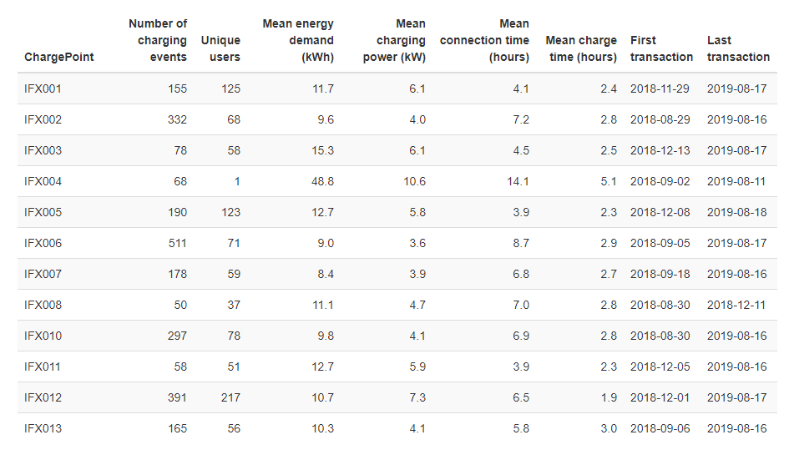
Table 23 Overview of the total number of charging events per charge point, with charging characteristics
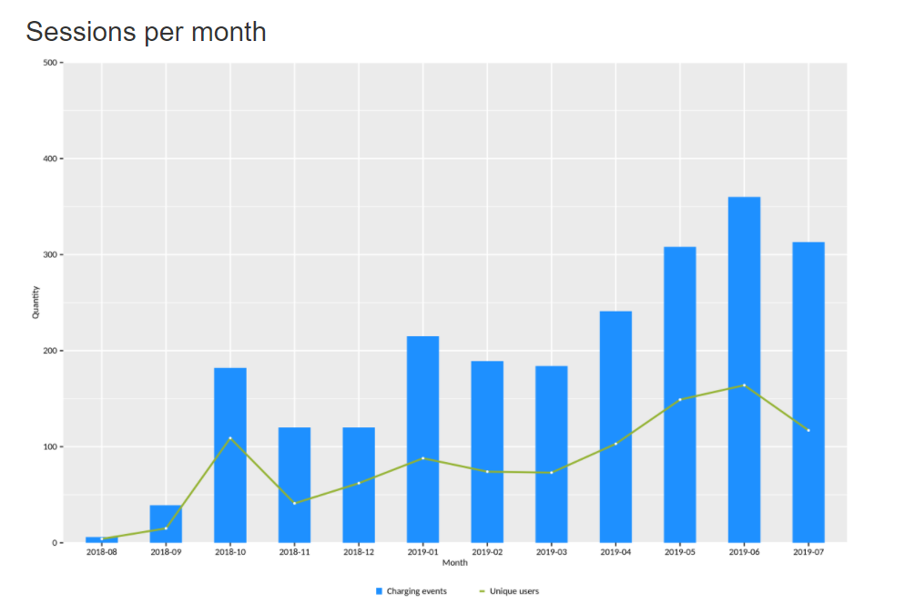
Figure 13 The overall usage of the charge points at Strijp-S increases gradually, with exceptions to the trend in October 2018 (probably linked to the event Dutch Design week) and July 2019 (summer holidays)

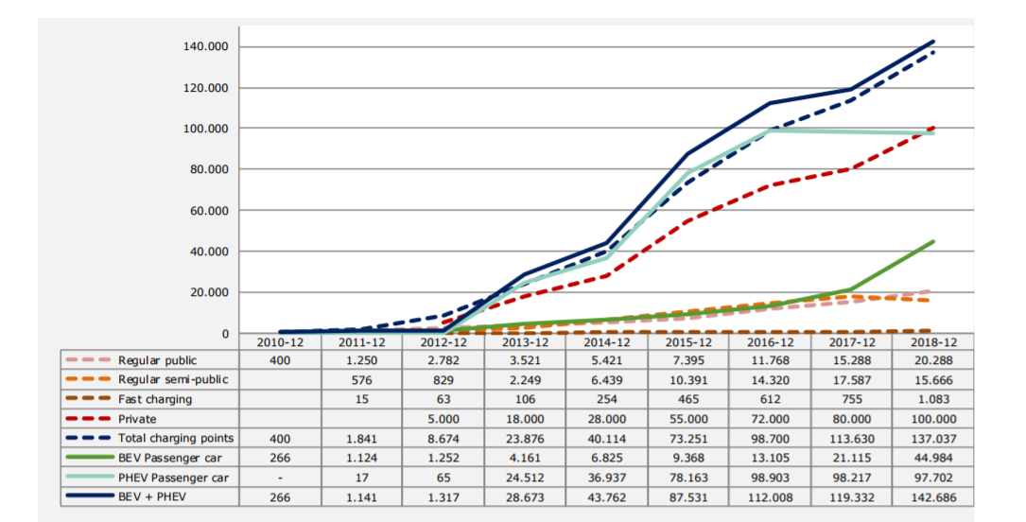
Figure 14 Development of number of Electric vehicles in the Netherlands (source: Rijksdienst voor Ondernemend Nederland). The usage of the chargers at Strijp-S is consistent with this overall growth of EV’s

First, we analysed the parking characteristics of the Regular sessions. The usage of the chargers is shown in Figure 15 and follows a consistent extended workday pattern, with arrival mostly taking place between 08:00 and 10:00 and departure mostly between 16:00 and 18:00.
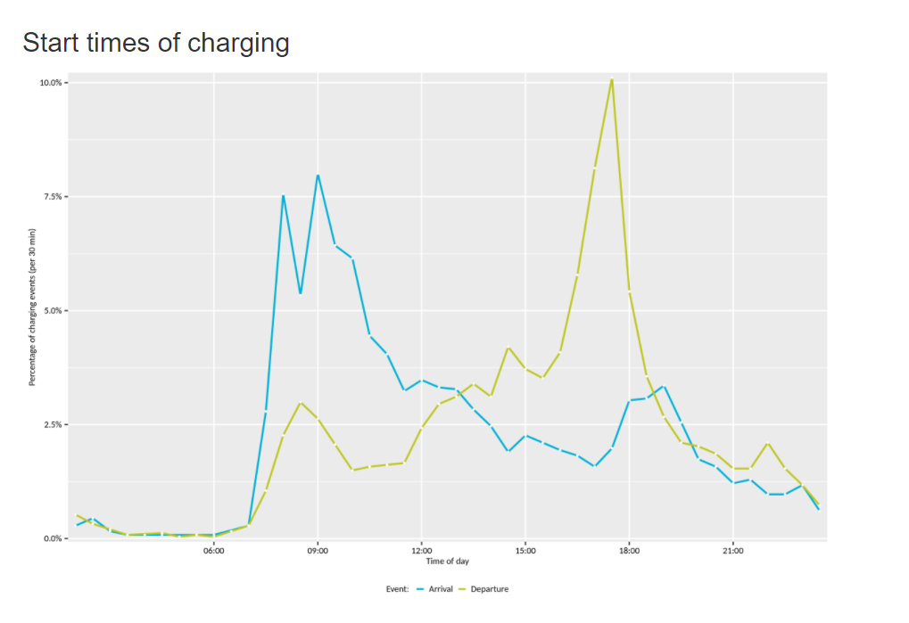
Figure 15 Overview of arrival and departure times of all charging events at the Interflex charge points

There is a lot of flexibility available in the charging, as can be seen in the next graph, Figure 16, where the ratio between [connection time minus charging time] over [charging time] is listed. Especially the sessions that start late in the evening (between 22:00h and 0:00h) and the sessions that start early in the morning have a lot of extra time available to fulfil flexibility requests. However, the mean charged power at each charger is just over 5 kWh per session, as was already shown in Table 7, so this implies that there are either not many full electric vehicles charging, or the vehicles arrive with a near full battery (but use the charger anyway because of the availability of the parking spot). This limits the amount of energy that can be shifted via smart charging, because once the battery is full, no further involvement of the vehicle on the flexibility market is possible. We currently do not have the possibility to check which situation is actually the case.

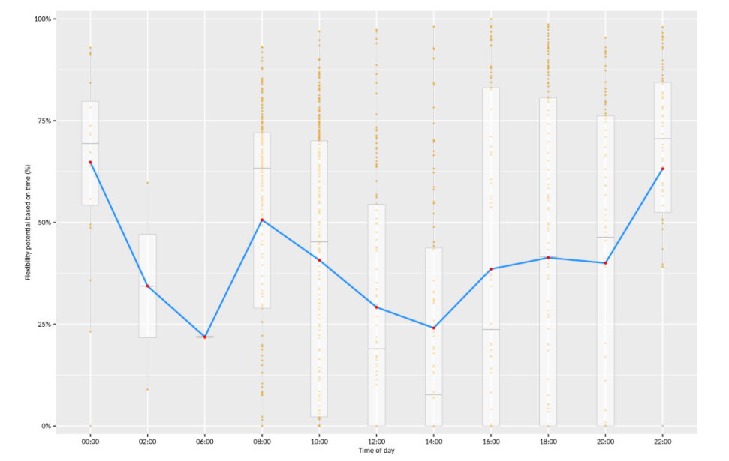
Figure 16 Flexibility potential based on available time (in percentage) listed per hour of arrival

Based on the available data on the regular charging sessions, it is safe to assume that sessions will have at least one hour of flexibility during their connection time and that sessions that started between 8:00 and 10:00 or between 22:00 and 0:00h have the highest flex potential.

Smart charging sessions:
As mentioned before, only 23 drivers registered for participation in the Flex market through the use of the Jedlix app. These drivers in total charged less than 100 times, causing significant ranges of uncertainty in quantitative or comparative analysis.

In the following analysis we will first describe the general characteristics of the Interflex Smart charging sessions before analysing the impact of the flex market on the sessions.
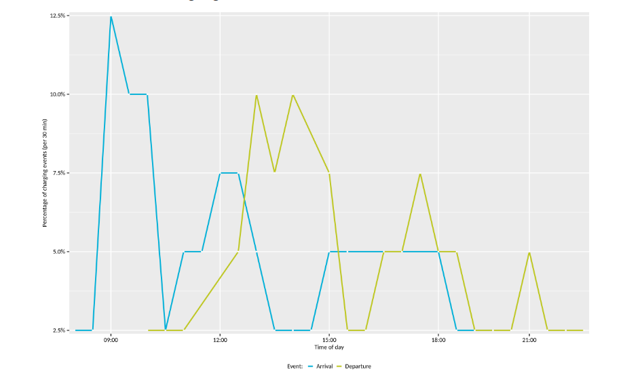
Figure 17 Arrival and departure times of the Smart sessions in Interflex

With respect to the arrival and departure times of the vehicles, it can be noted that both arrival and departure are spread more over time than what we saw in the Regular sessions, with a group of drivers arriving significantly later and a similar division in two groups for the departure time.
Because the amount of Smart charging sessions is so much smaller than the amount in total, individual differences in arrival and departure time have a big impact on the overall statistics of arrival and departure in this group, as can be seen in the Figure 17.

When looking at the overall power demand of the sessions in Figure 18, the pattern for Smart is different from the pattern we see for Regular. At first glance, the power demand of the Smart seems to be under the influence of flex requests, because the main power demand seems to be shifted to a later time of the day. However, the previous graph (Figure 17) already showed that a distinct amount of Smart sessions has an arrival time that is different from the average arrival time Regular, which has a big impact on the distribution of power demand. In order to determine whether flex requests or just the arrival time was causing the shift in peak power demand, we did some extra analyses.
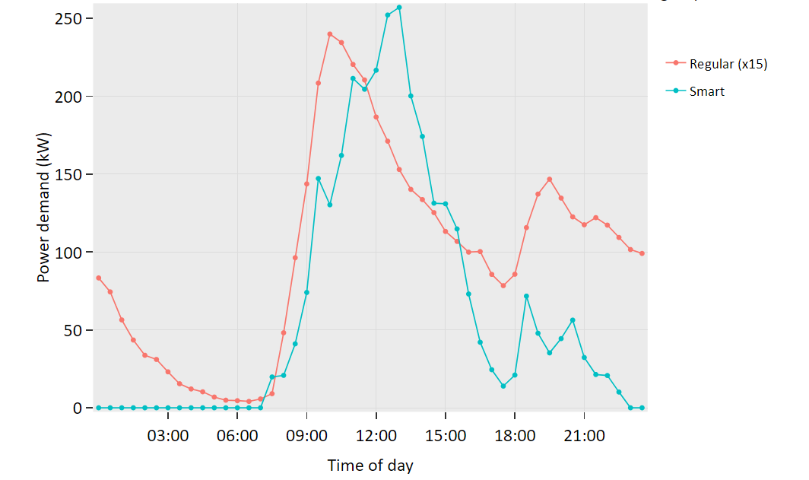
Figure 18 The power demand in kW for Regular and Smart, showing a different distribution of power between the two groups
In order to double check the absence of flexibility in Smart, we investigated the characteristics of the sessions that started charging before 12:00. The result is shown in Figure 19.
The power demand of just this group that started charging before 12:00h shows no significant difference with the regular sessions.
Finally, we visually studied the individual power delivery for all Smart sessions and found none where adjustments in power supply were visible that could be attributed to flexibility trading (figures not shown).
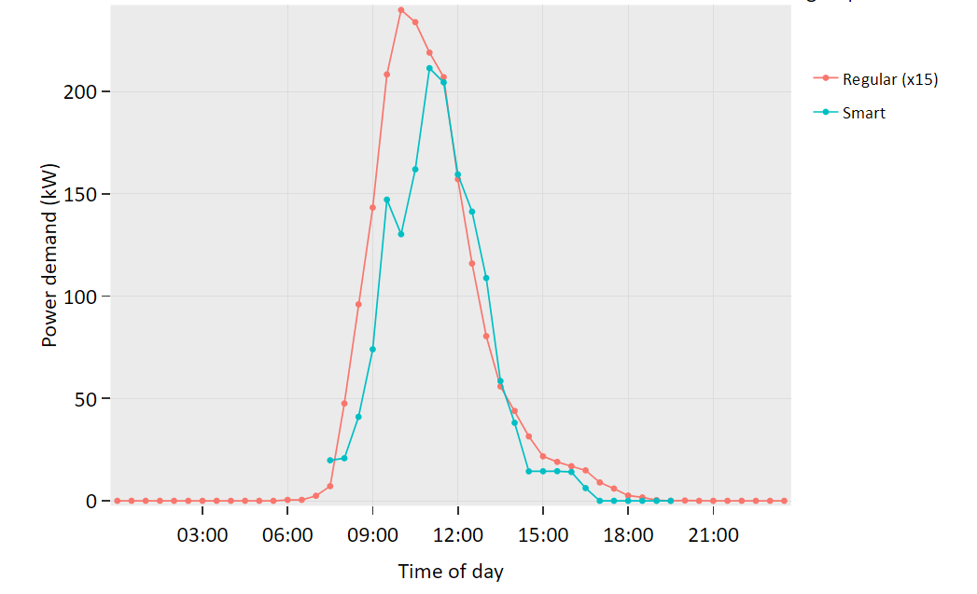
Figure 19 The power demand of only the sessions that started charging between 8:00 and 12:00am. No difference is visible between the Smart and Regular sessions

For electric vehicles, flexibility is defined as the difference between connection time and charging time, as [connection time minus charging time]/[connection time]. A percentage of 0 means the car immediately started charging at arrival and was still charging when disconnected. In a session in which flexibility was applied, the session flexibility will be lower compared to the default flexibility of that same session.
When looking at Figure 20, it appears as if flexibility services were provided during the Smart sessions have been performing flexibility services: the percentage of flexibility, which is determined after the session had finished, is significantly lower for Smart. This could suggest that more time was used for charging due to the vehicles offering flexibility services.
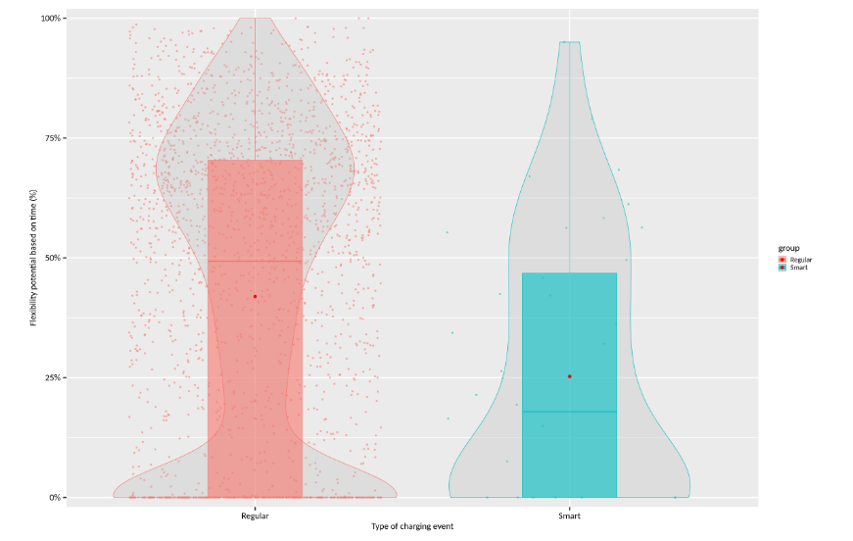
Figure 20 Distribution of flexibility potential for the two groups of EV charging sessions

Not only is the higher amount of sessions in Regular clearly visible, it is also evident that Regular has more flexibility available, both through the shape of the violin curve and the position of the average flexibility (red dot in the columns: 42% for Regular and 25% for Smart).

At a closer look, the explanation is found elsewhere: Smart sessions were simply connected to the chargers for a significantly shorter time than the Regular sessions, as can be seen in Figure 21. With practically similar amounts of charging time needed for both Regular and Smart sessions, the apparent flexibility offered does not exist.
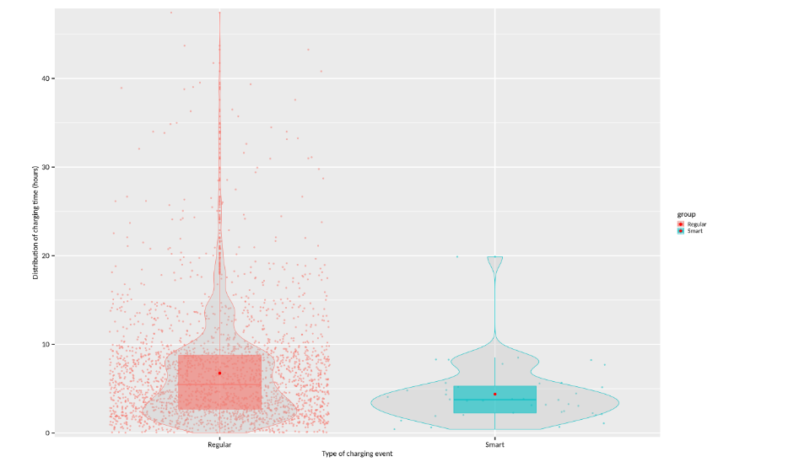
Figure 21 Distribution of connection times for the two groups of charging events. Regular has an average connection time of 6.8 hours, Smart of 4.4 hours

Technical description GMS and validation of the architecture
Description architecture
The main goal of the Grid Management System (GMS) is to address congestion problems in the distribution grid by exchanging flex messages with aggregators in a flexibility market. The Flex Decision Module which has been developed in Python will determine the flex need based on a Load Forecast (Inflexible load) and D-prognosis (Flexible load). The GMS sends the flexibility need in the format of a USEF message as Flex Request to the aggregators. Then it will receive the Flex Offers from active aggregators on each congestion point. By calculating the Acceptance Factor (AF), the GMS makes a decision to opt for the best possible offer and then sends a Flex Order to the specific aggregator.

Acceptance Factor (AF) gives a ranking to each Flex Offer based on the offered price as well as offered flexibility. This calculation is done through the following formula. These two criteria enable the Flex Order Decision module to pick the most reasonable offer, not only from cost point of view, but also considering the amount of resolved congestion.

$$AF=\sum_{t=1}^{96}{\frac{\min\left(\frac{{Flex}_{offer}}{{Flex}_{request}},1\right)}{{Price}_{offer}\left(t\right)}}×\frac{{Flex}_{offer}}{{Flex}_{request}}$$

The following constraint is also taken into account in order to ensure that the total price of offered flexibility will not exceed the maximum price that DSO is willing to pay.

$$\sum_{t}^{96}{{Price}_{request}\left(t\right)≥ }\sum_{t}^{96}{{Price}_{offer}(t)}$$

At the end of the process, the GMS receives a Flex Supply message which indicates how much flexibility actually has been delivered according to the aggregator. Figure 22 shows the GMS interface for the day-ahead process.

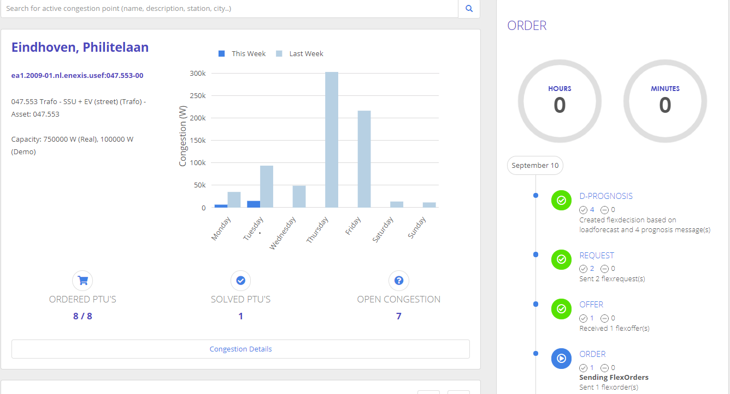
Figure 22 GMS interface per congestion point, for day-ahead process

The Flex Settlement is calculated once a week based on the actual delivered flexibility, which can specify the final cost/penalty for the DSO/aggregator. The specification of the GMS has been elaborated upon, with all its detailed components and steps in deliverable 7.6, see Appendix 1.

Validation architecture
The flexibility chain works correctly from trading point of view. The whole architecture worked as defined and the components communicated well together. Nevertheless, the proof of supply is still an open question that needs more investigation.

Some adjustments to GMS have been made for day-ahead scenario after deliverable 7.5 and 7.6. The research results from the field test led to an in-depth understanding of the flexibility chain and the interaction with the flexibility market via a day-ahead scenario. This helped to fix the bugs and improve the GMS system.
Furthermore, the GMS has been modified to realize the intra-day scenario. The adjustments that are made for the intra-day scenario are described in this chapter as well. The demonstration results for the intra-day scenario are too late to take up in this deliverable but will be analysed by the end of the project. The field test and research analysis for intra-day scenario will run in the last quarter of 2019.

Day-ahead scenario GMS
Within the day-ahead scenario, the flex decision module runs once a day to provide input for GMS including the flexibility need for each congestion point. Before the gate closure (10.30h), flex requests are sent to all aggregators connected to congestion points that have a flex need for the upcoming day. The flex request contains 96 Programme Time Units (PTU = 15 minutes timeslot) and can be either ‘requested’ or ‘available’. If one PTU is requested, then it will contain a value for the power that is needed to solve the congestion for that period. If one PTU is available, then DSO provides a power range for the aggregator in order to shift the load. Day-ahead has one trade iteration per day.

Data analysis and obtaining more profound knowledge of the flexibility chain and the flexibility market in the field test led to the following adjustments, compared to deliverable 7.6¹:
- Order Decision module: The order decision module has been developed to decide which flex offer from which aggregator should be selected. An adjustment is made in the selection procedure which determines which offer(s) should be adopted. In the current flexibility market model, DSO must accept the whole flex offer. It is not possible that DSO select part of the flex offer and reject rest of it. The analysis of the field test data revealed that only a small part of predicted congestion could be solved by choosing the offer with the lowest cost. The least expensive option cannot necessarily be the best option. In some cases, picking a bit more expensive offer can address the congestion completely which is more cost effective at the end. Therefore, an improvement was needed for accepting the best possible offer to solve the predicted congestion. Instead of making the order decision per PTU, the order decision is made on a set of PTU’s. The implemented acceptance factor in the flex decision module had to be changed to realise this change. In the revised model, acceptance factor considers both price and the degree of fulfilling the requested flex to solve the predicated congestion.
- Flex settlement: The data analysis of the field test demonstrated that there was a misinterpretation regarding the calculation of the delivered flex by aggregator. Hence, an adjustment in the flex settlement definition was required which had to be implemented by all aggregators as well as in GMS of the DSO. The new definition of the delivered flex is the delivered energy minus D-prognose. The observed baseline is not taken into account anymore. The delivered energy is the actual energy (positive or negative) that has been delivered, measured in Wh. The D-prognose is the expected power consumption profile from a commercial aggregator for a specific congestion point per PTU in Wh.
- Flex decision module: Both modules needed to be adjusted since the weather data provider did not send the complete set of predicated weather data required for the day-ahead forecast. The adjustment is to use historical weather data in case of missing weather data.

Building the intra-day scenario led to a more stable GMS, with less maintenance for the day-ahead scenario. Additional sanity checks were added to verify that the data received in the GMS is complete. Message synchronisation to the research database has been realized and extra GMS dashboards and screens are built to provide overview/insight within the more complex intra-day processing of USEF messages and decisions being made.

Intra-day scenario GMS
In the intra-day scenario, the intra-day flex requests are sent with a rolling horizon until the end of the next day. The intra-day flex requests are only sent to the aggregators that facilitates intra-day. Not all aggregators are involved in both day-ahead and intra-day process. During the research, one commercial aggregator (CA) will facilitate both scenarios and one CA only a day-ahead scenario.

Within the intra-day process the flexibility trade can be a day-ahead trade or an intra-day trade. Intra-day trade is triggered by events, where day-ahead is scheduled. Implementing the intra-day scenario had a positive impact on the whole chain, since it helps to optimise the day-ahead schedule and GMS architecture is more robust. See appendix 1 for details of the GMS intra-day interfaces.

Necessary adjustments to the GMS in the intra-day scenario are:
- Creating a stable webservice integration between the flex decision module and GMS. This means the process runs event based instead of being scheduled. Consequently, the day-ahead process also become more stable. This leads to less maintenance.
- Added validations to the USEF message processing to support intra-day. This means extra checks regarding period and gate closures. The intra-day scenario led to more rules with triggers for the decision module, D-prognose and the new load forecast. Trigger for the new load forecast is an update of the weather data.
- Monitoring and logging have been added to keep track of the intraday iterations. The process of intra-day trading is more complex than day-ahead trading.

It was a reasonable decision to start with a day-ahead scenario before implementing intra-day. Getting familiar with the flex market via the day-ahead scenario led to insights that are taken into account in the intra-day scenario. Findings from implementing intra-day led to improvements for day-ahead processes in the GMS.

The future GMS is being built on the intra-day scenario.

Main demonstration results LIMS
The LIMS is not only responsible for controlling the DERs based on the EFI+ messages it receives from the FAP, but also provides a forecast for the DERs, for the next 48 hours, and sends these forecasts once a day within an EFI+ message to the FAP, see below in Figure 23.

Figure 23 The LIMS with its connections to DERs and FAP
For these forecasts initially there was an algorithm develop based on RBFN (Radial Based Function Network). Because of the bad quality of the historical data a switch to a more linear based algorithm was made (like the PHOTOVOLTAIC GEOGRAPHICAL INFORMATION SYSTEM of Figure 24).

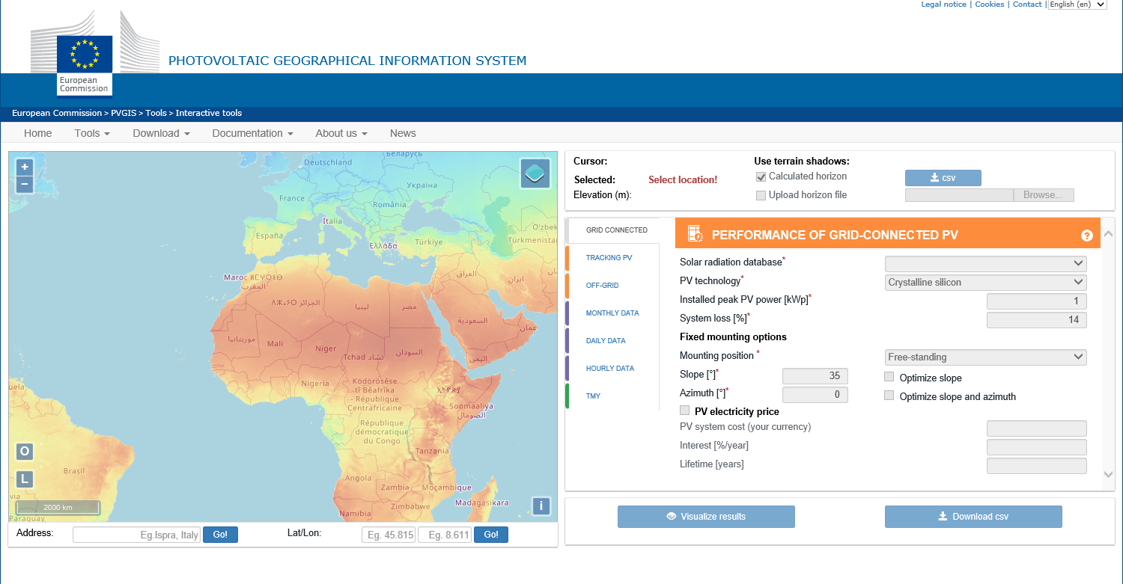
Figure 24 PHOTOVOLTAIC GEOGRAPHICAL INFORMATION SYSTEM
The results of these forecasts are incorporated in chapter 3.3.

Main demonstration results FAP-TNO
The following section starts by describing the market simulation of an envisioned future energy market. Next, the flexibility portfolio of the FAP-TNO in the demo is presented, followed by an explanation of the optimization strategy. Finally, the results and an analysis of the results are given.

Market simulation
The main energy market prices of the FAP-TNO are provided by an envisioned future, therefore simulated, energy market (with lots of renewable energy from PV and wind and extra demand in the form of electrified heating and transportation). The prices of this simulation are used by the FAP-TNO in the demo. The basic market mechanism is a price as function of standard demand (the default users request without applying flexibility) minus available supply. These prices vary significantly over time since a large amount of intermittency. The simulation includes using flexibility for demand-supply matching and incorporates storage, which obviously has substantial costs. In some rare cases we even see negative energy prices (as already occurs in Germany in recent years), as also mentioned in [Khoshrou 2018]. The figure below gives average price curves for the different months of the year.
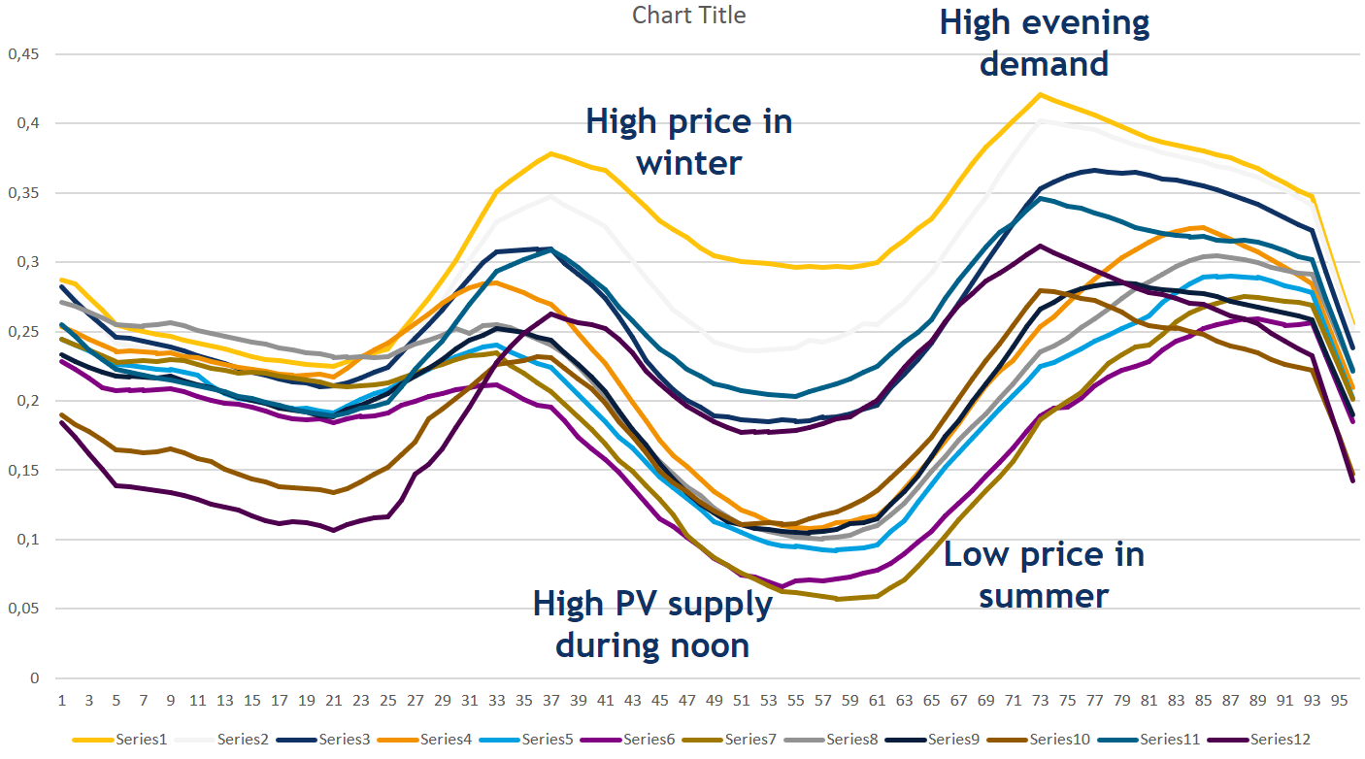
Figure 25 Monthly average day prices per month for a future high renewable scenario

In the simulation of a household using 10.000 kWh (including an EV and Heat Pump) an aggregator shifts about 1700 kWh (less than 5 kWh per day per household), so 17% of the total requested energy. The average value the aggregator gets for flexibility on this market -for shifting 1 kWh- is 0.14 €/kWh shifted. This adds up to approximately € 250 per household per year. Only about 1% of this household load was shifted to stay within the network constraints of the DSO (approximately 100 kWh per year per household).

Asset portfolio
In the pilot project FAP-TNO is controlling simulated EV charging stations, the Smart Storage Unit (a stationary battery), a curtailable photovoltaic system and the office building. During a refence period (26-09-2019 until 06-10-2019), devices under control of the TNO-FAP produced or consumed the following amounts of energy on average per day:

Asset | Energy produced | Energy consumed | Total consumption
Curtailable PV | 942 kWh / day | 0 kWh / day | -942 kWh / day
Simulated EV charging | 0 kWh / day | 200 kWh / day | 200 kWh / day
Smart Storage Unit (SSU) | 177 kWh / day | 159 kWh / day | -18 kWh / day
Office Building | 0 kWh / day | 162 kWh / day | 162 kWh / day
Total | 1119 kWh / day | 521 kWh / day | -598 kWh / day

The Smart Storage Unit produced more energy than it consumed because it ended the period with a lower state of charge than it began the period. On average, each day 436 kWh was shifted from one 15 minute period to another.

Optimization strategy
The system uses multi-goal optimization. It optimizes the behaviour of the flexible assets based on prices on a day-ahead spot market, as well as procured congestion management services by the GMS. The beforementioned simulation is basis for this day-ahead spot market. This behaviour is planned by the TNO-FAP, based on forecasted behaviour of the assets (e.g. a forecast of the PV production). The system keeps revaluation the planning and adjusts it regularly when necessary.

The FAP-TNO has the following optimization strategy: Based on the forecasted behaviour of the assets, on the morning the day before delivery, a plan for every asset is created to optimize on the day-ahead spot market. These plans take all device flexibility and constraints, which are known at that time, into consideration. These plans are aggregated to congestion point level, and is communicated through the USEF D-Prognosis messages to the GMS. The GMS can then order flexibility from the FAP-TNO. Flex ordered from the GMS results in constraints for the pool of assets under that congestion point. Figure 4 and Figure 5 show what the forecasted and optimized behaviour looks like, with the constraints visualized as the orange line, that pushes down the load on PTU’s where the GMS ordered flexibility. The pushing down, as well as the consequence on other PTU’s is visible when comparing Figure 4 and Figure 5. Translating the flexibility order from the GMS to constraints means that congestion management has priority over the optimization for the day-ahead spot market. The FAP-TNO will balance out the difference caused by the USEF congestion management trade by changing the plan of devices under other congestion points or devices that are not under a congestion point at all. In this way, the FAP-TNO is able to keep the plan of the whole cluster as stable as possible. Nevertheless, a USEF congestion management trade could lead to changes with the respect to the spot market position which means that ordering flexibility from the GMS can result in higher energy prices for the day-ahead spot market for the aggregator, which will be reflected in the prices for congestion management services.

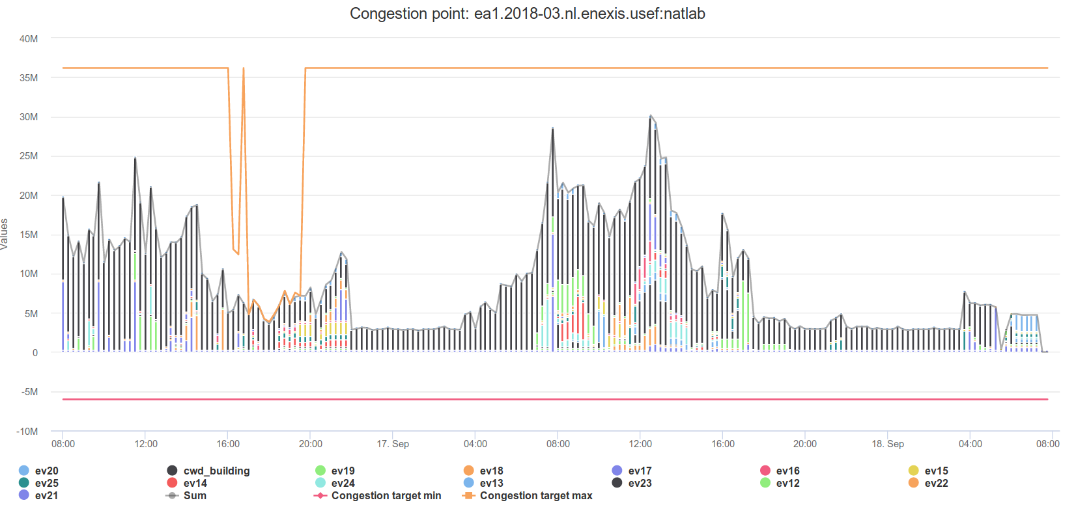
Figure 26 TNO's aggregator UI view on a congestion point, showing the day when that a congestion management trade is done and the next day (for which is trade is done) before flexibility is ordered

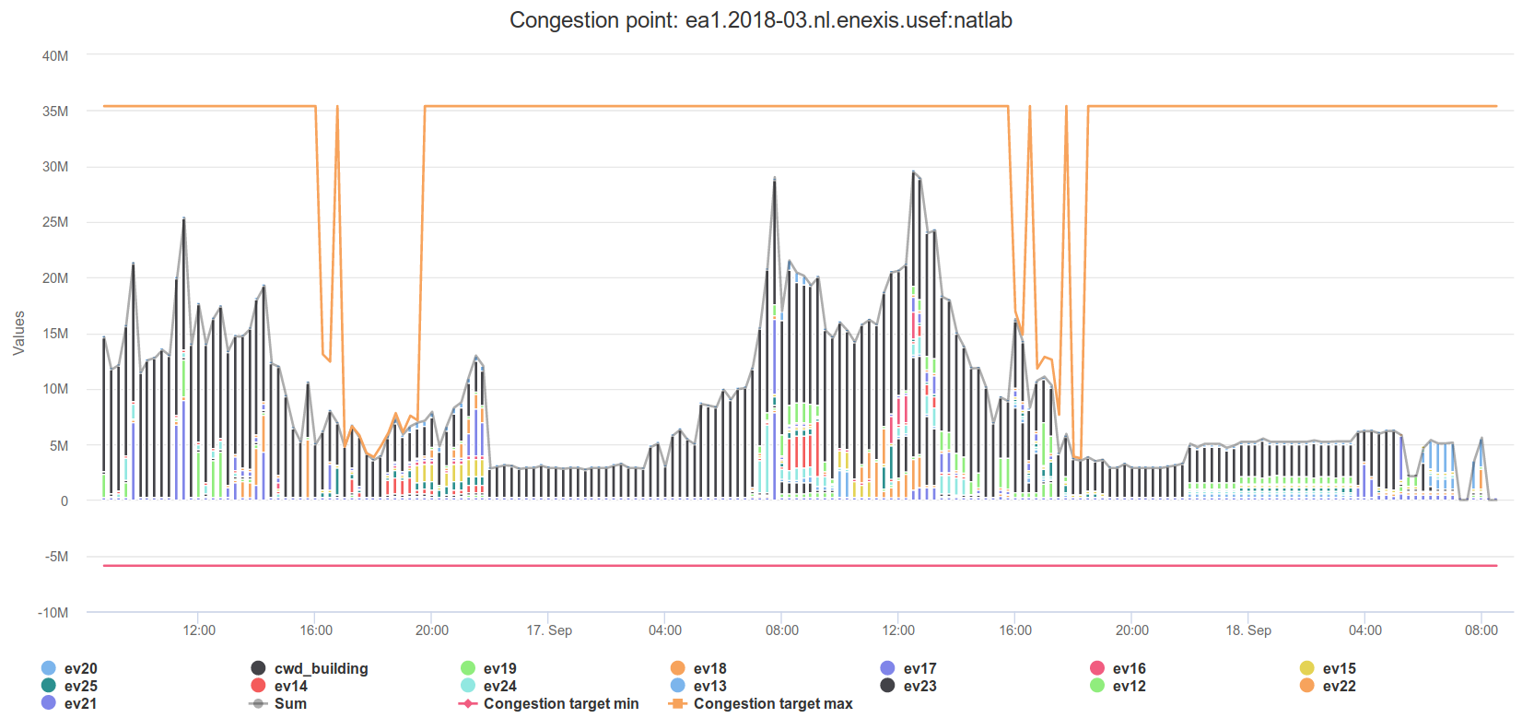
Figure 27 TNO's aggregator UI view on a congestion point, showing the day when the trade is done and the next day (for which is trade is done) after flexibility has been ordered

For congestion management services, an implementation of the USEF market model is used. The FAP-TNO generates flexibility offers towards the GMS based on a flex request. A visualization of a typical trade can be seen in Figure 28. These flexibility orders include a price per PTU. The GMS can accept or not accept this offer, based on market dynamics. The GMS makes its decisions based on the amount of flexibility needed and alternative offers from the competing FAPs, which will have different prices associated with them. The FAP-TNO uses the following strategy for composing flexibility offers:
- In case the flexibility is used from the SSU with shifting, a price € 0,10 per kWh is used, representing SSU depreciation and market costs for flexibility.
- In case energy is curtailed (e.g. from PV) the curtailment price is € 0,20 per kWh since the FAP needs to purchase more energy elsewhere as compensation for its market position.
- In case other flexibility is used (e.g. from an EV) a price of € 0,05 per kWh shifted is used, which are estimated average costs to compensate users.
- Also the loss/profit on the energy market of the new position (profile) can be calculated. These are often relatively low and irregular due to the high energy variability. For this reason, this is not included in the price of the flexibility offer.
It should be noted that these prices are based on consumer prices, which in contrast to the day-ahead spot market prices, do include taxes.

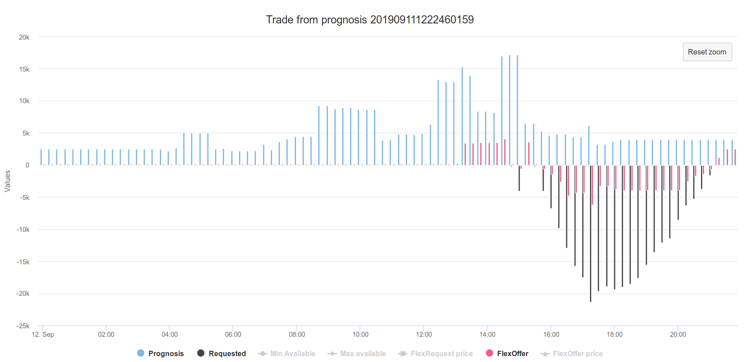
Figure 28 TNO's aggregator UI view on a USEF trade, showing the D-Prognosis in blue, the request in black and the offer (that was ordered) in red.

Analysis approach
As mentioned, the FAP-TNO operates on a simulated day-ahead spot market, which is not necessarily a realistic market. The focus of the research was technically demonstrating congestion management services. However, it is possible to create an estimation of the value of the flexibility of the sport market. In order to do that, the prices of the simulated market (which are inversely proportional to the total amount of power) were scaled to the actual prices on the EPEX spot market of the same period. The prices on the market varied between € 22,94 per MWh and € 70,44 per MWh. Based on these values, the energy costs and profits of the cluster can be calculated, as if the energy was bought and sold from this simulated market with realistic prices for the reference period.

It should be noted that the focus of the research was to demonstrate congestion management, in combination with other optimization goals. With more effort, it is possible to implement a better optimization strategy for day-ahead markets. The current implementation optimizes on a profile which is inversely proportional to the price. A better approach is to shift as much load as possible to the PTU where energy is cheapest, and as much production as possible to PTU where energy is most expensive. The provided numbers should therefore be considered as a rough estimate of the performance of the pilot, not as valuation of the flexibility of the assets.

Based on the design of the FAP-TNO, for analysis purposes, we can identify four different power profiles for the cluster of assets:
- Baseline behaviour: This is the behaviour we expect the assets to have exhibited, if they were not controlled by the FAP-TNO. The strategy of determining this behaviour differs per device type.
- Planned day-ahead spot market optimization: This is the planned behaviour of all devices, after their forecasted behaviour is optimized for the day-ahead spot market prices. This behaviour is determined the day before delivery.
- Planned behaviour after GMS trades: The planned behaviour of the assets after the GMS has procured congestion management services.
- Measured behaviour: The measured behaviour of the assets. Due to forecasting inaccuracy, communication problems, asset availability and potentially other problems, this behaviour can be different than the Planned behaviour after GMS trades.

Analysis
By comparing these different behaviours with the prices on the simulated energy market, we can make an estimation of the value of the day-ahead optimization. By looking at the trades done with the GMS, we can also estimate the value of providing congestion management services. The prices of the spot market do not include energy taxes and VAT. Energy tax and VAT can however be a very significant part of the energy bill in the Netherlands, which should be taken into consideration when looking at these numbers. For example, consumers pay € 0,11934 per kWh energy tax, with a € 0,02287 per kWh additional fee for storing renewable energy, plus 21% VAT, making the price of the energy itself only a small portion of the bill. The price of the energy itself varied during the reference period between € 0,02294 per kWh and € 0,07044 per kWh. Since energy tax depends largely on the type of user (i.e. consumer, business, public EV charging or non-business) and volume, we do not take it into consideration for this analysis. Energy tax for large companies can get as low as € 0,00058 per kWh.

Since the PV production dominates the cluster, the cluster mainly produced energy, always resulting in a net profit from selling energy. During the test period 18 congestion management trades with the GMS took place, with an average settlement value of € 14,65 per trade.

Behaviour | Spot market profit (excl. energy tax) | GMS trades profit | Profit increase w.r.t. baseline
Baseline behaviour | € 45,04 / day | € 0,00 / day | -
Planned day-ahead spot market optimization | € 52,44 / day | € 0,00 / day | € 7,40 / day  + 16%
Planned behaviour after GMS trades | € 51,53 / day | € 18,87 / day | € 25,36 / day  + 56%
Measured behaviour | € 47,32 / day | € 18,83 / day | € 21,11 / day  + 47%

When we look at these numbers, we see that for the measured behaviour spot market profits decrease quite a lot when we go from Planned behaviour after GMS trades to Measured behaviour, while the GMS trades profit only decrease a little bit. This is mainly due to forecasting inaccuracies of the PV installation, since this is the largest asset in the portfolio, and since shifting energy has a smaller impact on the profits then less generated energy than expected. The lesser value of the GMS trades in the Measured behaviour is due to small penalties for not completely delivering the ordered flexibility.

With the above data, we can make an estimation of the profit per shifted kWh. However, care should be taken when interpreting the number of shifted kWh’s. As the table 24 below shows, the trading with GMS results in a relatively low number of shifted kWh’s, but this is relative to the previous situation; optimization on the spot market prices, and not on the baseline. We see that the combined behaviour results in less shifted kWh’s than the optimization for the spot market, which suggests that GMS trading reverts some of the changes the spot market optimization made.

 | Energy shifted  per day | Average per day | Average per kWh shifted
Profit on spot market | 463 kWh | € 7,40 | € 0,0160
Profit on GMS trades | 102 kWh | € 18,87 | € 0,1850
Loss on spot market due to GMS trades |  | € -0,91 | € -0,0089
Combined profit | 436 kWh | € 25,36 | € 0,0582
Table 24 Trading GMS results
Although the prices for congestion management are relatively high (in particular compared to spot market prices) because of reasons mentioned above, we observe in the field tests that most of the flexibility offers are accepted by the GMS. The obvious reason is that we were the only party offering a significant amount of flexibility (not enough competition), ‘forcing’ the DSO to accept the offer anyway.

Experiences with the USEF market model
In addition to the technical challenges related to the implementation of the USEF communication specification that were addressed in D7.6 [InterFlex D7.6 2019], there are some experiences with the USEF market model itself that are described this section.
As the USEF specification mentions, one of the objectives of the USEF market model is not to provide a too detailed model, allowing flexibility to be traded in different flavours (like, day-head, intraday or in near real-time) and for different purposes (like congestion management, voltage control, spot-market optimization, balancing services). As a result, the specification explicitly mentions that some fundamental choices to allow a correct functioning of the market need to be made by the implementation of the model. A disadvantage of this decision is that different USEF market implementation are not interoperable. For example, in another field test in The Netherlands [Nijmegen Noord 2018, https://www.usef.energy/implementations/dynamo/] an implementation of the same USEF market model specification (v2015) was made with other implementation choices, preventing interoperability. In other words, the USEF specification is not detailed enough to be called a standard or be a candidate for that.

In order to create an implementation of the market model, USEF the specification contains quite some complexity, which is taken partly from existing electricity trading markets. This complexity should support connections to the existing markets but since those markets have different characteristics this is far from straightforward.
In the Interflex demo, extra complexity was added to the USEF market in the form of the sanction price (as introduced in [InterFlex D7.6 2019]). The USEF 2015 specification mentions a constant, market-wide penalty price per W of non-delivered flexibility. In this demo, the penalty to be paid by the aggregator for non-delivery, however, can be different for every PTU and every FlexRequest. In addition to the already quite complex pricing model for flexibility that the USEF 2015 prescribes, the sanction price added extra complexity to the implementation. In the end, it turned out to be too complex to successfully be used in the demo and thus was decided to use a fixed sanction price for all PTUs and all FlexRequests. This is effectively the same as the original constant, market-wide penalty of the USEF 2015 specification.
During the settlement phase, it is determined how much the aggregators are rewarded on basis of the amount of delivered flexibility. The USEF 2019 specification provides suggestions on how to settle (non)-delivered flexibility but leave a lot open to the implementation. During the implementation of the demo this led to many misunderstandings and discussions. The fact that the USEF foundation published in 2018 new pricing models for flexibility, support the idea that the settlement specification was far from directly useable. Note should be taken of the fact that the new pricing models published in 2018 are more complex than the original ones. Key in those models is that the payment of energy transactions is separated from the payment of flexibility.

Conclusions
In the portfolio of the FAP-TNO there are basically three types of flexibility: shifting EV charging in time, (dis)charging the Smart Storage Unit and curtailing the PV. Shifting EV charging has no direct physical costs, only requiring a control infrastructure, but still the EV users need to be rewarded for its flexibility as done in this demo. Using the battery has some more additional costs, in the form of wear to the unit, depreciation and extra energy consumption due to (dis)change inefficiency. PV curtailment is the most expensive source of flexibility, since the energy itself is lost here and cannot be sold at all. The costs of energy on electricity markets varies throughout the day, but also largely depends on the energy tax which can vary quite significantly. This means that the cost of providing flexibility can differ quite a lot among organizations offering it.

Although the above data is the result of an artificial congestion management market, and a simulated day-ahead spot market, we can draw some conclusions. We see that the profit of spot market optimization is relatively low compared to trades being made with the GMS. Also, the trades with the GMS only marginally impacts the profits from the spot market optimization. This suggests that congestion management services are too expensive right now, and that prices in a more competitive market could drop significantly. However, we should not forget that there is still room for improvement on the optimization on the spot market, which might balance the profit from spot market optimization and GMS trades in the future.

In this section only a day-ahead spot market was compared to congestion management services. As mentioned in Section 1.3, there are multiple markets which could be served in parallel by an aggregator to further increase profits.

Main demonstration results FAP EV
The FAP EV is the smart charging service that connects the GMS, the CPMS and the user. The goal of this system is to avoid local congestion in the electricity grid caused by electric vehicles.

It communicates with the GMS about the upcoming flexibility problems via the USEF protocol. The FAP EV can reach the electric vehicle through the CPMS, to get charging data and influence the charging process by pausing the charging when congestion occurs. The user has a user interface where it can set the for example the leaving time. This way the FAP EV knows at what time the car needs to be charged at the desired end state.

The service the FAP EV delivers to the GMS, is that combined charging speed per congestion point does not exceed a certain agreed level. This agreed level is based on the (updated) D-prognosis values. When the combined charging speed does exceed the agreed threshold, the FAP EV lowers the charging speeds of the individual charging sessions by sending updated charging schedules to the charging station.

Figure 29 shows the average values per PTU per message type for the FAP EV. Since the D-prognosis is a forecast of how much will be charged for the next day, the input for the D-prognosis is based on historical smart charging sessions. Unfortunately, the average charging speed per congestion point per PTU is only 5.7 kW. Be aware that this value is based on the smart charging sessions. However, it does mean that the impact that these smart charging users have on the electricity grid is very low. Next to that it is also true that if there is a problem, the problem most probably cannot be fully solved by the FAP EV since there is not a lot charging to be paused in times of high congestion. One can see that also from the differences between the Flex Request values and the Flex Offer values. The Flex Request values are significantly higher than the Flex Offer values.

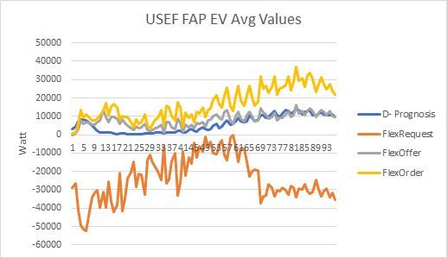
Figure 29 USEF FAP EV average values per PTU per message type
Flex requests were received by the FAP EV and answered by Flex Offers leading to Flex Offers.

When the (updated) D-prognosis is set, the FAP EV uses the D-prognosis values as input for the actual smart charging the day after. When the aggregated charging speed in a congestion point reaches is larger than the D-prognosis value in a certain PTU, the charging speed of the charging stations needs to be reduced. The implemented following logic is explained in appendix 2.

This way the FAP EV always make sure that the aggregated charger power is not exceeding the D-prognosis value.

From our analysis it is concluded that the implementation above never had to be executed since the aggregated charging power never exceeded the D-prognosis values.

Business case viability
In this section the business model viability is checked. Starting with grid reinforcement costs estimates. After adding measured flexibility costs, peak load reduction and Cost KPI, the business case viability can be checked.

Grid reinforcement costs estimates
In the Dutch pilot the different actors on the local flexibility market (the DSO and the aggregators) exchange flexibility requests, offers and orders, and settle based on the agreed pricing. From that end the DSO has a view on its current costs for using the flexibility for congestion management and grid load reduction. Since this flexibility enables the DSO to delay or defer reinforcement, the value of this reinforcement also needs to be estimated to be able to judge if the business case is positive.
When asking the DSO for grid reinforcement cost equations, it became clear that there is not a simple equation. Reinforcement costs depend on many factors. For the substation the costs are often clear. But cable reinforcement is often not needed, but when it is needed, especially for LV grid reinforcement, the costs are quite high (per kW peak), since than cables need to be replaced and dug up, which is labour intensive. Furthermore, sometimes a split can be made in the cable, then a new transformer and MV cable need to be added. These scenarios resulted in a large price range from € 100 to more than € 1000 per kW peak for grid reinforcement costs. Other estimates (rule of thumb) range from € 500 – 1000, which leads with a depreciation in 30 years of € 800 divided by 30 years to € 27 per kW per year. Besides this investment (CAPEX) also operational costs (OPEX) need to be taken into account. This is even more difficult to estimate per separate grid reinforcement.
Therefore, as alternative approach the investment and operational costs has been taken from annual year reports from Dutch DSOs and TSO.
Based on their revenues (excluding their gas revenues) a yearly cost of 114 € per year per kW peak has been estimated.
The next check done is look at the actual agreed cost structure for LV connections. These are published by the ACM (Authority Consumer and Market), https://www.acm.nl/nl/publicaties/tarieven-voor-transport-energie-stijgen-met-15-euro-jaarv). The average cost for a “1-phase >1*10A up to 3-phase up to 3*25A” is 134 € per year. This means a cost of € 141 per kW peak per year, around 0,04 € per kWh (excluding taxes, household average peak is ,95 kW and average use 3500 kWh).
This last number (€ 141 per kW peak per year) is most realistic and reliable. The lower number from the annual reports can be explained since MV connections (larger building and factories) pay less since they have their own substation and installation).
Therefore, in the remainder and conclusions of this document the € 141 per kW peak per year at LV grid as basic cost figure is used for the business case.

Flexibility costs and Cost KPI
In section 3.3.10 the cost KPIs for different congestion points have been calculated. The table is repeated here to be able to draw some business cases conclusions.
Congestion Point | CP: PV + EV parking |  | CP: Battery + EV street
Flex Source | PV | EV parking | Battery | EV street
Number of Days Flex Requested | 37 | 37 | 42 | 42
Number of Days Flex Ordered | 22 | 12 | 24 | 12
Number of Days Flex Delivered | 20 | 4 | 24 | 3
Average Peak Reduction (kW) | 65.4 | 4.6 | 48.6 | 2
BAU Costs (€) per Day | 25.3 | 1.8 | 18.8 | 0.8
Flex Costs (€) per Day | 35 | -7 | 28 | -9
Table 25 Flexibility costs per congestion point and per flex source compared with BAU costs

On both congestion points the BAU case is less expensive than the Flex costs, about 30% less. So in these case the business case for using local flexibility in negative. This is caused by the combination of high prices for PV curtailment and a very low demo capacity for this congestion point of 100 kW, which is taken so low to ensure enough congestion for the technical validation of the system. In reality the capacity is likely much higher. Then this scenario likely ends up in a positive business case.
Unfortunately there was no time left in this project before this deliverable to verify that in practice.

These business case conclusions are sensitive for the setting of demo capacity, time of year, etc. Therefor additional notes need to be made.
One: even if the business case is positive, the BAU grid enforcement is more reliable also for the longer term, since if enough aggregators will offer flexibility in the future is uncertain. From another angle the required flexibility is also unclear for the future, so the grid reinforcement rate and required moment in time is also difficult to calculate.
Two: The costs the aggregator asks the DSO in the demo seem to be on the high side, especially seeing the FAP-TNO profit margin in section 3.7. This means that at a lower profit margin the business case for DSO and FAP can be profitable for both.

Adding these points leads to the still not fully proven conclusion that local flexibility can be as well technically as well business wise profitable be used by a DSO to delay or defer grid congestion and reinforcement of the grid.

Further research is still required, for most of that a demo is not needed (or suitable). Parts can be done with larger simulations, others can be assessed by a combination of experts from different disciplines.

Conclusions
For the InterFlex Dutch demonstration several partners have built a complete technical system with a new integrated local flexibility market, enabling to validate the usability technically, economically and contractually. Therefore, the conclusions of this chapter are split in 4 conclusion areas: technical system, business model, regulation and consumer acceptance.

Technical system conclusions
The complete technical system, consisting of the CPMS, LIMS, the GMS, and three FAPs from aggregators, built around a local flexibility market work well together. The system has been running for several months in the field and the results show potential for substantial peak reduction and good performance on the KPIs.
But the system is rather complex, involving:
- a large number of stakeholder interactions and dependencies,
- low liquidity of the local flexibility market,
- pricing mechanisms and penalties defined per time unit,
- concurrent day-ahead and intraday operation, and
- dependency on forecasting reliability.
This complex system was implemented and operated in the field. This has shown very useful to learn what has to be implemented in practice when considering larger scale implementation. Additional simulations of expected future situations (with larger amounts of EVs, heat pumps and renewable generation), would give more and better insight in the strength and weaknesses of the developed system.
Although the implementation is complex it benefits from an architecture with a clear separation of concerns of the different stakeholders and by using often used protocols and/or standards. Further standardization of these type of protocols is required. At least on EU level, preferably world-wide.
- The used protocols and interfaces OCPI (a new OCPI foundation is being setup) and EFI (being used in a CEN CENELEC WG for a new standard, referred to as S2) work well in the demonstrator, also because these are not coupled to a certain market model or algorithm.
- USEF, on the contrary, is more than an interface. It is a framework that provides a market model that supports trading of all kinds of energy flexibility services. The market model is specified in general terms without all the details that an implementation needs. In InterFlex a signification part of the USEF market model is implemented and the USEF messaging standards are used. Because USEF does not prescribe implementation details, the InterFlex implementers had to define and agree upon the details themselves. As a result, the system is not interoperable with other USEF implementations. In conclusion, USEF works well in the demonstrator for communication between FAP and GMS but is based on an (implicit) market model, that is not (yet) fully capable handling all the issues discovered in InterFlex. These issues have been shared with the USEF foundation.

PV curtailment and SSU flexibility were ‘easy’ to obtain and forecast, but EV flexibility turned out to be difficult to forecast, to control, to measure and thus to obtain. EV users need to enable smart charging. On the other hand, we saw that PV curtailment and SSU flexibility costs can be higher that EV flexibility costs. The EV flexibility costs can be close to zero. In conclusion, it seems that reliability and predictability of flexibility – as provided by PV and SSU - also have its price.

Finally, based on the results of this project it seems that a local flexibility market can provide the DSO with an alternative to grid reinforcement. Given the complexity, outlined above, it is important to look further into how to such market set-up could work and be implemented on a larger scale. And to compare this solution with other options – including market-based options - for the DSO to unlock flexibility.

Business model conclusions
The basic business model with DSO and aggregators using the local flexibility market appears to be viable under the circumstances that were created for the demonstration of the flexibility market. This can be concluded from the Cost KPI. Since the demonstration had a high occurrence of congestion (up to several times a week) and used specific price settings, more validation is required under different circumstances, to understand under which conditions the business case can be positive.
Not only the technical system is complex, also the business model contains complexities and uncertainties. To list a few:
- Is the local flexibility market on short term liquid enough?
- Can gaming of aggregators be prevented?
- How to align the grid investment horizon of decades with the uncertainty of a transition to a system with aggregators, electricity markets, and regulation?
This leads to the question: Are other, simpler business models and systems feasible? One could think of a model where aggregators get a fixed price for their flexibility per year, or where aggregators reserve a part of their flexibility for DSO congestion management (based on new regulation).
From a DSO perspective, the value of flexibility is close to zero for 95% of the time. Only in situations with high overloads would the value become substantial. The preference is to prevent high overloads e.g. by means of a high network tariff for such moments.

Regulation conclusions
In this project we didn’t researched regulation items. But in the Bridge project discussions regulation issues were discussed and this with the analyses results from this demo we can conclude some regulation conclusions.
Regulation needs to be adapted (or latest regulation needs to be applied also in The Netherlands) to enable better use of the current and future electricity system possibilities, e.g. to allow flexibility to be used for, among other things, congestion management.
Aggregators can reduce the energy bill of consumers that offer energy flexibility, but this could also lead to a need for a DSO to invest in the grid. To prevent higher grid tariffs certain additional/different regulation maybe needed: e.g. some limitations for aggregators or some more options for DSOs. Changes are likely also needed to make the use of flexibility markets on short term feasible and not too complex.
Changing the (Dutch) taxation/tariff system can pave the way for using (local) flexibility and prevent more grid reinforcement than necessary. This can be accomplished with for example variable network tariffs. Coupling the energy tax not to energy amount, but the price of energy and network tariff can have a big positive effect. Note that those claims are based on conceptual considerations and it needs further study to determine which tariff system is applicable best.

Consumer acceptance conclusions
It was quite difficult to get EV drivers to participate in the demonstration. The requirements for smart charging in the field test were that users used the smart charging app of the participating aggregator and that they enabled smart charging for their EV. For a location independent smart charging provider this is not a problem, but in order to solve local congestion a substantial part of the EV drivers need to participate otherwise there is not enough flexibility available locally. From the field test it was learned that this challenge is not easy to solve and requires more study and other user propositions.
A possible solution can be to change the positioning of smart charging services to consumers. For example, by offering the EV owner a choice between low, medium and maximum flexibility. All users that want to use the charging point, have to make a decision and thus automatically engage with some form of smart charging. Also the charging points can be made subject to some form of variable capacity. Some form of EV smart charging could become a standard.

Recommendations and future steps
Like the conclusions, also the recommendations are split in the same areas: technical system, business model, regulation and consumer acceptance.

Technical system recommendations
- Start with a less complex system based on the Dutch InterFlex architecture. The current system is universal and scalable, but when the specific application area is known, a simplified version of the system can be used in e.g. an area with large amount of heat pumps, or a parking place dedicated for EV charging, or an area with PV and local storage. So apply the KISS principle (Keep It Simple & Small).
- Promote smart grid standards, actively work with various partners on this topic.
- Separate the USEF communication protocol and the USEF market model so the communication protocol can be applied for several market models (e.g. bilateral contracts, open flexibility market, variable tariffs, ...).

Business model recommendations
- Study if and under which conditions profit margins can be sufficient for aggregators and DSOs simultaneously. Would other more simple business models and systems be feasible? A good way to start may be do define ‘minimum viable products’ that can be developed and scaled up step by step. Alternative models, projects experiments and initiatives can used for reference and built upon (e.g. GOPACS)
- Initially maybe business models can be developed for specific and concrete situations: like a neighbourhood, an area with a lot of heat pumps, a parking area with high amount of EVs. It is therefore recommended to distinguish different type of networks situations, flexibility needs, areas with large supply from PV. This enables a different but not unique approach per neighbourhood.
- Is sufficient flexibility at low voltage level available at reasonable prices, in case of congestion? This is so far not clear and requires further study. Alternatively, insight in the potential flexibility for resolving congestion in medium voltage networks needs to be studied and assessed.
- In addition to demonstrations, which are very valuable to learn and gain experience with respect to the practical implementation of flexibility solutions, it is recommended to perform technical simulations which include new business models with expected future situations (such as large amount of EVs, heat pumps and renewable generation). These can provide insights for the technical system and business model viability in the future, while avoiding the complexity of building a future situation in a demonstration.
- Currently, the limited market liquidity and the related limitations to reliability of supply, urge the DSO to use different approaches. For example, bilateral contracts with a duration of several years can provide an aggregator with more certainty that their flexibility services will be used and thereby facilitate investment in flexibility sources. In turn, the DSO ensures a more reliable supply of flexibility.

Regulation recommendations
It is recommended to study which new or adapted regulation enables simpler business models. Also to ensure a good and reliable pricing or business model, since a local flexibility market can suffer from a lack of competition.
It is also recommended to study which tariff and taxation system is best applicable and unlocks and gets the local flexibility being used. In this context also a DSO ‘bandwidth model’ can be considered. In a bandwidth model, the customer pays a flat tariff for the use of a certain bandwidth of capacity (e.g. -10 kW to 10 kW). For all use outside the bandwidth, a surcharge applies.

Consumer acceptance recommendations
Study under which circumstances EV drivers accept that their flexibility is being used. Different customer propositions for smart charging services should be included in that study.
Also a study beyond EV flexibility needs to be done. Think of heat pumps, aircos, stationary batteries in homes. What are the propositions/services consumers like and will accept? In this study also drivers for consumers besides financial ones need to be studied (e.g. CO2 footprint, gamification, …).

Future steps
The most important step can be centred around the key question:
“Are more simple business models and technical systems feasible?”
Of course these systems need to be effective and fit for a future scaling up.

Steps forward to start answering this question can be made with:
- Study possible simple and attractive business models for local flexibility markets. Enexis already started with this and is participating in various flexibility initiatives (such as bilateral contracts and new tariff structures). Also allow regulation to be modified. DSOs together with research institutes and consultancy companies can perform these studies.
- Simulate most promising models. This will provide insight in the fit for purpose of these solutions and the stability of these models.
- In parallel, consumer acceptance and conditions need to be studied, also for the most promising models.
- This should lead to a limited set of easily applicable business models and related regulation, the new directive including Citizen and Local Energy Communities needs to be in scope if this.
- Then adapt and build the technical systems, and strive for standard protocols to be used and applied.
- After a possible experimental phase, introduction of new regulation and business models needs to be done.
Questions that are still open and need further study are:
- What are the costs of aggregator systems, what is the margin aggregators need to make a decent business?
- Which market models (long term/short term) are suitable and attractive so that DSOs and aggregators are willing to partake. Is special regulation needed for this?
- Flexibility costs are also influenced by taxation rules. Will these change or do these need to be changed in the near future?
- Since using flexibility by aggregators on electricity markets will likely cause higher grid peaks, can these be prevented by ‘simply’ allowing DSOs to reclaim part (e.g. 10%) of this flexibility on certain moments or days? This would make the market model and technical system less complex, no flexibility prices or penalties would be required.
- Stationary batteries have a good predictability of flexibility. Can flexibility of EVs be better predicted. What is the cost and value of this flexibility?
- Do we need to approach EV smart charging in a different way? E.g. by default an EV will be smart charged, and per charge session EV drivers can opt out if needed.

Reference list

[InterFlex D7.1 D7.2 2017] ENEXIS; 31/10/2017, UC planning, District architecture requirements and tested innovations Version 1.0, see https://interflex-h2020.com/wp-content/uploads/2018/07/D7.1-Enexis-DEMO-District-architecture-requirements-and-tested-innovations.pdf
[InterFlex D7.3 2018] ENEXIS; 29/5/2018, D7.3 Innovative solutions to be tested in the use cases
[InterFlex D7.5 2019] ENEXIS; 1/6/2019, D7.5 Lessons learnt from use case #1
[InterFlex D7.6 2019] ENEXIS; 1/6/2019, D7.6 Lessons learned to draw business models in use case #2 and #3
[Khoshrou 2018] The evolution of electricity price on the German day-ahead market before and after the energy switch, Abdolrahman Khoshrou, 2018
[Liander Open Data] See https://www.liander.nl/partners/datadiensten/open-data/data
[Nijmegen Noord 2018] https://www.usef.energy/implementations/dynamo/ (and in Dutch: https://www.liander.nl/partners/energietransitie/dynamo-flexmarktontwikkeling/flexmarkt-nijmegen-noord)

AppendiCes

Appendix 1: GMS interfaces intra-day process

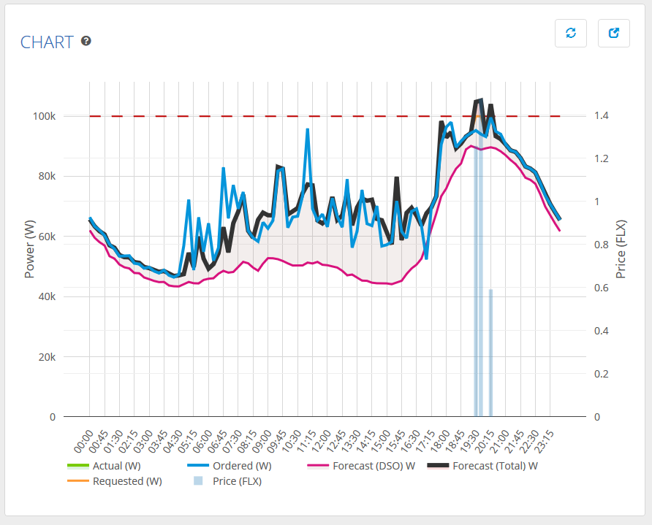
Figure 30 Visual display of the forecast / decision and trades made, including price, for the intra-day process

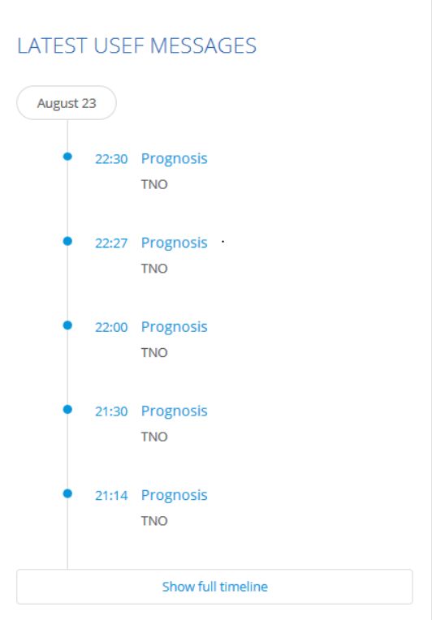
Figure 31 Message tree showing the newest USEF messages for this congestion point

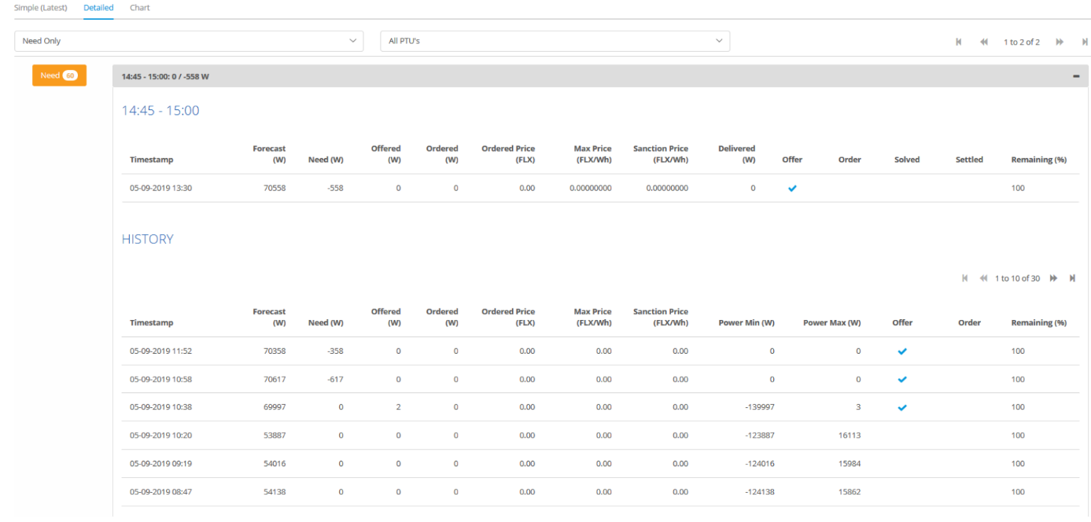
Figure 32 Decision history, showing the full history for each time unit per congestion point (per day)

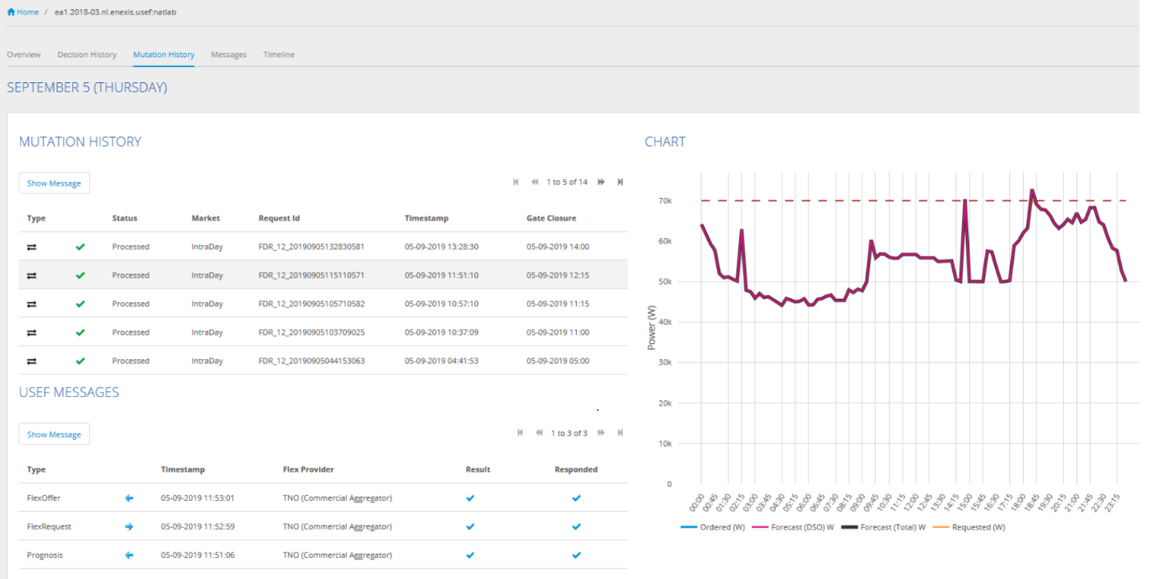
Figure 33 Mutation history, showing details for each intra-day mutation and connected USEF messages

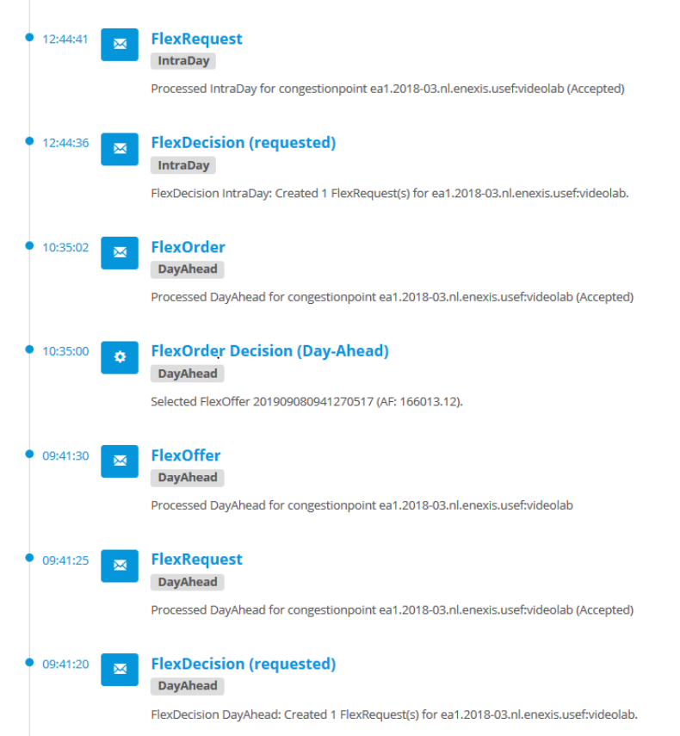
Figure 34 Timeline, all important decisions and trade interactions in chronological order

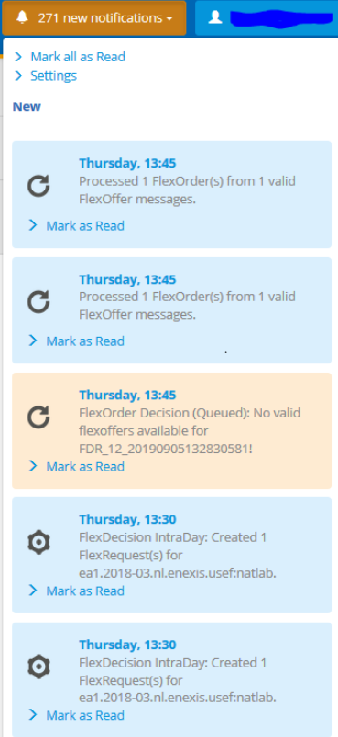
Figure 35 Notifications, configurable notifications for data analyses to raise attention

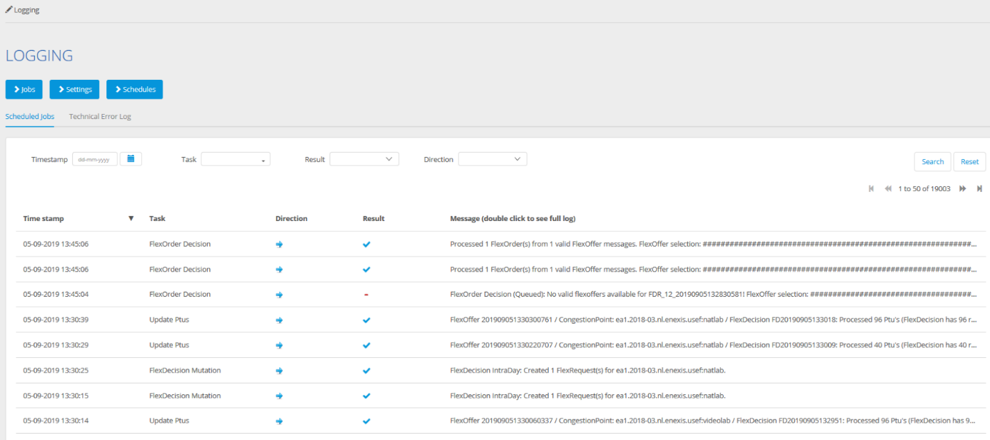
Figure 36 Logging, an overview of all jobs and schedules actions that have occurred within the system, for debugging and analyses

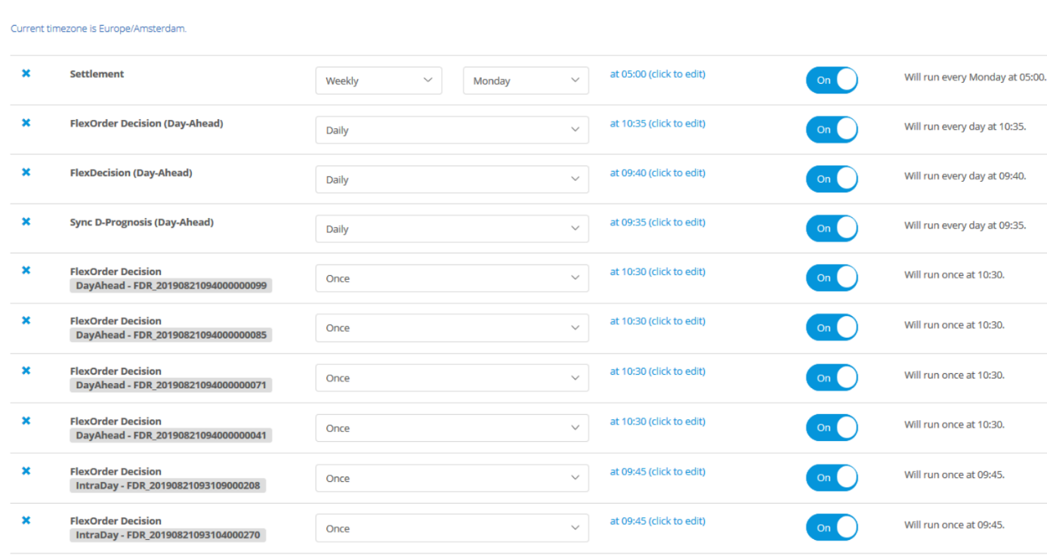
Figure 37 Schedules, showing all scheduled events with different intervals

Appendix 2: D prognose EV logic
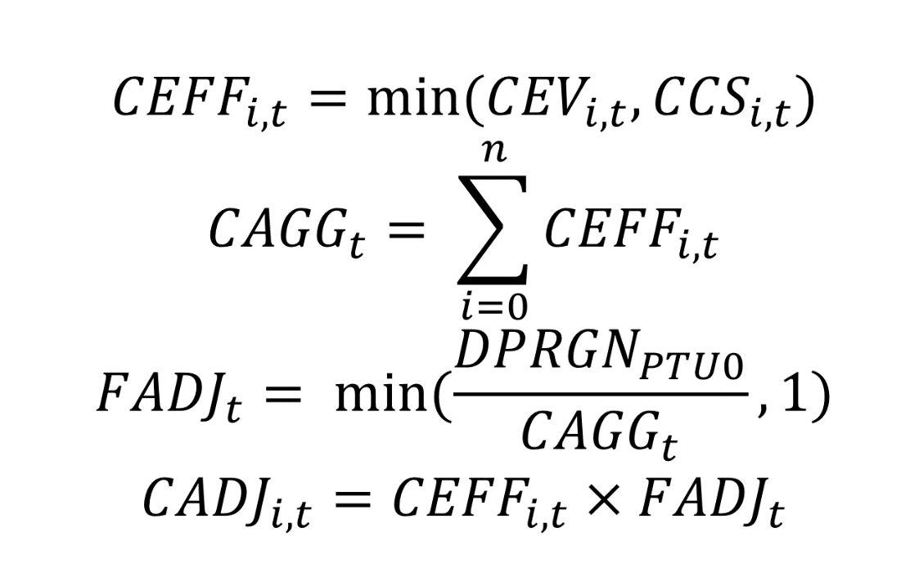
Whereas:
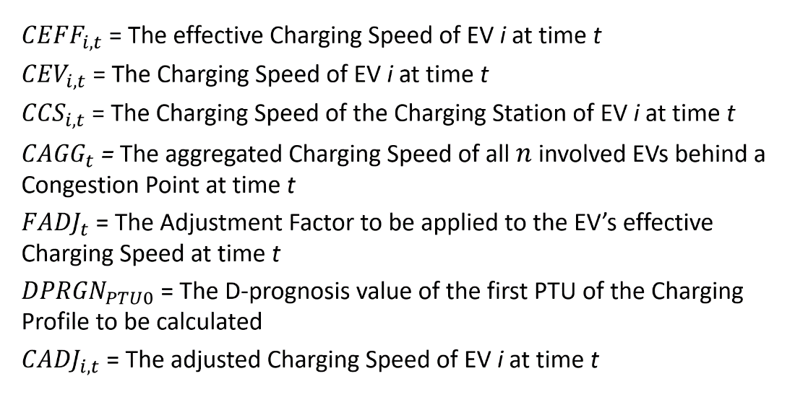
Combining this leads to:
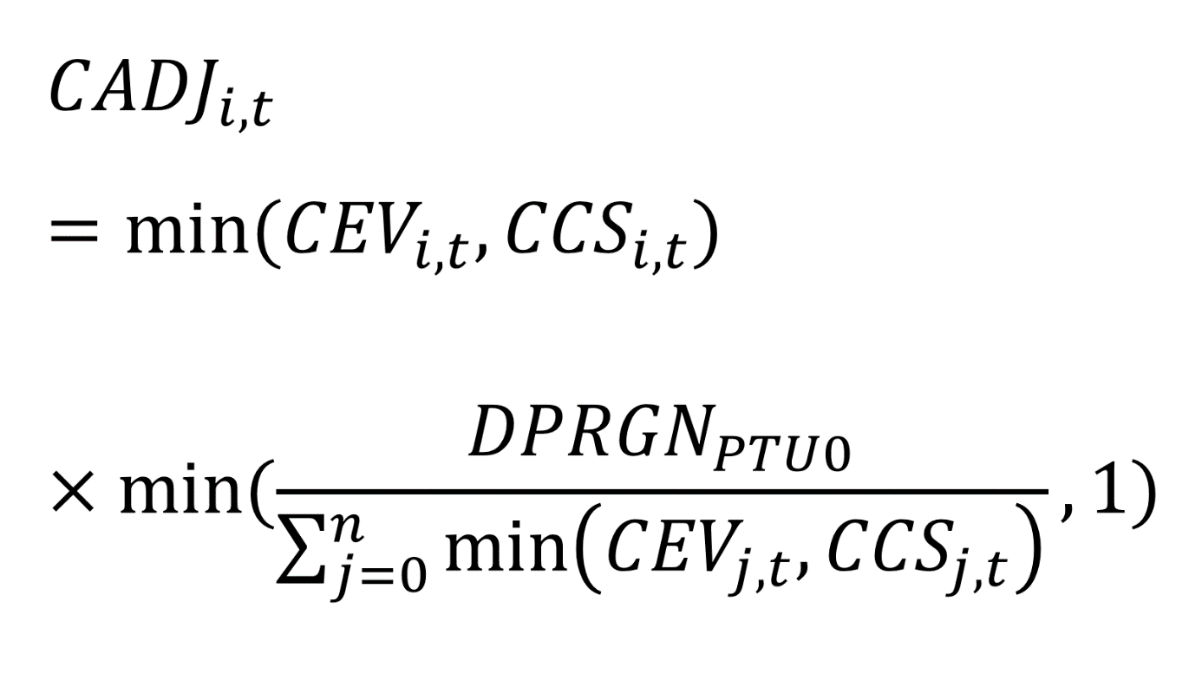

Source EPEX Spot website (https://www.epexspot.com)
The average price of accepted bids is taken as the source data as represented by the ENTSO-E (https://transparency.entsoe.eu/). For the calculation, the total costs of the called primary reserve are divided by the amount of primary reserve.
Source data the average price for ramping up, as published by Tennet (Dutch). (http://www.tennet.org/bedrijfsvoering/Systeemgegevens_afhandeling/verrekenprijzen/index.aspx)
A scenario with intraday-trading is implemented in November 2019 and results are expected beginning of 2020.
GOPACS: Grid Operators Platform for Congestion Solutions. See https://gopacs.eu/

